Epigallocatechin gallate reverses cTnI low expression induced age related heart diastolic dysfunction through histone acetylation modification
Bo Pan ^{1,2,3,4}, Xupei Huang ⁵, Jie Tian^{1,2,3,4}
1.Department of Cardiology, Children's Hospital of Chongqing Medical University, Chongqing, China;
2.Ministry of Education Key Laboratory of Child Development and Disorders, Chongqing, China;
3.China International Science and Technology Cooperation Base of Child Development and Critical Disorders, Chongqing, China;
4.Chongqing Key Laboratory of Pediatrics, Chongqing, China;
5.Charlie E. Schmidt College of Medicine, Florida Atlantic University, Boca Raton, Florida, USA

Abstract (300 word limit)

Cardiac diastolic dysfunction (CDD) is the most common form of cardiovascular disorders, especially in elderly people. Cardiac troponin I (cTnI) plays a critical role in the regulation of cardiac function, especially diastolic function. Our previous studies showed that cTnI low expression induced by histone acetylation modification might be one of the causes that result in diastolic dysfunction in aging hearts. This study was designed to investigate whether epigallocatechin-3-gallate (EGCG) would modify histone acetylation events to regulate cTnI expression and then improve cardiac functions in aging mice. Our study shows that EGCG improved cardiac diastolic function of aged mice after 8 weeks treatment. Low expression of cTnI in the aging hearts was reversed through EGCG treatment. EGCG inhibited the expression of histone deacetylase 1 (HDAC) and HDAC3, and the binding levels of HDAC1 in the proximal promoter of cTnI. Acetylated lysine 9 on histone H3 (AcH3K9) levels of cTnI’s promoter were increased through EGCG treatment. Additionally, EGCG resulted in an ascent of the binding levels of transcription factors GATA4 and Mef2c with cTnI’s promoter. Together, our data indicate that EGCG may improve cardiac diastolic function of aging mice through up-regulating cTnI by histone acetylation modification. These findings provide new insights into histone aceytlation mechanisms of EGCG treatment that may contribute to the prevention of CDD in aging populations.

Image

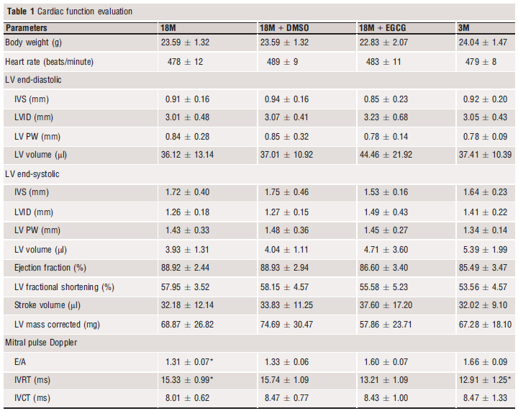
Table1: Values are expressed as mean _ SE for each group. LV, left ventricle; IVS, intraventricular septum; LVID, left ventricular internal diameter; PW,posterior wall thickness of LV; IVRT, isovolumetric relaxation time; IVCT, isovolumetric contraction time; EGCG, epigallocatechin-3-gallate. Statistical significance was determined by ANOVA followed by post hoc Student–Newman–Keuls (SNK) tests. *P < 0.05, compared with the 18M + EGCG and 3M groups.

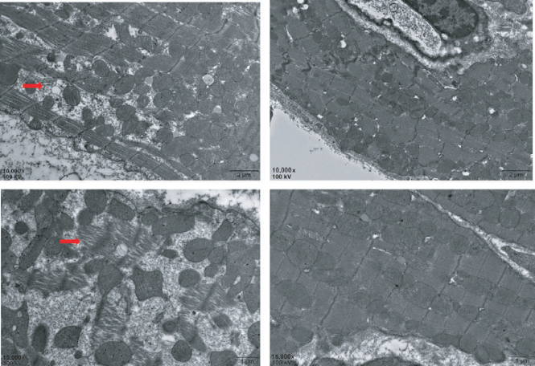
Fig. 1 EGCG treatment prevents sarcomere dissolution in cardiomyocytes. Red arrow shows sarcomere dissolution in the hearts of 18-month-old mice (A 10,0009; B 15,0009); (C and D) the cardiac ultrastructure after EGCG treatment. Scale bars in A and C = 2 lm; B and D = 1 lm. EGCG: epigallocatechin-3-gallate

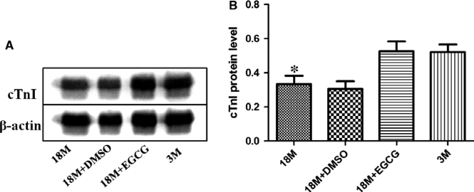
Fig. 2 EGCG treatment increases cTnI protein levels in ageing hearts. (A) Western blotting analysis using cTnI and cTnT antibodies. b-Actin was used as protein loading control. (B) A summary of Western blotting results of cTnI. Values are expressed as mean _ S.D. from four separate experiments. Statistical significance was determined by ANOVA followed by least significant difference (LSD) tests. *P < 0.05 as compared with the 18M + EGCG and 3M groups. EGCG: epigallocatechin-3-gallate.

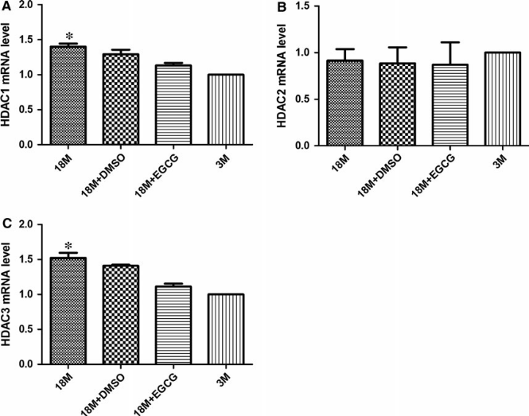
Fig. 3 EGCG inhibits class I HDACs mRNA levels in ageing hearts. mRNA levels of HDAC1 (A), HDAC2 (B) and HDAC3 (C) were detected in the four groups. The values of the 3M group are standardized as 1. Values are expressed as mean _ S.D. from three separate experiments. Statistical significance was determined by ANOVA followed by least significant difference(LSD) tests. *P < 0.05 as compared with the 18M + EGCG and 3M groups. EGCG: epigallocatechin-3-gallate.

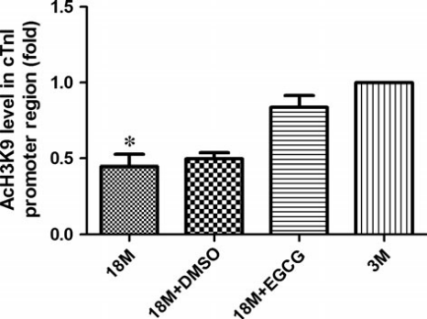
Fig. 4 EGCG reverses the hypoacetylation of AcH3K9 near the proximal
promoter of cTnI in ageing hearts. Acetylation levels of specific lysine 9
amino acid in H3 (AcH3K9) are detected near the promoter of cTnI. The
values of the 3M group are standardized as 1. Values are expressed as
mean _ S.D. from three separate experiments. Statistical significance
was determined by ANOVA followed by least significant difference (LSD)
tests. *P < 0.05 as compared with the 18M + EGCG and 3M groups. EGCG: epigallocatechin-3-gallate.
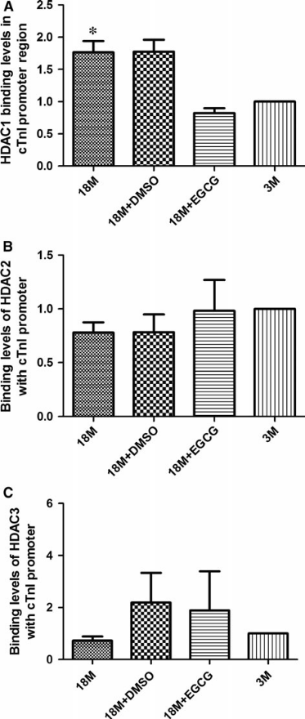
Fig. 5 EGCG inhibits HDAC1 binding levels with cTnI’s proximal promoter.
Binding levels of HDAC1 (A), HDAC2 (B) and HDAC3 (C) with
the cTnI’s promoter region were detected in the four groups. The values
of the 3M group are standardized as 1. Values are expressed as
mean _ S.D. from three separate experiments. Statistical significance
was determined by ANOVA followed by least significant difference (LSD)
tests. *P < 0.05 as compared with the 18M + EGCG and 3M groups. EGCG: epigallocatechin-3-gallate.

Recent Publications (minimum 5)
- XQ Wu(#), Bo Pan(#),Liu L, Zhao W, Zhu J, Huang X, Tian J. In utero exposure to PM2.5 during gestation caused adult cardiac hypertrophy through histone acetylation modification. J Cell Biochem. 2018 Sep 30. doi: 10.1002/jcb.27723.
- Bo Pan(#) , Junjun Quan(#), Lingjuan Liu, Jing Zhu, Xupei Huang, Jie Tian(*). Epigallocatechin gallate reverses cTnI low expression induced age related heart diastolic dysfunction through histone acetylation modification. J Cell Mol Med. 2017 Oct; 21(10):2481-2490. doi: 10.1111/jcmm.13169. Epub 2017 Apr 6.
- Pan B(#), Xu Z W, Xu Y, Liu L J, Zhu J, Wang X, Nan C, Zhang Z, Shen W, Huang X P(*), Tian J (*). Diastolic dysfunction and cardiac troponin I decrease in aging hearts. Arch Biochem Biophys, 2016.8.1, 603:20~28.
- Pan Bo(#), Zhu Jing, Lv Tiewei, Sun Huichao, Huang Xupei, Tian, Jie(*). Alcohol consumption during gestation causes histone3 lysine9 hyperacetylation and an alternation of expression of heart development-related genes in mice.，Alcohol Clin Exp Res, 2014.9.01, 38(9):2396~2402.
- Wu X, Pan B, Wang Y, Liu L, Huang X, Tian J (2018) The protective role of low-concentration alcohol in high-fructose induced adverse cardiovascular events in mice. Biochem Biophys Res Commun. 495:1403-1410.
- Xing Shen(#), Bo Pan, Huiming Zhou, Lingjuan Liu, Tiewei Lv, Jing Zhu, Xupei Huang, Jie Tian(*). Differentiation of mesenchymal stem cells into cardiomyocytes is regulated by miRNA-1-2 via WNT signaling pathway, Journal of Biomedical Science, 2017.5.10 24-29.


Biography (150 word limit)
Dr. Pan got his M.D. from Sichuan University, in 2010, and completed his Ph.D. from Chongqing Medical University.
Email:panbo910@qq.com

Notes/Comments: None

