Epigenetic regulation of phosphodiesterase 4d in restrictive cardiomyopathy mice with cTnI mutations
Weian Zhao¹, Xiaoqi Wu¹, Zhiyuan Wang¹, Bo Pan¹, Lifei Liu^{1,}, Lingjuan Liu¹, Xupei Huang², Jie Tian¹
- Department of Cardiology, Heart Centre, The Children’s Hospital of Chongqing Medical University, Chongqing, China; Ministry of Education Key Laboratory of Child Development and Disorders, Key Laboratory of Pediatrics in Chongqing, Chongqing International Science and Technology Cooperation Center for Child Development and Disorders, 136 Zhongshan 2nd Road, Yu Zhong District, Chongqing 400014, PR China.
- Department of Biomedical Science, Charlie E. Schmidt College of Medicine, Florida Atlantic University, Boca Raton, FL, USA

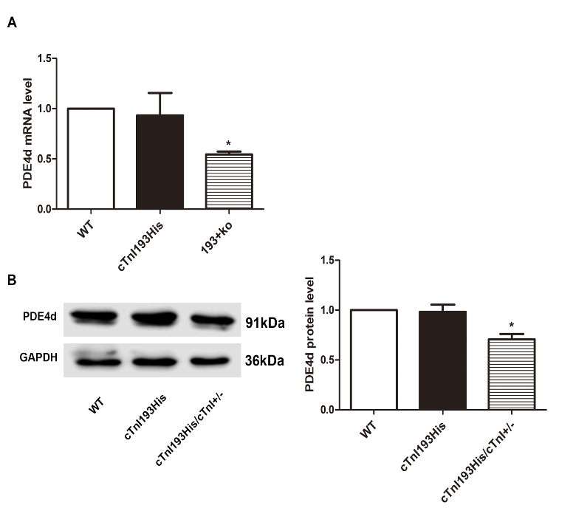
Abstract (300 word limit)

Epigenetic regulations play an important role in disease development. In this study, we have investigated epigenetic regulations in restrictive cardiomyopathy mice with cTnI 193His mutation. Our results demonstrated that phosphodiesterase (PDEs) 4d was down-regulated in the heart of these mice. Further studies showed that the epigenetic modifications were associated with enhanced acetylation of histone 3 lysine 4 and lysines 9, whereas tri-methylation of histone 3 lysine 4, were decreased in histones near the PDE4d gene promoter regions. The binding levels of histone transmethylase SMYD1 and histone deacetylase HDAC1 were increased in the gene promoter regions in cTnI193His transgenic hearts. Using immune-fluorescent labeling we found an evidence of cTnI existence in the nucleus of cardiomyocytes and Western blotting further confirmed that both wild type and mutated cTnI could be detected in the cell nucleus of the hearts. Furthermore, an interaction between cTnI and SMYD1, or cTnI and HDAC1 was observed. Overexpression of the mutated cTnI in cultured cardiomyocytes reduced the expression of PDE4d. Our data suggest that the decrease of PDE4d expression in RCM mice caused by cTnI mutations may be related to epigenetic regulation, i.e. histone acetylation and methylation, and cTnI might be involved in this procedure via an interaction with HDAC1 and SMAD1 in the hearts.
Image
Figure 1 The mRNA and protein levels of PDE4d in WT, cTnI193His, and cTnI193His/cTnI+/− mice. (A) PDE4d mRNA levels. (B) Western blotting analysis of PDE4dand quantification of Western blotting results. The results are expressed as mean ± SD. The WT mean was set as 1 for comparison with other groups. Statistical significance was determined by ANOVA followed by Least-Significant Difference (LSD) tests. * P < 0.05 relative to WT; n = 8 per group
Recent Publications (minimum 5)
- Zhao, W., Liu, L., Pan, B., Xu, Y., Zhu, J., Nan, C., Huang, X., & Tian, J. (2015). Epigenetic Regulation of Cardiac Myofibril Gene Expression During Heart Development. Cardiovasc Toxicol 15, 203-209..

Biography (150 word limit)
Zhao weian now is a PhD student from Chongqing Medical University. Email: zhaoweian1987@outlook.com

Notes/Comments: None

