

In-silco analysis of HAND class bHLH transcription factor

Shouhartha Choudhury¹ and, Supriyo Chakraborty^{2*}
Department of Biotechnology, Assam University, Silchar-788011
School of Life Sciences, Assam University, Silchar-788011

Keywords: eHAND, dHAND, bHLH, Transcription Factor

Abstract:

The present study investigated the HAND (Heart and neural crest derivatives) class basic helix-loop-helix (bHLH) transcription factor essential for normal cardiac and extra-embryonic development. In spite of their high evolutionarily conserved genetic function, expressions of these factors differ subtly across species. The cardiac hypertrophy demonstrated eHAND downregulated corresponding to cardiomyopathy, and dHAND expressed in atria. The downregulation expression in human cardiomyopathy reflects a permissive role. Cardiomyocytes (cardiac myocytes) reinitiate fetal gene program and initiate adaptive physiological changes, which allow the heart to compensate. Therefore, a great deal of the research is required for the identification of HAND gene and their specific bHLH domain. The genomic complement of the bHLH transcription factor is an essential component for the identification of the specific gene. Our investigation suggested that the number of HAND gene and their bHLH domain in the genomic data. The conserved domain, motifs, phylogeny, chromosome location, and gene expression analysis demonstrated HAND transcription factor is responsible for cardiogenesis. In this study, we performed bioinformatics and computational techniques together information on HAND class bHLH transcription factor.

Image:

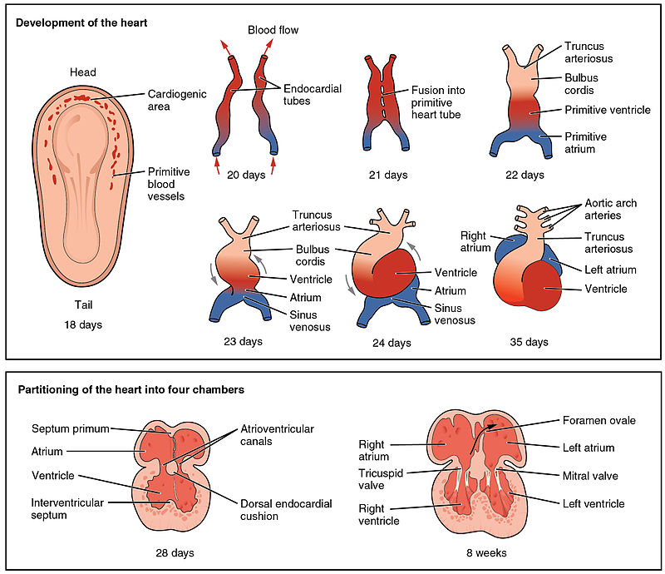

Reference:

Srivastava D¹, Cserjesi P, Olson EN. A subclass of bHLH proteins required for cardiac morphogenesis. Science. 1995 Dec 22; 270(5244):1995-9.

Thattaliyath BD¹, Livi CB, Steinhelper ME, Toney GM, Firulli AB. HAND1 and HAND2 are expressed in the adult-rodent heart and are modulated during cardiac hypertrophy. Biochem Biophys Res Commun. 2002 Oct 4; 297(4):870-5.

Stella Marie Reamon-Buettner1, Yari Ciribilli2, Ilaria Traverso2, Beate Kuhls1, Alberto Inga2 and Juergen Borlak1. A functional genetic study identifies HAND1 mutations in septation defects of the human heart. Human Molecular Genetics, 2009, Vol. 18

Biography:
Shouhartha Choudhury has completed his B.Tech, M.Tech in Bioinformatics and M.Phil in Life Science and Bioinformatics from India, and now pursuing Ph.D. from School of Life Sciences, Department of Biotechnology, Assam University, Silchar-788011, India

Author details:


Full Name: Shouhartha Choudhury
Contact number: +91-9954411181
Email-id(s): shouharthac@gmail.com
Twitter account: Shouhartha Choudhury
Linked In account: Shouhartha Choudhury
Session name/ number: shouharthac@gmail.com
Category: Oral presentation
Passport Number:



