ABSTRACT TEMPLATE

EXPLORING LIPOPROTEIN PATTERNS IN GENERAL POPULATION WITH ADVANCED ¹H-NMR TESTING

Gil-Serret M¹, Correig E^{1,2}, Ibarretxe D³, Rodriguez D¹, Pardo MA¹, Rodriguez C³, Plana N³, Masana L³, Amigó N²

¹Biosfer Teslab. Reus, Spain.
²Biosfer Teslab; University Rovira i Virgili
³Unitat de Medicina Vascular i Metabolisme (UVASMET). Reus, Spain.; Research Unit on Lipids and Atherosclerosis (URLA). Reus, Spain; Sant Joan University Hospital. Reus, Spain; University Rovira i Virgili; Institut Investigació Sanitària Pere Virgili (IISPV). Reus, Spain; CIBER of Diabetes and Associated Metabolic Diseases (CIBERDEM). Barcelona, Spain.

- Abstract Body
Advanced lipoprotein testing has largely been proposed for improving evaluation of cardiovascular disease risk associated to dyslipidemia in clinical practice. The aim of the study was to define new lipoprotein patterns by 2D-diffusion-ordered ¹H-Nuclear Magnetic Resonance (NMR) spectroscopy data (Liposcale Test)¹.
This cohort included 1442 subjects who underwent a health checking. The Liposcale Test was used to quantify lipid content –cholesterol (-C) and triglycerides (-TG)-, particle number (-P) and size (-Z) of main lipoprotein classes (VLDL, IDL, LDL, HDL) from plasma. We performed exploratory multivariate analysis (unsupervised k-means clustering) to identify four lipoprotein patterns among population. Graphical models were designed to represent each pattern.
The statistical method grouped study subjects according to their lipoprotein pattern. Group A (29%, age 25±16, 37% women, BMI 22±5) and group B (9%, age 45±14, 44% women, BMI 27±6) were constituted by apparently healthy people with low lipid levels and low risk lipoprotein pattern. Subjects in group C (37%, age 52±15, 45% women, BMI 28±6) were mainly hypercholesterolemic exhibiting mean LDL-C level around the decisional threshold (133 mg/dl), increased number of large, medium and small LDL particles as well as large LDL mean size (21.23 nm).

Image:
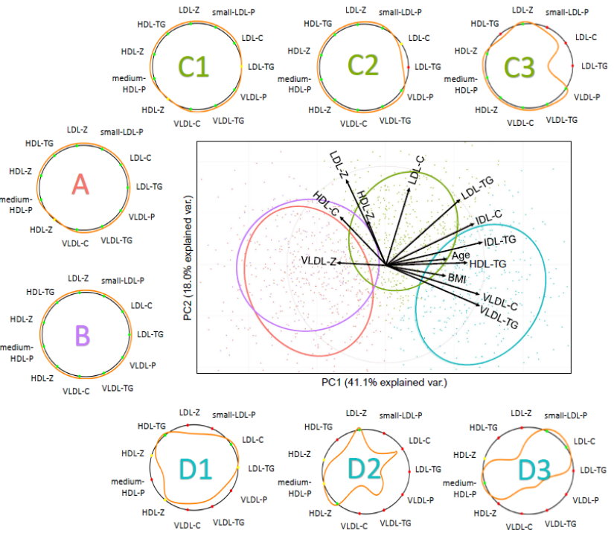

This group showed varying concentrations in IDL-C and IDL-TG. Hypertriglyceridemic subjects were found in group D (25%, age 55±13, 45% women, BMI 32±7) showing high levels of VLDL-TG (161 mg/dl) and IDL-TG (14 mg/dl) accompanied by small LDL mean size (20.83 nm). We found varying concentrations in small LDL particles and triglyceride composition in HDL among these subjects.
The Liposcale Test provides a more complete insight into lipid metabolism disturbances. Lipoprotein pattern recognition beyond standard lipid values allows a broad analysis of lipoprotein disturbances, a better stratification of patients and thus a more accurate clinical assessment.

- Reference:
1. Mallol R, Amigó N, Rodríguez MA, et al. Liposcale: a novel advanced lipoprotein test based on 2D diffusion-ordered 1H NMR spectroscopy. J Lipid Res. 2015;56(3):737-746. doi:10.1194/jlr.D050120.

Biography:
Dr. Núria Amigó (co-founder and CEO of Biosfer Teslab S.L.) is graduated in Physics from the University of Barcelona, master in Biophysics (2010) and has a PhD in Biomedical engineering at the URV. She has carried out research at the Science Park of Barcelona (X-Ray Diffraction Crystallography) and worked as a researcher in Biophysics and Neural Networks at the University of Barcelona (2009-2010) during which time she visited the Complex Systems department at Weizmann Institute of Science (Rehovot, Israel). She performed her doctoral stage at the Brigham and Women’s Hospital / Harvard Medical School (Boston, USA).

Presenting author details

Full Name: Núria Amigó Grau
Contact: 0034 676 129 966
Twitter account: @nuriaamigo
LinkedIn account: www.linkedin.com/in/núria-amigó-546b5a18
Session name: Cardiovascular risk reduction
Category: Oral presentation

