ABSTRACT TEMPLATE

Title: Fetal heart rate extraction from abdominal electrocardiograms through multivariate empirical mode decomposition.
Authors and Co-authors-Gupta P¹, Sharma KK², Joshi SD³

- Government Polytechnic College, Jaipur
- Department of Electronics, MNIT, Jaipur
- Department of Electrical Engineering IIT, Delhi

- Abstract Body (up to 250 words)
Assessment of fetal heart rate (FHR) and fetal heart rate variability (fHRV) reveals important information about fetal well-being, specifically in high risk pregnancies. Abdominal electrocardiogram (abdECG) recording is a non-invasive method to capture fetal electrocardiograms. In this paper, we propose a methodology to extract FHR (fetal RR time series) from the abdECG recordings using the recently introduced multivariate empirical mode decomposition (MEMD) technique. MEMD breaks a signal into a finite set of intrinsic mode functions (IMFs). First, elimination of the noisier abdECG channels, based on comparison of similar indexed IMFs that were obtained through the MEMD technique, is conducted. Thereafter, denoising of the remaining abdECG channels is performed by eliminating certain similar indexed IMFs. The unwanted mother QRS complexes are removed from these noise-free abdECG channels, and the candidate fetal R-peaks are detected through a wavelet based approach. The proposed methodology is validated using an open source real-life clinical database. The proposed technique resulted in a high value (0.983) of cross correlation between the detected and true FHR signals.

Image:

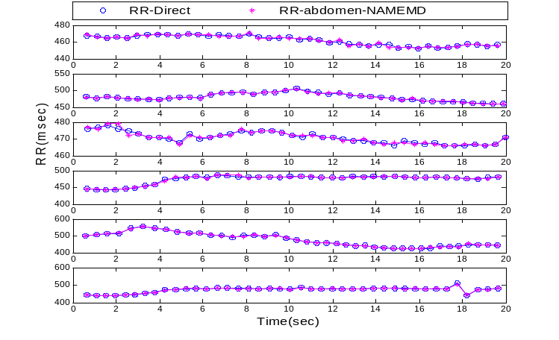
Fig. RR time series of all abdominal ECG recordings from top to bottom (rec_1, rec_2,rec_3,rec_4, rec_5, and rec_6) obtained using the NA-MEMD and its comparison with direct fetal scalp recordings.

- Reference:

- Prof. S.D. Joshi, Department of EE, IIT-Delhi
- Prof. K.K. Sharma, Department of EC, MNIT, Jaipur

Biography:
Praveen Gupta received B.E. (Distinction) degree in Electronics Engineering from Sardar Vallabhbhai National Institute of Technology, Surat (India), in 1994. He did his Master’s degree in VLSI from Malaviya National Institute of Technology, Jaipur (India) in 2008. He started his professional career with the position of Lecturer (Electronics) in Department of Technical Education (DTE), Rajasthan in 1995. Presently, he is Lecture (Selection Grade- stage-4) in DTE, Rajasthan. He has also worked as Technical Advisor in Government of Rajasthan from Dec.2014 to Feb.2016. His field of interest is Biomedical Signal Processing, specifically abdominal ECG signal processing, intra cellular neuronal recordings and algorithms. Apart from his engineering interests, Mr. Gupta is greatly interested in policy issues in higher & technical education. He has a professional membership of IEEE.

Presenting author details

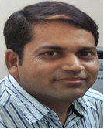

Full Name: Dr. Praveen Gupta
Contact number: +91 9414240681
Twitter account:
LinkedIn account:
Session name/ number:
Category: (Oral presentation)

