Short-Term Molecular Effects of Boost versus Radical Doses of Intraoperative electron Radiotherapy in Breast Cancer Tumor Bed Using High-throughput Approaches
Minoo Shahani¹; Jafar Shakeri¹; Babak Arefnezhad¹; Ali Tafti¹; Nahid Nafisi¹; Hakimeh Zali¹; Seyed Hamid Jamaldini Ezabady²; Hamid Reza Mirzai¹; Mohammad Esmaeil Akbari¹*.
- Cancer Research Center, Shahid Beheshti University of Medical Sciences, Tehran, Iran.
- Department of Genetics, Faculty of Advanced Science and Technology, Tehran Medical Sciences, Islamic Azad University, Tehran, Iran.
Keywords: Breast-Conserving Surgery (BCS); Intraoperative electron Radiation Therapy (IOeRT); mRNA sequencing (RNA-Seq); Isobaric Tag for Relative and Absolute Quantitation (iTRAQ)

- Abstract

Intra-operative electron Radiation Therapy (IOeRT) as a partial-breast single high dose leads to decrease the local recurrence through tumor bed modification. With the aim of reduce received irradiation dose in patients. This study designed to investigate short-term effects of single high dose- dependent and -independent (12Gy; Boost vs 21Gy; Radical), molecular mechanisms of tumor bed modification induced by IOeRT using transcriptomics and proteomics approaches. Six random selected breast cancer patients were treated by IOeRT after breast-conserving surgery. mRNA sequencing and Isobaric Tag for Relative and Absolute Quantitation(iTRAQ) were performed to study the transcriptome and proteome profile of the margin. Using mRNA sequencing, ~6 Giga base clean data per individual samples and totally 125.3 million reads of transcriptome sequence were generated from the patient samples. Moreover, using iTRAQ for proteome quantification, in total, 1045410 spectrums were generated, 31572 peptides and 5860 proteins were identified (FDR <0.01). Functional annotation and Gene Ontology (GO) indicated that significant enrichment in biological pathways for local and systemic response to short-term effects of IOeRT have induced in tumor bed, independently to the Boost versus Radical doses. Generally, by modification of Radical dose, with the same effectiveness, it is possible to reduce received irradiation dose in breast cancer patients.

Reference:

- Bravata, V. et al. High-dose ionizing radiation regulates gene expression changes in the MCF7 breast cancer cell line. Anticancer research 35, 2577-2591 (2015).
- Baskar, R., Lee, K. A., Yeo, R. & Yeoh, K.-W. Cancer and radiation therapy: current advances and future directions. International journal of medical sciences 9, 193 (2012).
- Belletti, B. et al. Targeted intraoperative radiotherapy impairs the stimulation of breast cancer cell proliferation and invasion caused by surgical wounding. Clinical Cancer Research 14, 1325-1332 (2008).

- Biography:

Minoo Shahani has completed her Ph.D.in ‘biophysics’ from the Shahid Beheshti Medical University at the age of 27 years and in addition received another PhD ‘ cancer biology’ from the same university at the age of 32 years , In the last 5 years ago, she started to works with Intra Operative Radiation Therapy(IORT) as pioneer in Iran and somehow west Asia. She started our researches on the biological effects of IORT, and nowadays after 5 years the new researches, are presenting the clinical outcome of IORT for the patients.

- Presenting author details

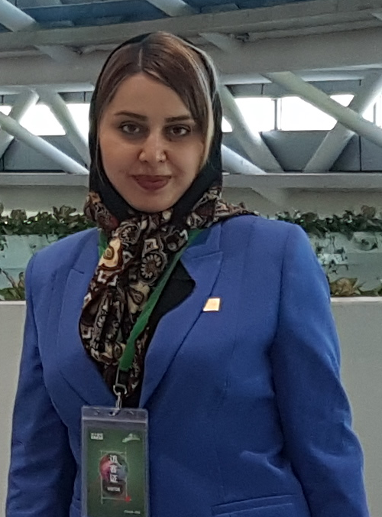

Full Name: Minoo Shahani
Contact number: 00989123075819
Email Id: minoo.shahani@gmail.com
Session name/ number:
Category: (Oral presentation/ Poster presentation/Workshop/ Keynote/YRF) Oral presentation
Passport Number: Y41178560

