Breast cancer and the perioperative window
Michael Retsky, PhD, University College London, UK

Abstract
Most current research in cancer is attempting to find ways of preventing patients from dying after metastatic relapse. Driven by data and analysis, this project is an approach to solve the problem upstream, i.e., to prevent relapse. This project started with the unexpected observation of bimodal relapse patterns in breast and a number of other cancers. This was not explainable with the current cancer paradigm that has guided cancer therapy and early detection for many years. After much analysis using computer simulation and input from a number of medical specialists, we eventually came to the conclusion that the surgery to remove the primary tumor produced systemic inflammation for a week after surgery. This systemic inflammation apparently caused exits of cancer cells and avascular micrometastases from dormant states and resulted in relapses in the first 3 years post-surgery. Two animal studies agree with these findings It was determined in two retrospective studies that the common inexpensive perioperative NSAID ketorolac could curtail the early relapse events after breast cancer surgery. Ketorolac is routinely used at the surgeon’s option either before or after breast cancer surgery at Beth Israel Deaconess Medical Centre. Based on what we now know, surgeons and anesthesiologists should take extra efforts to reduce systemic inflammation during the perioperative window.

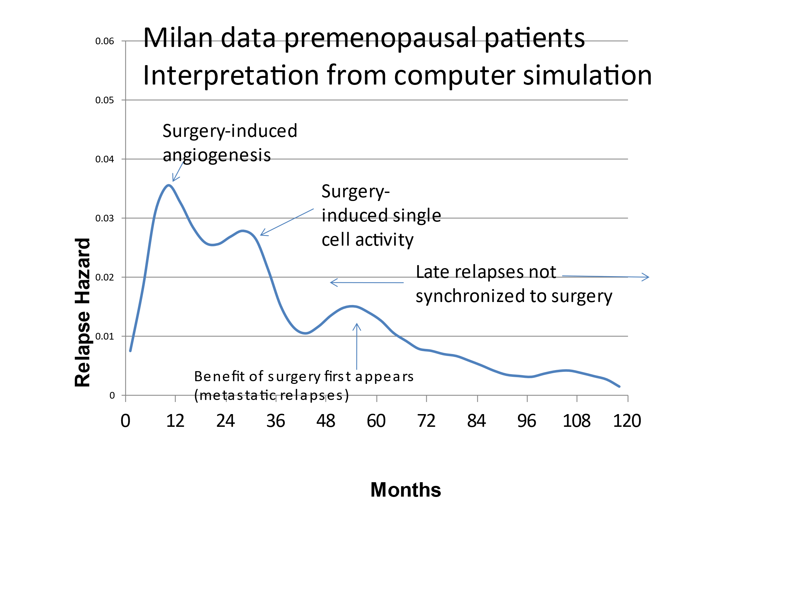


Michael Retsky received a Ph.D in physics from University of Chicago in 1974. Retsky was working at Hewlett-Packard in Colorado Springs in 1982 when a friend’s wife was diagnosed with cancer. This friend organized an informal study group to see if we could help his wife survive cancer. (She died 30 years later.) Retsky got more interested in cancer research than physics research and gradually made a career change to cancer research. He became Prof of Biology at University of Colorado, Visiting Prof at University of Texas and later joined Judah Folkman’s laboratory at Harvard. He is currently Hon Assoc Prof at University College London. Relevant links:
https://www.propublica.org/article/where-are-the-low-cost-cancer-treatments
https://magazine.iit.edu/fall-2019/when-life-happens

Recent Publications (minimum 5)
- Retsky, Demicheli, Baum, James, Hrushesky, Vaidya, Nelson, Forget; Breast Cancer and the Black Swan. eCancer, 2020
- Demicheli R, Hrushesky W, Retsky M, Biganzoli E. Interpreting Breast Cancer Survival Data by the Hazard Function: Remarkable Findings from Event Dynamics. Medicina (Kaunas). 2020 Sep 12;56(9):468. doi: 10.3390/medicina56090468. PMID: 32932597; PMCID: PMC7559922.
- Forget P, Aguirre JA, Bencic I, et al. How Anesthetic, Analgesic and Other Non-Surgical Techniques During Cancer Surgery Might Affect Postoperative Oncologic Outcomes: A Summary of Current State of Evidence. Cancers (Basel). 2019 Apr 28;11(5):592. doi: 10.3390/cancers11050592. PMID: 31035321; PMCID: PMC6563034.
- Baum M, et al. Does surgery unfavourably perturb the "natural history" of early breast cancer by accelerating the appearance of distant metastases? Eur J Cancer. 2005 Mar;41(4):508-15. doi: 10.1016/j.ejca. 2004.09.031. Epub 2005 Jan 18. PMID: 15737554.
- Retsky M. It May Be Possible to Prevent both Early and Late Relapses in Breast Cancer; Perhaps This Is an Opportunity for Sensors or Biosensors to Help. Sensors (Basel). 2020 Dec 18;20(24):7261. doi: 10.3390/s20247261. PMID: 33352842; PMCID: PMC7766622.

This project started in 1993 when Retsky was attending a breast cancer conference in Europe. Out in the lobby a poster was presented by Romano Demicheli of the Milan National Cancer Institute showing a bimodal relapse pattern for 1073 patients who were treated with mastectomy. Retsky recently made a career change from physics research to cancer research and he had never seen such data. Then in the lecture hall, Michael Baum discussed a bimodal relapse pattern for UK patients. We three got together later and found that both Demicheli and Baum were presenting equivalent data.
Statement of the Problem: Was this quality data and if so, what was the implication?
We have been studying the Milan data in detail and determined that these data are indeed valid. There was an early sharp surge of relapses in the three years post-surgery followed by a minimum at about 4 years followed again by a shallow broad peak of relapses extending to 10 and more years.
This project has crossed into other medical specialties and now includes three surgeons, two medical oncologists and one anesthesiologist plus a laboratory scientist and a physicist.
These data must be considered anomalous.
Women who have experienced intimate partnerviolence (IPV) are at greater risk for physical and mental health problems including posttraumatic stress disorder (PTSD) and alcohol dependency. On their own IPV, PTSD and alcohol dependency result in significant personal, social and economic cost and the impact of all three may compound these costs. Researchers have reported that women with these experiences are more difficult to treat; many do not access treatment and those who do, frequently do not stay because of difficulty maintaining helping relationships. However, these women’s perspective has not been previously studied. The purpose of this study is to describe the experience of seeking help for alcohol dependency by women with PTSD and a history of IPV in the context in which it occurs. Methodology & Theoretical Orientation: An inter subjective ethnographic study using hermeneutic dialogue was utilized during participant observation, in- depth interviews and focus groups. An ecological framework was utilized to focus on the interaction between the counselors and the staff to understand this relationships and the context in which it occurs. Findings: The women in this study were very active help seekers. They encountered many gaps in continuity of care including discharge because of relapse. Although the treatment center was a warm, healing and spiritual place, the women left the center without treatment for their trauma needs and many without any referral to address these outstanding issues. Conclusion & Significance: Women with alcohol dependence and PTSD with a history of IPV want help however the health and social services do not always recognize their calls for help or their symptoms of distress. Recommendations are made for treatment centers to become trauma- informed that would help this recognition.

Image

Recent Publications (minimum 5)
- Retsky, Demicheli, Baum, James, Hrushesky, Vaidya, Nelson, Forget; Breast Cancer and the Black Swan. eCancer, 2020

- Ask Google if surgery causes cancer to spread and you will get 50 to 200 million hits; How did this happen?

- Michael Retsky
- University College London, UK

- Having recently made a career change from experimental physics to cancer research, I was attending a breast cancer conference in Europe in 1993. Out in the lobby a poster was presented by Romano Demicheli of the Milan National Cancer Center. He showed relapse data for 1234 patients that were followed over 10 years. and . has been going on for In developed countries, metastatic relapse after diagnosis of early stage breast cancer is the common pathway leading to mortality from the disease. How to prevent relapses remains perhaps the most important unsolved problem in oncology.
As my colleagues and I recently reported, analysis of clinical breast cancer relapse data after mastectomy suggests most distant relapses occur within 4 years of surgery and are precipitated or accelerated by something that happens around the time of surgery. Sudden growth from single cells and angiogenesis of avascular micrometastases are indicated. Late relapses are not accelerated by surgery. Many clinical characteristics of breast cancer can be explained with this hypothesis. Recent retrospective analysis of clinical data from one Brussels hospital indicates early relapse events were reduced 5-fold when an NSAID was used as perioperative analgesic. Combining the surgery induced metastatic activity hypothesis with these Brussels data suggests transient systemic inflammation following primary tumor removal (identified by markers in serum) may facilitate early metastatic activity and was effectively blocked by the NSAID. While breast cancer is a disease that runs its course in over a decade, most of the damage seems to occur in the week or two after surgery. This suggests new mechanisms for metastatic initiation and possibly an effective nontoxic, low cost intervention that may significantly reduce mortality from breast cancer. Our recommendation is for the surgeon and anesthesiologist to keep systemic inflammation low starting before and continuing after the surgery.
- (http://www.clintransmed.com/content/1/1/17)

- (Retsky et al Med Hypoth 1990, BCR&T 1997 and 2001

- Biography

Biography (150 word limit)
Michael Retsky received a Ph.D in physics from University of Chicago in 1974. Retsky was working at Hewlett Packard in Colorado Springs when a friend’s wife was diagnosed with cancer. This friend organized an informal study group to see if we could help his wife survive cancer. (She died 25 years later.) Retsky got more interested in cancer research than electron beam research and gradually made a career change to cancer research. He became Prof of Biology at University of Colorado, Visiting Prof in Bill McGuire’s department at University of Texas and later joined Judah Folkman’s laboratory at Harvard and stayed there until Folkman died in ????. While in Folkman’s lab, Retsky was diagnosed with stage 3-c colon cancer. He became the first person to use what is now called metronomic chemotherapy. This is documented as …. And … Retsky is now Assoc Prof at University College London.

His thesis project was to build a 100kV electron microscope that could resolve single atoms and could distinguish single silver atoms from uranium atoms.

ivalence, was on staff at Harvard School of Public Health, and honorary Assoc prof at University College London, and Prof Adj at UANL, Monterrey, Mexico. He was on Judah Folkman’s staff at Harvard Medical School for 12 years. He was a founder and was on the board of directors of the Colon Cancer Alliance and has published more than 60 papers in physics and cancer. He has a patent pending for treatment of early stage cancer.

Notes/Comments:

Most current research in cancer is attempting to find ways of preventing patients from dying after metastatic relapse. Driven by data and analysis, this project is an approach to solve the problem upstream, i.e., to prevent relapse. This project started with the unexpected observation of bimodal relapse patterns in breast and a number of other cancers. This was not explainable with the current cancer paradigm that has guided cancer therapy and early detection for many years. After much analysis using computer simulation and input from a number of medical specialists, we eventually came to the conclusion that the surgery to remove the primary tumor produced systemic inflammation for a week after surgery. Two animal studies agree with these findings. This systemic inflammation apparently caused exits of cancer cells and micrometastases from dormant states and resulted in relapses in the first 3 years post-surgery. It was determined in two retrospective study that the common inexpensive perioperative NSAID ketorolac could curtail the early relapse events after breast cancer surgery. Perioperative ketorolac is routinely used at the surgeon’s option before or after breast cancer surgery at Beth Israel Deaconess Medical Centre. Based on what we now know, surgeons and anesthesiologists should take extra efforts to reduce systemic inflammation during the perioperative window.

with triple-negative breast cancer (TNBC) patients, the category that could respond best to the perioperative NSAID. If this works as well as we expect, we would then transfer this technology to low- and/or middle-incomes countries (LMICs), starting with Nigeria where early onset type of TNBC is common. There is an unmet need in LMICs, especially in countries like Nigeria (190 million population), for a means to prevent surgery induced relapse that we are attempting to resolve. This work aims, thus, to describe eventual mechanisms, and ways to test a solution addressing an unmet need. But first, we consider the context, including within an historical perspective, important to explain how and why a Kuhnian paradigm shift may be considered.

