Cisplatin and metformin nano-cubosomes demonstrate higher cytotoxicity in CRC than individual drugs
Mona M. Saber, Abdulaziz M. Al-mahallawi, Noha N. Nassar, Samia A. Shouman
Cairo University, Egypt

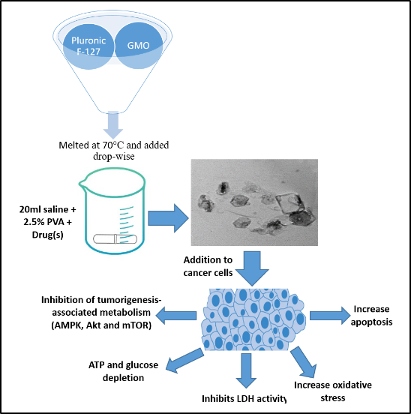

Abstract (300 word limit)
Colorectal cancer (CRC) remains a leading cause of death worldwide. The use of cisplatin as an anti-cancer drug in CRC is correlated with severe adverse effects and drug resistance. Utilizing combination of anticancer agents can effectively kill cancer through multiple pathways; nonetheless, improvements in their delivery are needed. Nano-cubosomes, thanks to the advantages of their liquid crystalline porous nano-architecture and capability for multi-drug encapsulation, appear to be of interest as nanocarriers for anti-cancer therapies. Hence, delivering cisplatin, as nano-cubosomes, concomitantly with other chemo-dugs can lead to a rationally designed therapy for chemo-resistant cancers and might overcome problems associated with conventional cisplatin treatment. Therefore, we constructed nano-cubosomes bearing either cisplatin alone or cisplatin-metformin combination that are able to enhance drug transport to HCT-116 CRC cells. Results from this study revealed that nano-cubosomal formulations exhibited superior cytotoxic effect compared to unformulated cisplatin. This cytotoxic effect was profound upon incorporation of metformin, an mTOR inhibitor, in cisplatin nano-cubosomes. The induced CRC cell apoptosis was through inhibition of several metabolic pathways, namely, AMPK/mTOR and Akt/mTOR. Drug-loaded nano-cubosomes ensued depletion in glucose and energy levels that led to AMPK activation and thus mTOR inhibition. mTOR was additionally inhibited via suppression of p-Akt levels after nano-cubosomal treatment. Moreover, drug-loaded nano-cubosomes produced a notable escalation in ROS levels, evident as an increase in NADPH oxidase, inhibition of LDH and a consequential upsurge in caspase-3. These results demonstrated the influence exerted by cisplatin-loaded nano-cubosomes on CRC cell survival and enhancement of their cytotoxicity upon metformin addition.

Image

Fig 1: A graphical abstract representing the preparation of cisplatin and cisplatin-metformin nano-cubosomes using the emulsification technique. Treatment of CRC cells with drug-loaded nano-cubosomes resulted in a substantial inhibition of several metabolic pathways, including AMPK/mTOR and Akt/mTOR pathways. The resultant ATP and glucose depletion led to an increased oxidative stress and therefore apoptosis. Another mechanism for the cytotoxic effect of the nano-cubosomes is the inhibition of LDH activity which in turn results in caspase-3 activation.
Recent Publications (minimum 5)
- Mona M. Saber, May A. Galal, Afaf A. Ain-Shoka and Samia A. Shouman (2016). Combination of metformin and 5-aminosalicylic acid cooperates to decrease proliferation and induce apoptosis in colorectal cancer cell lines. BMC cancer 16:126.
5. Mona M. Saber, Abdulaziz M. Al-mahallawi, Noha N. Nassar, Björn Stork and Samia A. Shouman (2018). Targeting colorectal cancer cell metabolism through development of cisplatin and metformin nano-cubosomes. BMC cancer 18:822.

 Biography (150 word limit)
I completed my PhD from Cairo University in 2018. I am currently a lecturer in the Pharmacology and Toxicology department, a premier research organization. I published 2 articles related to colorectal cancer in the BMC Cancer journal. I spent 6 months in the institute of molecular medicine in Heinrich Heine University, Düsseldorf, Germany. This was a German Egyptian Research Short term scholarship funded by the DAAD (Deutscher Akademischer Austauchdienst). I have attended several international and national conferences including but not limited to; European cancer congress (ESMO 2015), 12th and 13th congress of EACPT, 2016 and 2017 conference of BGICC.
Email: mona.magdy@pharma.cu.edu.eg

Notes/Comments:

