Comparative Genomics: Novel Bcl-2 Family

Shouhartha Choudhury¹ Prosenjit Paul² and, Supriyo Chakraborty^{3*}
¹Department of Biotechnology, Assam University, Silchar-788011
²School of Life Sciences, Assam University, Silchar-788011

Keywords: BCL-2 Family, Pro-apoptotic; Anti-apoptotic; and Divergent genes
Abstract
The present study investigated BCL-2 family is evolutionary conserved and share BCL-2 homology domain. BCL-2 family promotes or inhibits apoptosis. It’s logically assumed apoptosis critical in cancer development and major barrier of the effective treatments. In response to intracellular damage signals induce cancer therapy, the cell’s decision to undergo apoptosis determine between homology domains (BH1-BH4). BCL-2 family clarify cancer development and resistance to the cancer treatment. Conventional therapy works and stimulating search of ‘BH3 mimetic’ as a novel class of anticancer drugs. The BCL-2 (B cell lymphoma 2) located chromosomes 18 and 14 are joined tumor cells of follicular lymphoma patients, a founding gene in BCL-2 family. In this study, investigations carried out and analyze genes known so far that have different composition of functional domain and analysis of amino acid profile degree of domain, motifs, phylogeny, chromosome location and gene expression. The comparative and functional analysis between Homo sapiens, Pan Troglodytes and Mus musculus was performed. Our investigation summarized, bioinformatics and computational technique to the current knowledge of BCL-2 family in eukaryotes.

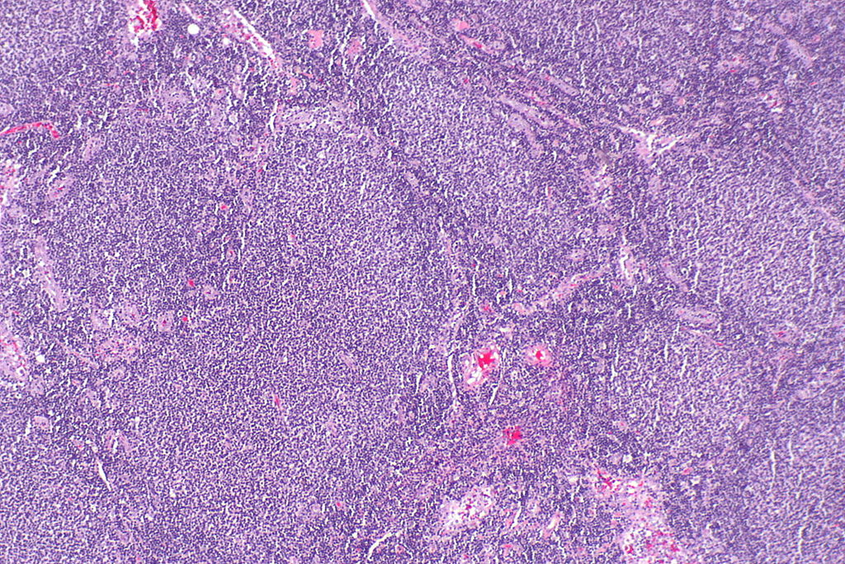

Reference
- Cory, S. and J.M. Adams, The Bcl2 family: regulators of the cellular life-or-death switch. Nature Reviews Cancer, 2002. 2(9): p. 647.
- Cory, S., D.C. Huang, and J.M. Adams, The Bcl-2 family: roles in cell survival and oncogenesis. Oncogene, 2003. 22(53): p. 8590.
- Lanave, C., M. Santamaria, and C. Saccone, Comparative genomics: the evolutionary history of the Bcl-2 family. Gene, 2004. 333: p. 71-79.

Biography
Shouhartha Choudhury has completed his B.Tech and M.Tech in Bioinformatics from India and now pursuing integrated pre-Ph.D. form School of Life Sciences, Department of Biotechnology, Assam University, Silchar-788011. He submitted four research reports entitled (a) Genome-wide analysis of AP2/ERF Family in plants, (b) Comparative Genomics: Novel: BCL-2 Family, (c) Genomics of OLIG Family of bHLH transcription factor and, (d) Genome-wide analysis of NeuroD Family of bHLH transcription factor in Assam University, for short communication

Author details

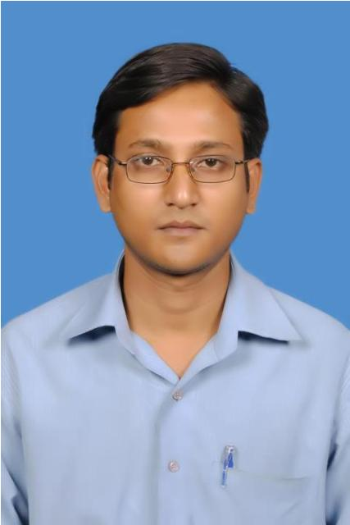
Full Name: Shouhartha Choudhury
Contact number: +91-9954411181
Twitter account: Shouhartha Choudhury
Linked In account: Shouhartha Choudhury
Session name/ number:
Category: (Oral and poster presentation)
Passport Number:

