The Use of Polyphenols to Improve Clinical Outcomes in Prostate Cancer
Keonie Moore (B Naturopathy SCU NHAA), ReMed Natural Medicine Clinic, AUS

Abstract

Polyphenols are secondary metabolites of plants; that naturally occur in a wide range of fruits and vegetables. Polyphenols have increasingly become of interest due to their potential benefit on human health and associated with lowered rates of chronic diseases including cardiovascular disease, cancer, and diabetes. Polyphenol-rich, plant based diets have been shown to reduce the risk of cancer, particularly for breast, pancreas, ovary, prostate and bowel.

Prostate cancer is a leading cause of death in men both in Australia and the US and remains one of the most frequently diagnosed cancers. Identifying those that are best monitored through active surveillance is an important aspect to ensuring that men don’t unnecessarily undergo radical treatments with potential complications and side effects that can substantially impact quality of life.

Prostate cancer outcomes have been shown to be improved by adopting a healthier diet by slowing PSA rise, whereas breast cancer survivors have been shown to have reduced recurrence with a higher intake of polyphenols.

The evidence and clinical application for three polyphenol-rich foods; pomegranate, green tea and turmeric will be discussed in relation to potential mechanisms on tumour growth in prostate cancer, results of human clinical trials, in addition to bioavailability and clinical application of these specific interventions.

Case studies will be used to highlight the assimilation of research findings and evidence into clinical practice with a strong focus on evidence-based dietary and nutritional interventions during active surveillance in prostate cancer. Assimilation of these aspects creates a platform for the increased inclusion of complementary therapies in oncology health care to increase the awareness of the safe use of complementary and alternative medicine to improve clinical outcomes in prostate cancer.

Image

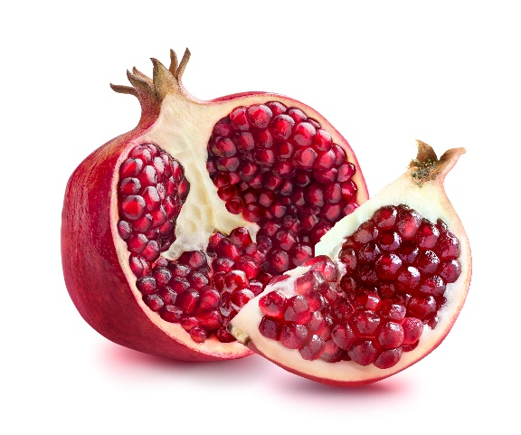
Recent Conference Presentations
- Invited Speaker, 7th Asian Congress on Autoimmunity on Nutrition and Autoimmunity, March 2017 Melbourne AUS
- Speaker: 10th International on Herbal Medicine on Adjunctive Breast Cancer Care and The Role of Point of Care screening in the Detection of Modifiable Risk Factors for Chronic Diseases, March 2017. Brisbane AUS
- Keynote presenter 7th Global Dieticians and Nutritionist Annual Conference on the Role of Vitamin E in the Management of Gliomas, December 2016. Philadelphia IL.
- Keynote speaker: Integria Healthcare Symposium on Complementary Medicine in Gastrointestinal Autoimmune diseases, October 2016. Gold Coast AUS
5. Speaker: 9th International Conference of Herbal Medicine on Healthy Business Models: sustaining our passion for practice, March 2015. Sydney AUS

 Keonie Moore Biography
With a strong focus on clinical relevance, Keonie Moore is a sought-after keynote presenter due to her focus on translational science; using case studies to highlight how research findings can be implemented into routine settings in practice and influence key clinical outcomes.

Career highlights include being invited as keynote speaker for the 2nd International Endocrinology conference, Chicago IL in 2014. Keonie has since been invited to present keynote presentation at the 7th Global Dieticians and Nutritionist Annual Conference December 2016 in Philadelphia and invited to present at the 7th Asian Congress on Autoimmunity in March 2017.

Drawing on her extensive clinical experience, Keonie is the founding director of ReMed a multi-modality clinic with 2 Melbourne locations. Leading a team of over 30 staff, Keonie is committed to lifting the standards of complementary medicine and establishing key operational systems that ensure that research findings and evidence are integrated into clinical practice.

Email: keonie@remed.com.au
Notes/Comments:

