Clinicopathological behavior and oncological outcomes of malignant parotid tumors in Pakistani population
Introduction:
The incidence of salivary gland tumors is influenced by geographical and racial factors. Salivary gland tumors account for 0.3% of all cancers and 1-6% of head and neck cancers. Diverse histological variation and limited data on etiology and risk factors have resulted in difficulty presenting the true epidemiological picture.
Methods:
Retrospective analysis of 209 patients from 2004-2016, diagnosed with malignant parotid tumors have been performed. The overall and disease specific survival were calculated and overall survival was evaluated according to different parameters. Data were analyzed using IBM SPSS Statistics version 20 (IBM Corp., Armonk, NY, USA). Kaplan–Meier survival curves were used to assess time to death and time to disease recurrence.
Results:
Median age at diagnosis was 40 years. The male to female ratio was 1.2:1. Mucoepidermoid carcinoma was the most common histological variant (50%) followed by adenoid cystic carcinoma (13%), adenocarcinoma (10%), squamous cell carcinoma (6%), acinic cell carcinoma (5%), carcinoma ex pleomorphic adenoma 4%, salivary duct carcinoma and myoepithelial carcinoma (3%). Grading showed 34 % to be low, 28% to be intermediate and 21% to be high. AJCC 7th edition clinical staging was stage I (21%), stage II (28%), Stage III (15%) and stage IV (34%). Median follow up was 24 months. The 5 year and disease free survival were 67% and 46% respectively
Conclusion:
Mucoepidermoid is the most common malignant parotid tumor in our population. Like other developing countries, significant proportion present with locally advanced and inoperable disease with dismal outlook. Operable patients have comparable outcomes when compared with data from other geographic areas.

Introduction
Malignant tumors of the parotid gland are characterized by a low incidence (1–3% of all head and neck cancers) and a marked histopathological heterogeneity [1]. Approximately 70% of the malignant tumors of the major salivary glands are located in the parotid glands [2]. Tumors in the submandibular and parotid regions are not quite as accessible. For these tumors, fine-needle aspiration (FNA) is the preferred method of biopsy. Several studies have now demonstrated FNA is a reliable technique achieving a diagnostic result in 88% to 98% of biopsies [3-5]. Superficial parotidectomy while preserving facial nerve has stayed as the recommended treatment modality whenever possible with adjuvant treatment and cervical lymph node removal preserved only for advanced stage, high grade and histology of the tumor [6-8]. Diverse histology, primary tumor and regional nodal involvement, adjuvant use of chemo-radiotherapy are some of the factors influencing oncological outcome of these tumors. The aim of our study is to describe the clinicopathological behavior of malignant parotid tumors and oncological outcomes related to survival from a tertiary care cancer hospital in Pakistan.
Materials and methods:
Retrospective analyses of 209 patients, who have been diagnosed with malignant parotid tumors and treated at Shaukat Khanum Memorial Cancer Hospital and Research Center, Lahore, Pakistan, have been retrospectively analyzed.
All the patients were presented to the head and neck clinic after confirmation of malignancy by fine needle aspiration cytology whether done outside or in our hospital. Imaging such as CT or MRI was utilized to assess local extent of the disease as well nodal status.
All the patients were discussed in tumor board as part of Head and Neck Multi-disciplinary team activity before final decision on treatment was made.
Surgical procedures performed were superficial parotidectomy (Nerve sparing), completion parotidectomy (operation following incomplete previous procedure), radical parotidectomy (nerve sacrificing), extended radical parotidectomy (Sacrificing adjacent muscles and soft tissue such as skin based on local extension of the disease. Neck dissection as part of the procedure was offered to those with tumor size > 3cm, clinically involved lymph nodes, nodes found to be positive during intraoperative frozen sections and high grade of malignancy.
Similarly, adjuvant radiotherapy was offered to those with high grade malignancy, close or positive resection margins, tumor size > 4cm and positive lymph nodes.

Variables such as patient’s age, gender, clinical and pathological staging, final histology, grading, type of treatment modality used, extend of neck dissection, margin status and site of recurrence were evaluated and collected. We have grouped patients into locally early (T1-T2) and locally advanced (T3-T4) disease to avoid dispersing of data. Similarly the patients are also categorized into clinically node negative and positive as well as pathological node negative and positive to compare survival analysis.
The study has been reviewed by Institutional Review Board and exemption was granted from Ethical Review Committee of Shaukat Khanum Memorial Cancer Hospital and Research Center, Lahore, Pakistan.

 | N | %
Age
<50 yrs | 141 | 67.5
>50 yrs | 68 | 32.5
Sex
Male | 115 | 55
Female | 94 | 45
cT
1 | 49 | 23.4
2 | 65 | 31.1
3 | 31 | 14.8
4 | 64 | 30.6
pT
1 | 43 | 26.2
2 | 60 | 36.5
3 | 38 | 23.1
4 | 23 | 14
cN0 | 156 | 74.6
cN+ | 53 | 25.3
pN0 | 128 | 78
pN+ | 36 | 22
Surgical treatment type
Superficial parotidectomy | 82 | 50
Completion parotidectomy | 71 | 43.2
Radical parotidectomy | 9 | 5.4
Extended radical parotidectomy | 2 | 1.2
Histology
Mucoepidermoid carcinoma | 105 | 50.2
Adenoid cystic carcinoma | 27 | 12.9
Adenocarcinoma | 22 | 10.5
Squamous cell carcinoma | 13 | 6.2
Acinic cell carcinoma | 11 | 5.2
Carcinoma Ex-pleomorphic adenoma | 9 | 4.3
Others | 22 | 10.5
Treatment modality
Surgery | 23 | 11
Surgery + Adjuvant radiotherapy | 141 | 67.4
Adjuvant radiotherapy | 39 | 18.6
Adjuvant chemotherapy | 6 | 2.8
Neck dissection
Yes | 41 | 19.6
No | 168 | 80.3

 | 5 year survival | 10 year survival | p-value
Age  < 50 years | 82% | 58% | .029
>50 years | 62% | 51% | .029
Gender  Male | 77% | 51% | 0.57
Female | 77% | 61% | 0.57
c T1-T2 | 86% | 79% | <0.0001
c T3-T4 | 43% | 14% | <0.0001
p T1-T2 | 88% | 71% | <0.0001
p T3-T4 | 58% | 25% | <0.0001
c N0 | 77% | 65% | <0.0001
c N+ | 33% | 0% | <0.0001
p N0 | 85% | 73% | <0.0001
p N+ | 55% | 0% | <0.0001
ND  Yes | 74% | 74% | <0.0001
No | 85% | 79% | <0.0001
Grade
High | 56 | 30 | <0.001
Low | 87 | 70 | <0.001
PNI
Yes | 56% | 0% | 0.08
No | 77% | 58% | 0.08
Extra-parenchymal extension |  |  | 0.150
Yes | 66% | 0% | 0.150
No | 75% | 54% | 0.150
Adjuvant PORT |  |  | 0.250
Yes | 76% | 49% | 0.250
No | 90% | 90% | 0.250

Results:
We have retrospectively analyzed records of 209 patients diagnosed with malignant parotid neoplasms treated both with radical and palliative intent. There were 119 males and 94 females. There were 164 patients who were primarily treated with surgery or surgery followed by radiotherapy in our hospital while 39 patients were operated outside but were given adjuvant treatment in our setup. The median age at diagnosis was 40 years. The median follow up was 24 months. Table 1 showed the clinical and pathological staging, histology, type of parotidectomy and treatment modality used. Clinical tumor stage showed cT1 49 cases, cT2 65 cases, cT3 31 cases and cT4 64 cases. Pathological classification showed pT1 43 cases, pT2 60 cases, pT3 38 cases and pT4 23 cases.
Superficial parotidectomy was performed in 82 patients, completion parotidectomy in 71 patients, radical parotidectomy in 9 patients and extended radical parotidectomy in 2 patients.
As a part of procedure, neck dissection was performed in 41 patients. Thirty six (36) of those were classified as pN+ while 5 were pN0.
Histology revealed Mucoepidermoid carcinoma to be the most common malignancy (50%) followed by adenoid cystic carcinoma (10.5%) and adenocarcinoma (9.6%). Surgery only has been used in 23 patients while surgery followed by radiotherapy was offered to 141 patients. There were 39 patients who have been operated outside our hospital and keeping in view the adverse features (Close/positive margin, high grade malignancy, size > 4cm, facial nerve involvement and extra-parenchymal extension), were given post-operative radiotherapy. The median post-operative dose was 60 Grey on the parotid and 55 Grey on the neck. Adjuvant chemotherapy was used in selective cases of grossly involved lymph nodes.
The 5 and 10 year overall survival (OS) was 68% and 45% respectively for all the patients. The 5 and 10 year survival was 78 % and 54 % respectively for those treated exclusively in our hospital. Variables which have statistical significance on survival were age (<50 and > 50 years) (p 0.029), grade (high vs. low) (p <0.001), pathological nodal involvement (pN0 vs. pN+) (p <0.001), pathological tumor size (pT1-2 vs. pT3-4) (p < 0.001)
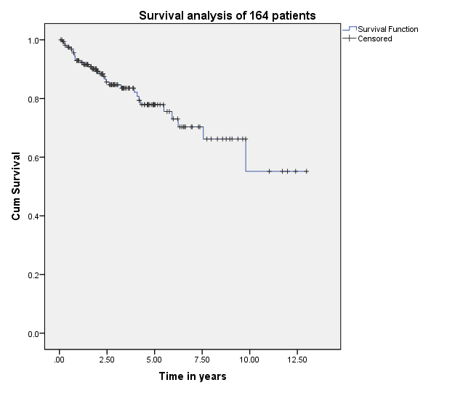

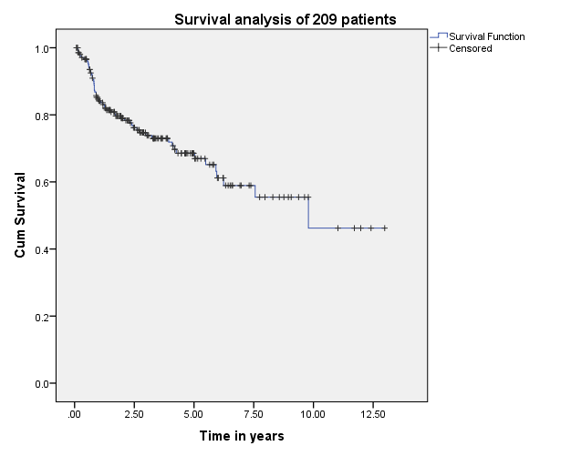

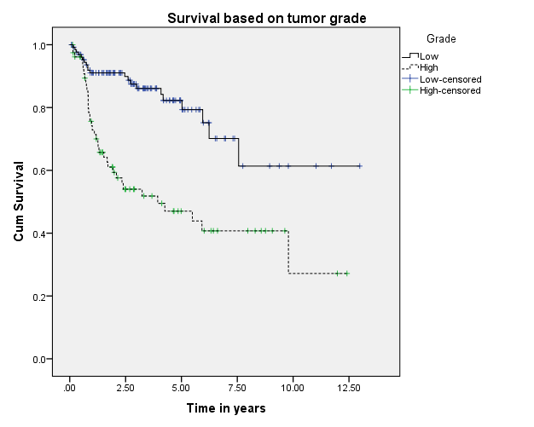

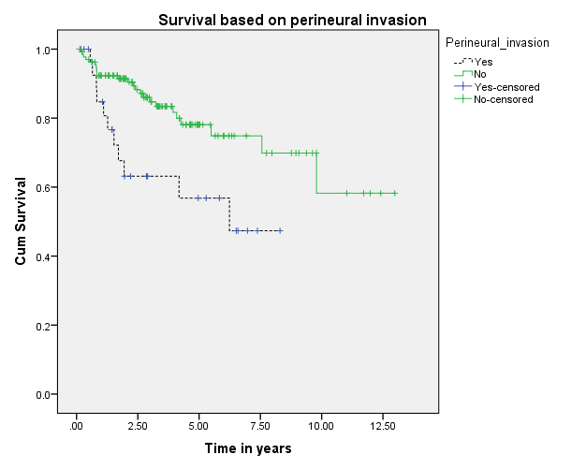

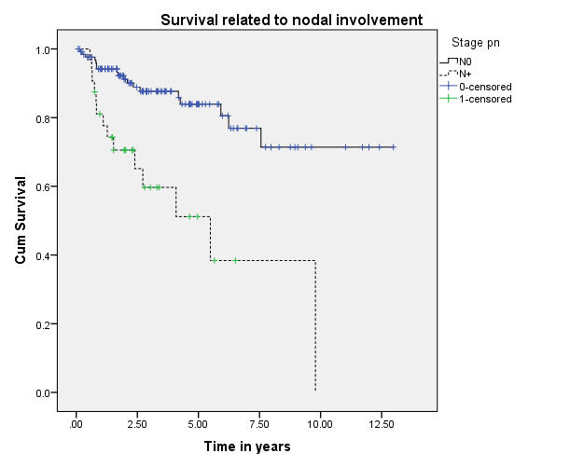

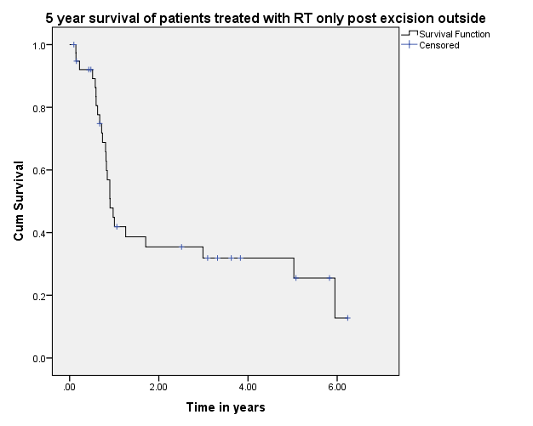

Discussion:
The majority of salivary neoplasms originate in the parotid gland, while minor salivary gland and submandibular gland neoplasms are much less common. Low incidence combined with histological heterogeneity posing a challenge in evaluating survival outcome and oncological outcomes [9].
Age and gender have been postulated as prognostic factors by studies published by Malata et al., Lima et al., Pohar et al., Koul et al and Jouzdani et al. as compared to a study by Mercante et al. showing no difference in survival based on age and gender [10-15]. Our study has shown age to be an important prognostic factor in terms of survival (p- value 0.029) but no significant difference was found as far as gender is concerned.
Harbo et al. has established a relationship related to tumor stage and histological classification. A retrospective study was performed on 152 patients with parotid tumors and found statistically significant difference in survival based on stage. The survival rate for stage I and II was 65% and 50 % where it falls to 9% in stage IV patients [16]. The prognosis for survival in histologically well differentiated tumors (52%) was also better than that associated with poorly differentiated lesions (19%). Our experience showed that survival related to malignant parotid tumors depends upon cT (<0.0001), pT (<0.0001), cN (<0.0001), pN (<0.0001), histology (<0.001) and ND (<0.0001), which, is following the pattern of other retrospective series as demonstrated by Terhaard et al., Lima et al. and Stennar et al. Thus, patients with clinical and pathological tumor size > T2, high grade histology, clinical and pathological nodal involvement and perineural involvement have worse 5 and 10 year survival. Similarly, the role of extraparenchymal extension affecting survival has been described in literature by Klussmann et al., but, its role has not been statistically evident in our study. This may be due to only a small number of patients having extraparenchymal extension and a larger sample size may possibly highlight its role in survival. The role of adjuvant radiotherapy has been thought to improve survival in literature as depicted by Armstrong et al., North et al. and Mendenhall et al. but our results have shown no such benefit.. Post-operative radiation therapy has thought to be reducing the risk of loco-regional failure thus decreasing the risk of damage to facial nerve in cases of loco-regional failures. Clear evidence of a dose response is lacking in this rare disease and the dose of 60Gy in daily 2Gy fractions represents a practical consensus. Developments in radiotherapy technique, such as intensity modulated radiotherapy, have been applied to parotid treatment [23, 24]. Careful analysis of our data has shown that patients with adverse features were the candidates for adjuvant radiotherapy and this could possibly explain the poor survival outcome in these individuals. As the only tertiary care referral cancer hospital, we cannot refuse patients who have been previously treated outside with inadequate resections. Out of 209 malignant parotid tumor patients, 39 were those who were accepted for adjuvant treatment post-surgery outside our hospital. The 5 year survival of these individuals was 25% only.

Our study has mainly focused on malignant tumors of the parotid gland and relating the factors to the survival outcome in these individuals. Previous studies reported a 5- year DSS ranging between 50% (16) and 95% (9) and a 10-year DSS between 40% (12) and 84% (9). Due to extreme variation and diversity in histology, there is a need to have more randomized trials and adequate number of cases to address the heterogeneity of these tumors.
Conclusion:
Our study has shown oncological outcomes of malignant parotid salivary gland tumors by identifying the prognostic factors affecting survival. Advanced age, high grade histology, increased size (> T2), perineural invasion and clinico-pathological nodal involvement have adversely affect overall survival. Adjuvant radiotherapy, on the other hand, have not resulted in improved survival.

CONSORT 2010 Flow Diagram
Analysed (n=141))

Died of disease (n=25)
Lost to follow up such as refused to participate (n=4)
Retrospectively analyzed (n=209)

Follow-Up
Analysed (n=12)

Analysis
Died of disease (n=27)
Lost to follow up (Logistic issues such as remote location, died of other causes) (n=6)

Enrollment
Treated with PORT
(Operated outside) (n=39)
Treated with CRT (n=6)

Allocation
Treated with Surgery and Radiotherapy
, (n=164)
Surgery only (141)
Surgery + RT (23)
Excluded (n=41)
♦ Not meeting inclusion criteria (n=25)
♦ Declined to participate (n=10)
♦ Other reasons (n=6)
Assessed for eligibility (n=250)

References:
1. Tsai HH. Parotid neoplasms: diagnosis, treatment and intraparotid facial nerve anatomy. J Laryngol Otol. 2002;116:359–62.
2. Van Eycken L. Cancer incidence in Belgium 2004–2005. Head Neck Cancer. 2008:41.
3. Seethala RR, LiVolsi VA, Baloch ZW. Relative accuracy in fine needle aspiration and frozen section in the diagnosis of lesions in the parotid gland. Head Neck. 2005;27:217–223.
4.Cohen EG, Patel SG, Lin O, et al. Fine-needle aspiration of the salivary gland lesions in a selected patient population. Arch Otolaryngol Head Neck Surg. 2004;130:773–778.
5. Postema RJ, van Velthuysen MF, van den Brakel MWM, et al. Accuracy of fine-needle aspiration cytology of salivary gland lesions in the Netherlands Cancer Institute. Head Neck. 2004;26:418–424.
6. Vander Poorten VL, Valm AJ, Hilgers FJ. Management of cancer of the parotid gland. Curr Opin Otolaryngol Head Neck Surg.
2002;10:134–44.
7. Granell J, Sánchez-Jara JL, Gavilanes J, Velasco MJ, Collazo T, Herrero J, et al. Manejo de la enfermedad quirúrgica de la glándula parótida: revisión de 54 casos. Acta Otorrinolaringol Esp. 2010;61:189–95.
8. North CA, Lee D, Piantadosi S, Zahurak M, Johns ME. Carcinoma of the major salivary glands treated by surgery or surgery postoperative radiotherapy. Int J Radiat Oncol Biol Phys. 1990;18:1319–26.
9. Spiro RH. Treating tumors of the sublingual glands, including a useful technique for repair of the floor of the mouth after resection. Am J Surg 1995; 170: 457–60.
10.Malata CM, Camilleri IG, McLean NR, Piggot TA, Kelly CG, Chippindale AJ, et al: Malignant tumours of the parotid gland: a 12 year review. Br J Plast Surg 50: 600e608, 1997.
11. Lima RA, Tavares MR, Dias FL, Kligerman J, Nascimento MF, Barbosa MM, et al: Clinical prognostic factors in malignant parotid gland tumours. Otolaryngol Head Neck Surg 133: 702e708, 2005
12.Pohar S, Gay H, Rosenbaum P, Klish D, Bogart J, Sagerman R, et al: Malignant parotid tumours: presentation, clinical/pathological prognostic factors and treatment outcomes. Int J Radiat Oncol Biol Phys 61: 112e118, 2005
13.Koul R, Dubey A, Butler J, Cooke AL, Abdoh A, Nason R: Prognostic factors depicting disease-specific survival in parotid-gland tumours. Int J Radiat Oncol Biol Phys 68: 714e718, 2007
14.Jouzdani E, Yachouh J, Costes V, Faillie JL, Cartier C, Poizat F, et al: Prognostic value of a three-grade classification in primary epithelial parotid carcinoma: result of a histological review from a 20-year experience of total parotidectomy with neck dissection in a single institution. Eur J Cancer 46: 323e 331, 2010
15. Mercante, G., Marchese, C., Giannarelli, D., Pellini, R., Cristalli, G., Manciocco, V, et al: Oncological outcome and prognostic factors in malignant parotid tumours. Journal of Cranio-Maxillofacial Surgery, 42(1), 59-65, 2014. DOI: 10.1016/j.jcms.2013.02.003
16. Harbo G, Bundgaard T, Pedersen D, Sogaard H, Overgaard J. Prognostic indicators for malignant tumors of the parotid gland. Clin Otolaryngol. 2002;27:512–6.
17. Terhaard CH, Lubsen H, Rasch CR, Levendag PC, Kaanders HH, Tjho-Heslinga RE, et al: Dutch head and neck cooperative group. The role of radiotherapy in the treatment of malignant salivary gland tumours. Int J Radiat Oncol Biol Phys 61: 103e111, 2005
18. Lima RA, Tavares MR, Dias FL, Kligerman J, Nascimento MF, Barbosa MM, et al: prognostic factors in malignant parotid gland tumours. Otolaryngol Head Neck Surg 133: 702e708, 2005
19. Stenner M, Molls C, Klussmann JP, Hüttenbrink KB: Prognosis of surgically treated primary parotid gland cancer e an evaluation of 231 cases. Laryngorhinootologie 90: 664e671, 2011
20. Armstrong JG, Harrison LB, Spiro RH, Fass DE, Strong EW, Fuks ZY: Malignant tumours of major salivary gland origin. A matched-pair analysis of the role of combined surgery and postoperative radiotherapy. Arch Otolaryngol Head Neck Surg 116: 290e293, 1990.
21. North CA, Lee DJ, Piantadosi S, Zahurak M, Johns ME: Carcinoma of the major salivary glands treated by surgery or surgery plus postoperative radiotherapy. Int J Radiat Oncol Biol Phys 18: 1319e1326, 1990.
22. Mendenhall WM, Morris CG, Amdur RJ, Werning JW, Villaret DB: Radiotherapy alone or combined with surgery for salivary gland carcinoma. Cancer 104: 2544e2550, 2005.
23. Nutting CM, Rowbottom CG, et al. Optimisation of radiotherapy for carcinoma of the parotid gland: a comparison of conventional, three-dimensional conformal, and intensity-modulated techniques. Radiother Oncol. 2001;60:163–172
24. Bragg CM, Conway J, Robinson MH. The role of intensity-modulated radiotherapy in the treatment of parotid tumors. Int J Radiat Oncol Biol Phys. 2002;52:729–738.
25. Klussmann JP, Ponert T, Mueller RP, Dienes HP, Guntinas-Lichius O: Patterns of lymph node spread and its influence on outcome in resectable parotid cancer. Eur J Surg Oncol 34: 932e937, 2008

