The Effect of Achillea wilhelmsii extract on expression of the human Telomerase Reverse Transcriptase (hTERT) mRNA in prostate cancer PC3 cell line
Hosniye Amini, Master, Tehran University, Iran,
Mojtaba Ashtiani,Master,Tehran University,iran
Fariba Nabatchian,Ph.D,Tehran University
Saeideh Salimi,Ph.D,Zahedan university

Abstract
Purpose: Evidence showed that Human telomerase reverse transcriptase (hTERT) was overexpressed in prostate cancer. Achillea wilhelmsii (AW) is a plant that has been traditionally used for its medicinal properties. The aim of current study is evaluation the effects of AW extract on a prostate cancer cell line
Methods: The cytotoxic activity of the hydroalchoholic extract of AW was studied on prostate cancer PC3 cell line using MTT assay. Flow cytometry was used to evaluate the effects of the extract on the apoptosis. The expression of hTERT mRNA was analyzed by Real-Time PCR method. ELISA method was used to measure the levels of telomerase enzyme.
Results: The hydroalcoholic AW extract showed the appropriate inhibitory effect in 150μg/ml concentration (IC50) on PC3 cell line after 48h treatment. Treatment of the PC3 cells with AW resulted in a significant increase in early and late apoptotic cells in a dose-dependent manner. Moreover, the early apoptotic cells were significantly higher than late apoptotic cells. The h-TERT mRNA expression was decreased after 24h treatment of AW extract, though it was not different between 2, 4, 8 and 12 h treatments or 24, 48 and 72h treatments. Also, the h-TERT concentration was significantly decreased after 24h treatment of AW extract.
Conclusions: The hydroalcoholic extract of AW induced potent antiproliferative and apoptotic effects in PC3 cell line, which could be explainable by its high potency to inhibit expression of the prominent oncogene hTERT in prostate cancer.

Image
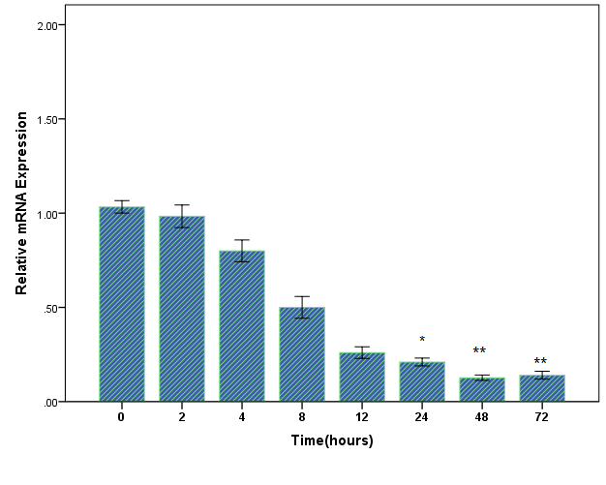
Recent Publications (minimum 5)
- Isfahani LD, Monajemi R, Amjad L. Cytotoxic effects of extract and essential oil leaves of Achillea cancerwilhelmsii C. Koch on colon cancers cells. Exp Anim Biol. 2013;1:1-6.
- Csupor‐Löffler B, Hajdú Z, Zupkó I, Réthy B, Falkay G, Forgo P, et al. Antiproliferative effect of flavonoids and sesquiterpenoids from Achillea millefolium sl on cultured human tumour cell lines. Phytotherapy Research. 2009;23(5):672-6.
- Bali EB, Açık L, Elçi P, Sarper M, Avcu F, Vural M. In vitro anti-oxidant, cytotoxic and pro-apoptotic effects of Achillea teretifolia Willd extracts on human prostate cancer cell lines. Pharmacognosy magazine. 2015;11(Suppl 2):S308.
- Wang C-M, Jia Z-J, Zheng R-L. The effect of 17 sesquiterpenes on cell viability and telomerase activity in the human ovarian cancer cell line HO-8910.
- Dadkhah A, Fatemi F, Alipour M, Ghaderi Z, Zolfaghari F, Razdan F. Protective effects of Iranian Achillea wilhelmsii essential oil on acetaminophen-induced oxidative stress in rat liver. Pharmaceutical biology.

 Biography :
Hosniyeh Amini has completed his Master at the age of 27 years from Tehran. She study about effect of drugs in cancer and mental.
Email: mojtaba.ashtiani.20@gmail.com

