THE POSSIBILTY OF EMPLOY THE MICRONUCLEUS TEST FOR THE DIAGNOSIS OF THE DOUBT CASES IN THE SCREENING FOR THE DETERMINATION OF BREAST CANCER
Menicagli Roberto *- RomaBiomedResearch, Lab
Menicagli Laura**- Esseridou Anastassia-, IRCCS .POLICLINICO SAN DONATO-Dept- of Radiodiagnostic UNIVERSITY MILAN
INTRODUCTION AND OBJECTIVES : The aim of this study is to check the possibility to use the test with micronuclei in saliva, for cases doubts,(BIRADS 3), detected in screening for breast cancer.
MATERIAL AND METHODS It is been executed a bibliographic search on Pub Med, for articles published from Jan 1, 2000 to Dec 31, 2016,for the keywords : "micronuclei in exfoliated buccal cells in breast cancer “ .The key words are used in the research in free text, and with cross –referencing method application. Are also executed preliminary tests, not statistically evaluable for low numbers of patients,(seven for both groups), to evaluate the difference, of the score concerning the presence of micronuclei in BIRADS 3 ,versus BIRADS2
RESULTS Five studies show that in buccal cells, in breast cancer , the amount of MN are significantly higher than compared to benign cases as in six studies for the detection of micronuclei in needle aspiration in ductal carcinoma ,. Contrasting results are for MN in peripheral blood lymphocytes. Experimentally, in three patients, group BIRADS 3, were shown to have micronuclei, while no positive findings were found in none of BIRADS 2 .
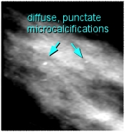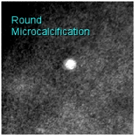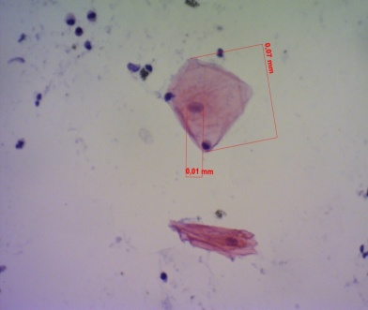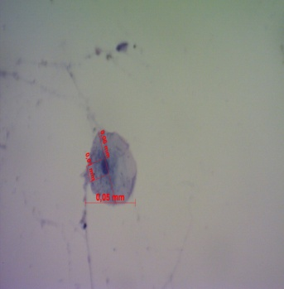
These tiny specs are diffuse This microcalcification is round, MICRONUCLEUS not MICRONUCLEI
Punctuate microcalcifications but the edges are not sharply MICRONUCLEUS
defined (indeminate birads 3)
DISCUSSION .The references show as the micronuclei scoring can be used as a biomarker on fine needle aspiration cytology smears of breast cancer, while the tests in peripheral blood lymphocytes , have known reproducibility problem. Also the bibliography show ,in breast cancer , an increase of MN in exfoliated buccal mucosa as well our preliminary cells test,
CONCLUSIONS May be interesting to apply the MN scoring in cases of doubt, according to functional BI-RADS category 3 (probably benign), and which are sent to a successive control
BIOGRAPHY MENICAGLI ROBERTO
Roberto Menicagli has completed his PhD at the age of 25 years from Milan University .Postdoctoral studies in biochemistry and molecular genetics, at the faculty of biology at Milan University, where, two years he has been ,a contract professor He is the director of Roma Biomed Research Lab a Private Medical Service Organization. Has published more than 20 papers in reputed journals ,some also with impact factor ; is also the principal author of 4 international patent ,in the field of the environment, and of the biomarkers applications ;has been serving as an editorial board member of two magazine concerning the medical sciences.
mail :romabiomedresearch@libero.it

