Increased H3K9me3 drives spontaneous transformation of rat MSCs
Yong Zheng PhD, Wuhan University, China
Liu He PhD, Wuhan University, China

Abstract
Rodent mesenchymal stromal cells (MSCs) have been demonstrated to spontaneously undergo tumorigenic transformation after long term ex vivo culture. The mechanism leading to the MSCs spontaneous transformation is unclear. To investigate the role of H3K9me3 for the spontaneously transformation of MSCs, the pre-senescent and transformed MSCs were prepared according to the criterion described previously. H3K9me3 target genes was evaluated with ChIP-on-chip arrays. The expression of tumor suppressor genes (cdkn2b, cdkn2c, cdkn1c and pten) was evaluated with RT-qPCR, these gene-associated H3K9me3 were quantified with chromatin immunoprecipitation (ChIP), and the DNA methylation levels were analyzed with bisulfite DNA sequencing (BSP). We found that there were 1277 genes in pre-senescent MSCs and 2519 genes in transformed MSCs targeted by H3K9me3 (Cutoff：FDR≤0.05). The genes associate with H3K9me3 are related to the catalogs of cell differentiation, development, and nucleotide and protein metabolism. The expression of cdkn2b, cdkn2c, cdkn1c and pten were obviously decrease in transformed MSCs, with an up-regulation in genes associated H3K9me3 and CpG sites methylation. These results demonstrate that an H3K9me3 enhanced DNA methylation contributes a crucial role in the spontaneous transformation of MSCs.

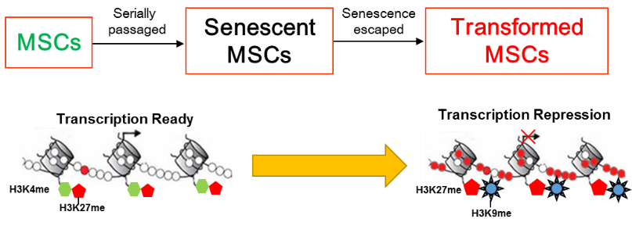
Figure.1 Tumor suppressor genes were suppressed by H3K9me3 enhanced DNA methylation during the spontaneous transformation of rat MSCs.
Recent Publications
- Zheng Y, Yuan Q, He X, Lei Y (2016) A Rare Variation of the Testicular Blood Supply by the Deferential Artery. International Journal of Morphology 34:950-952.
- Zheng Y, Lei Y, Hu C, Hu C (2016) P53 regulates autophagic activity in senescent rat mesenchymal stromal cells. Experimental gerontology 75:64-71.
- He L, Zhang F, Zheng Y, Wan Y, Song J (2016) Loss of interactions between p53 and survivin gene in mesenchymal stem cells after spontaneous transformation in vitro. International Journal of Biochemistry & Cell Biology 75:74-84.
- Zheng Y, Hu C, Zhuo R, Han N, He L (2014) Inhibition of autophagy alleviates the senescent state of MSCs during long-term culture. Molecular Medicine Reports 10:3003-3008.
- Zheng Y, He L, Wan Y, Song J (2013) H3K9me-Enhanced DNA Hypermethylation of the p16INK4a Gene: An Epigenetic Signature for Spontaneous Transformation of Rat Mesenchymal Stem Cells. Stem Cells and Development 22: 256-267.

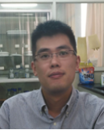Biography (150 word limit)
Yong Zheng has the interests in the understanding the molecular mechanisms of tumorigenesis. He has indetified the key stages during the spontaneous of rat mesenchymal stem cells. His privious study identified, for the first time, an Ezh2/H3K27me-independent and H3K9me enhanced aberrant DNA methylation of the p16 gene, which might be an epigenetic signature for MSC spontaneous transformation. He is studying the mechanisms underlying these changes of epigenetic modification recently.
Email: zhengyong@whu.edu.cn

Notes/Comments:

