High expression of apoptosis protein (Api-5) in chemoresistant triple-negative breast cancers: an innovative target
Guilhem Bousquet1,2,3,6, Jean-Paul Feugeas4, Yuchen Gu1, Christophe Leboeuf1,2, Morad El Bouchtaoui2, He Lu2, Marc Espié5, Anne Janin1,2,7 and Melanie Di Benedetto1,2,3
1Université Paris Diderot, Sorbonne Paris Cité, Laboratoire de Pathologie, UMR-S 1165, F-75010, Paris, France2INSERM, U942, F-75010, Paris, France 3Université Paris 13, Sorbonne Paris Cite, F-93000, Villetaneuse, France4INSERM, U1137-Paris, F-75018, France5AP-HP, Hôpital Saint-Louis, Centre des Maladies du Sein, F-75010, Université Paris Diderot, Sorbonne Paris Cité, INSERM CNRS UMR7212, Paris, France6AP-HP, Hôpital Avicenne, Medical Oncology, F-93000, Bobigny, France7AP-HP, Hôpital Saint-Louis, Laboratoire de Pathologie, F-75010, Paris, FranceCorrespondence to: Melanie Di Benedetto, email: melanie.dibenedetto@univ-paris13.fr Guilhem Bousquet, email: guilhem.bousquet@aphp.frKeywords: triple-negative breast cancer; chemotherapy resistance; apoptosis-inhibitor-5; peptide; anti-angiogenic therap

I.Abstract
Anti-apoptotic protein-5 (API-5) is a survival protein interacting with the protein acinus, preventing its cleavage by caspase-3 and thus inhibiting apoptosis. We studied the effect of targeting API-5 in chemoresistant triple negative breast cancers (TNBCs), to reverse chemoresistance. 78 TNBC biopsies from patients with different responses to chemotherapy were analysed for API-5 expression before any treatment. Further studies on API-5 expression and inhibition were performed on patient-derived TNBC xenografts, one highly sensitive to chemotherapies (XBC-S) and the other resistant to most tested drugs (XBC-R). In situ assessments of necrosis, cell proliferation, angiogenesis, and apoptosis in response to anti-API-5 peptide were performed on the TNBC xenografts. Clinical analyses of the 78 TNBC biopsies revealed that API-5 was more markedly expressed in endothelial cells before any treatment among patients with chemoresistant TNBC, and this was associated with greater micro-vessel density. A transcriptomic analysis of xenografted tumors showed an involvement of anti-apoptotic genes in the XBC-R model, and API-5 expression was higher in XBC-R endothelial cells. API-5expression was also correlated with hypoxic stress conditions both in vitro and in vivo. 28 days of anti-API-5 peptide efficiently inhibited the XBC-R xenograft via caspase-3 apoptosis. This inhibition was associated with major inhibition of angiogenesis associated with necrosis and apoptosis. API-5 protein could be a valid therapeutic target in chemoresistant metastatic TNBC

II. Image
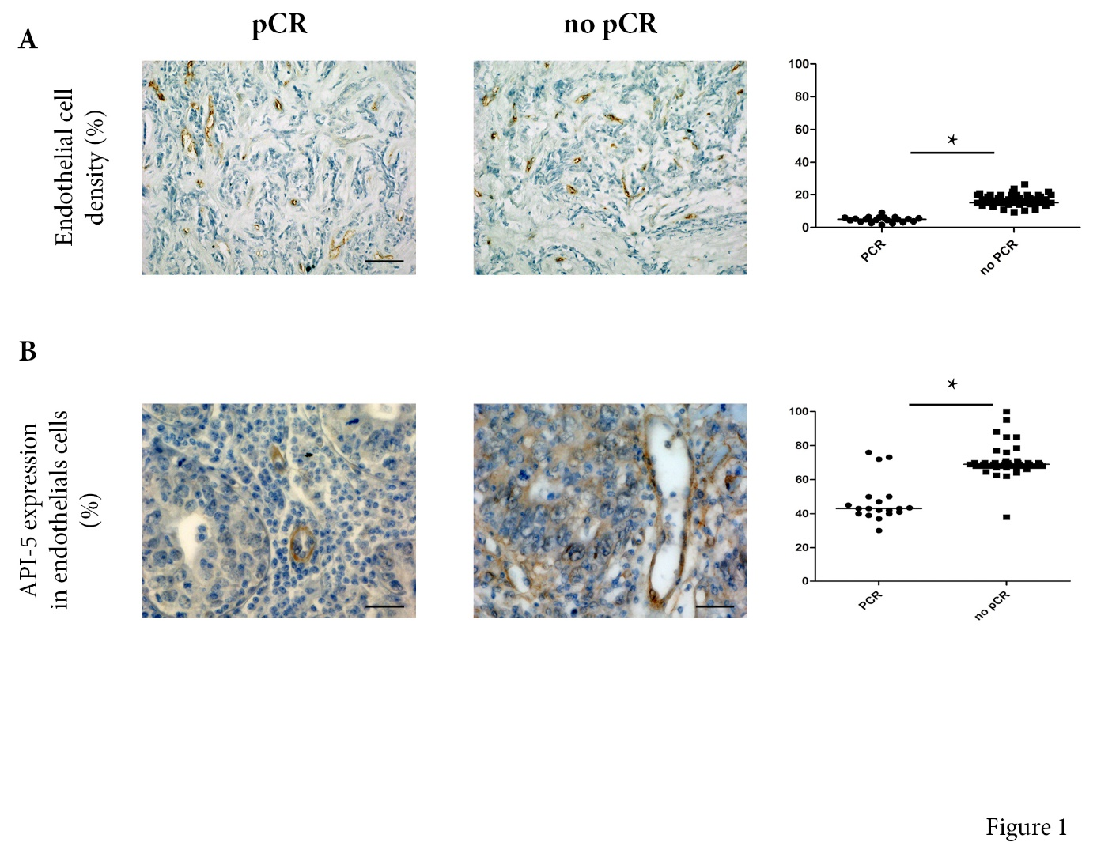
III. Reference:
1 Tewari M, Yu M, Ross B, Dean C, Giordano A, Rubin R. AAC11, a novel cDNA that inhibits apoptosis after growth factor withdrawal. Cancer Res. 1997; 57:4063–4069. [PubMed]
2. Bousquet G, Feugeas JP, Ferreira I, Vercellino L, Jourdan N, Bertheau P de Bazelaire C, Barranger E, Janin A. Individual xenograft as a personalized therapeutic resort for women with metastatic triple negative breast carcinoma. Breast Cancer Res. 2014; 16:401. https://doi.org/10.1186/bcr3615. [PubMed]
3. Bousquet G, El Bouchtaoui M, Sophie T, Leboeuf C, de Bazelaire C, Ratajczak P, Giacchetti S, de Roquancourt A, Bertheau P, Verneuil L, Feugeas JP, Espié M, Janin A. Targeting autophagic cancer stem-cells to reverse chemoresistance in human triple negative breast cancer. Oncotarget. 2017; 8:35205– 35221. https://doi.org/10.18632/oncotarget.16925. [PubMed

IV. Biography:
Melanie Di Benedetto has completed his PhD at the age of 27 years from Paris13 University and several Postdoctoral Studies from School of Medicine, Paris 13 and Paris 7 University. She is associated professor in Inserm U942 Laboratory. She is the Director of a biology department at technical institute of Paris13 University . she has published more than 30 papers in reputed journals

V. Presenting author details

Full Name:Di Benedetto
Contact number:03161463026
Twitter account:
Linked In account:
Session name/ number:targeted therapy
Category: (Oral presentation)

