Abstract Template

Title: microrna’s signature and it’s role in carcinogenesis for biomaker of prostate cancer

Anggia Noor Ramadhani¹, Christin Hendriyani Bonnu¹, Ranu Bagus Saputro¹, Peristiwan Ridha Widhi Astana², Nau Pakpahan², Sofia Mubarika Haryana³, Danarto⁴, Indwiani Astuti⁵
¹Biotechnology Department, Universitas Gadjah Mada, Yogyakarta, Indonesia
²Biomedicine Department, Universitas Gadjah Mada, Yogyakarta, Indonesia
³Department of Histology, Faculty of Medicine Universitas Gadjah Mada, Yogyakarta, Indonesia
⁴Department of Pharmacology and Therapy, Faculty of Medicine Universitas Gadjah Mada, Yogyakarta, Indonesia
⁵Department of Urology, Faculty of Medicine Universitas Gadjah Mada, Yogyakarta, Indonesia

Keywords: microRNA, prostate cancer, biomarker, cancer diagnostic

- Abstract
The usual diagnostic method to diagnostic Prostate cancer is the PSA (prostate specific antigen) method. However this method is considered to be less effective because the interpretation of the value in cancer patients can be the same as in BPH (Benign Prostate Hypertrophy) patients or other prostate infections. One alternative diagnostic method that can be combined with this usual method to reach best result is finding the molecular signature of this cancer. The aim of this study is to determine microRNAs that can use as biomarkers of prostate cancer. The method used in this study is microRNA expression analysis in two prostate cancer tissue samples and two BPH tissue samples using Nanostring nCounter ®, validation by microarray database and molecular docking. The result shows that there are 7 miRNAs with p values ​​close to 1. There are hsa-mir-98-5p, hsa-let-7a-5p, hsa-mir-106b-5p, hsa-mir-1-3p which are upregulated and hsa-mir- 25-3p, hsa-mir-205-5p, hsa-mir-152-3p which are downregulated in prostate cancer. Microarray database analysis proves the dysregulated microRNAs in prostate cancer are hsa-mir-25-3p, hsa-mir-106b-5p, hsa-let-7a-5p and hsa-mir-98-5p. The docking result shows that hsa-mir-25-3p has stronger interaction with E2F1 than hsa-mir-106b-5p. The last analysis from Kaplen Meier also shows that all these miRNAs have influence on patient’s survival rate, although it is unsignificantly. Our findings revealed that all these miRNAs have potential to be novel biomarker for prostate cancer patients, especially hsa-mir-25-3p and hsa-mir-106b-5p.

- Image:

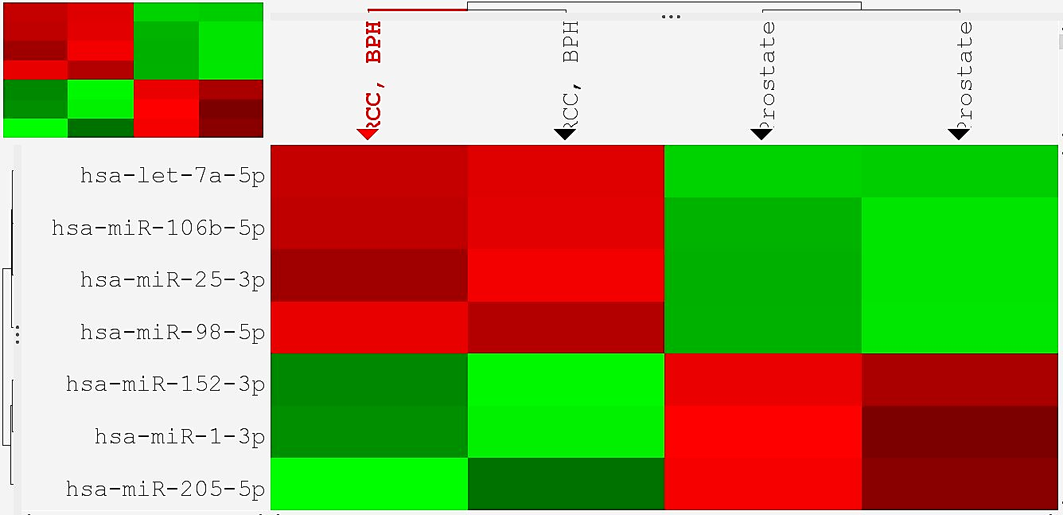

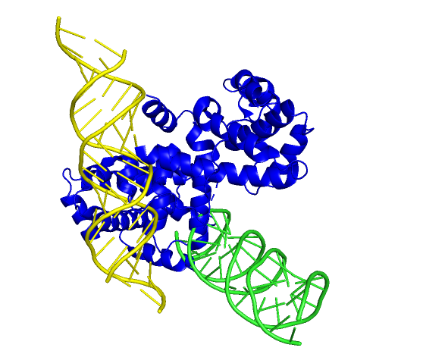
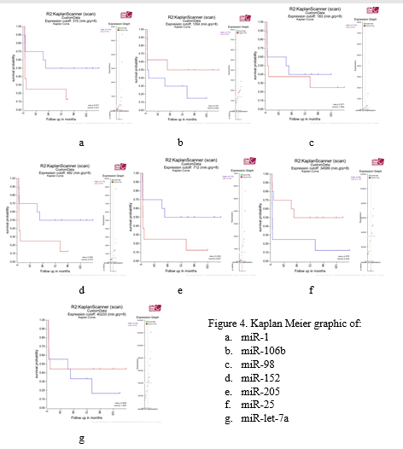

- Reference:
- Bray, F., Ferlay, J., Soerjomataram, I., Siegel, R.L., Torre, L.A. and Jemal, A., 2018. Global cancer statistics 2018: GLOBOCAN estimates of incidence and mortality worldwide for 36 cancers in 185 countries. CA: a cancer journal for clinicians, 68(6), pp.394-424.
- Bucay, N., Sekhon, K., Majid, S., Saini, S., Dahiya, R., 2016. MicroRNAs and epithelial-mesenchymal transition in prostate cancer. Oncotarget 7. doi:10.18632/oncotarget.11708
- Chen, Q., Zhu, L., Zheng, B., Wang, J., Song, X., Zheng, W., Wang, L., Yang, D. and Wang, J., 2013. Effect of AQP9 expression in androgen-independent prostate cancer cell PC3. International journal of molecular sciences, 17(5), p.738.
- Danarto, R., 2017, Kanker Prostat dan BPH RSUP. Dr. Sardjito, Unpublished data.
- Dong Q, Meng P, Wang T, Qin W, Qin W, et al. (2010) MicroRNA Let-7a Inhibits Proliferation of Human Prostate Cancer Cells In Vitro and In Vivo by Targeting E2F2 and CCND2. PLoS ONE 5(4): e10147
- Feig M, Onufriev A, Lee MS, Im W, Case DA, Brooks CL. 2004. Performance comparison of generalized born and Poisson methods in the calculation of electrostatic solvation energies for protein structures. J Computat Chem 25(2): 265–284.
- Fredsøe, Jacob & Rasmussen, Anne & R. Thomsen, Anni & Mouritzen, Peter & Hoyer, Soren & Borre, Michael & F. Ørntoft, Torben & Sørensen, Karina Dalsgaard. (2017). Diagnostic and Prognostic MicroRNA Biomarkers for Prostate Cancer in Cell-free Urine. European Urology Focus. 10.1016/j.euf.2017.02.018.
- Hagman, Z., Haflidadóttir, B.S., Ceder, J.A., Larne, O., Bjartell, A., Lilja, H., Edsjö, A., Ceder, Y., 2013. MiR-205 negatively regulates the androgen receptor and is associated with adverse outcome of prostate cancer patients. Br. J. Cancer 108: 1668–1676. doi:10.1038/bjc.2013.131
- Heneghan, H.M.; Miller, N.; Kelly, R.; Newell, J.; Kerin, M.J. Systemic miRNA-195 differentiates breast cancer from other malignancies and is a potential biomarker for detecting noninvasive and early stage disease. Oncologist 2010, 15, 673–682.
- Ho, S.M. and Lau, K.M., 2002. DNA microarrays in prostate cancer. Current urology reports, 3(1), pp.53-60.
- Ivanovska, I., Ball, A. S., Diaz, R. L., Magnus, J. F., Kibukawa, M., Schelter, J. M., ... & Linsley, P. S. (2008). MicroRNAs in the miR-106b family regulate p21/CDKN1A and promote cell cycle progression. Molecular and cellular biology, 28(7), 2167-2174.
- Ke, X., Qu, Y., Rostad, K., Li, W., Lin, B., Halvorsen, O.J., Svein, A., 2009. Genome-Wide Profiling of Histone H3 Lysine 4 and Lysine 27 Trimethylation Reveals an Epigenetic Signature in Prostate Carcinogenesis 4. doi:10.1371/journal.pone.0004687
- Kitchen DB, Decornez H, Furr JR, Bajorath J 2004. Docking and scoring in virtual screening for drug discovery: methods and applications. Nat rev Drug disc 3(11): 935–949.
- Kretzschmar, A.K., Horn, F., Tomm, J.M., Verhaegh, G., Hackermüller, J., von Bergen, M., Mörbt, N., Schalken, J., Kasack, K., Reiche, K., Boll, K., 2012. MiR-130a, miR-203 and miR-205 jointly repress key oncogenic pathways and are downregulated in prostate carcinoma. Oncogene 32: 277–285. doi:10.1038/onc.2012.55
- Lefort K, Ostano P, Mello-Grand M, Calpini V et al. Dual tumor suppressing and promoting function of Notch1 signaling in human prostate cancer. Oncotarget2016 Jul 26;7(30):48011-48026. PMID: 27384993
- Lengauer T, Rarey M. 1996. Computational methods for biomolecular docking. Curr Opin Struct Biol 6(3): 402-406.
- Li, N., Miao, Y., Shan, Y., Liu, B., Li, Y., Zhao, L., & Jia, L. (2017). MiR-106b and miR-93 regulate cell progression by suppression of PTEN via PI3K/Akt pathway in breast cancer. Cell death & disease, 8(5), e2796.
- Luu, H. N., Lin, H. Y., Sørensen, K. D., Ogunwobi, O. O., Kumar, N., Chornokur, G., ... & Yamoah, K. (2017). miRNAs associated with prostate cancer risk and progression. BMC urology, 17(1), 18.
- Mehlich, D., Garbicz, F., & Włodarski, P. K. (2018). The emerging roles of the polycistronic miR-106b∼ 25 cluster in cancer–A comprehensive review. Biomedicine & Pharmacotherapy, 107, 1183-1195.
- Moya, L., Meijer, J., Schubert, S., Matin, F., Batra, J., 2019. Assessment of miR-98-5p, miR-152-3p, miR-326 and miR-4289 Expression as Biomarker for Prostate Cancer Diagnosis. Int. J. Mol. Sci. 20: 1154. doi:10.3390/ijms20051154
- Ni, S., Weng, W., Xu, M., Wang, Q., Tan, C., Sun, H., ... & Sheng, W. (2018). miR-106b-5p inhibits the invasion and metastasis of colorectal cancer by targeting CTSA. OncoTargets and therapy, 11, 3835.
- Pashaei, Elnaz, Pashaei, Elham, Ahmady, M., Ozen, M., Aydin, N., 2017. Meta-analysis of miRNA expression profiles for prostate cancer recurrence following radical prostatectomy. PLoS One 12: 1–23. doi:10.1371/journal.pone.0179543
- Quek, S.I., Ho, M.E., Loprieno, M.A., Ellis, W.J., Elliott, N. and Liu, A.Y., 2012. A multiplex assay to measure RNA transcripts of prostate cancer in urine. PloS one, 7(9), p.e45656.
- Ramalho-Carvalho, J., Gonçalves, C.S., Graça, I., Bidarra, D., Pereira-Silva, E., Salta, S., Godinho, M.I., Gomez, A., Esteller, M., Costa, B.M., Henrique, R., Jerónimo, C., 2018. A multiplatform approach identifies miR-152-3p as a common epigenetically regulated onco-suppressor in prostate cancer targeting TMEM97. Clin. Epigenetics 10: 1–15. doi:10.1186/s13148-018-0475-2
- Shi, D. M., Bian, X. Y., Qin, C. D., & Wu, W. Z. (2018). miR-106b-5p promotes stem cell-like properties of hepatocellular carcinoma cells by targeting PTEN via PI3K/Akt pathway. OncoTargets and therapy, 11, 571.
- Sokoll LJ, Sanda MG, Feng Z, Kagan J, Mizrahi IA, et al. (2010) A prospective, multicenter, National Cancer Institute Early Detection Research Network study of [-2]proPSA: improving prostate cancer detection and correlating with cancer aggressiveness. Cancer Epidemiol Biomarkers Prev 19: 1193–1200.
- Song, C. J., Chen, H., Chen, L. Z., Ru, G. M., Guo, J. J., & Ding, Q. N. (2018). The potential of microRNAs as human prostate cancer biomarkers: A meta‐analysis of related studies. Journal of cellular biochemistry, 119(3), 2763-2786.
- Theodore, S.C., Davis, M., Zhao, F., Wang, H., Chen, D., Rhim, J., Dean-Colomb, W., Turner, T., Ji, W., Zeng, G., Grizzle, W., Yates, C., 2015. MicroRNA profiling of novel African American and Caucasian Prostate Cancer cell lines reveals a reciprocal regulatory relationship of miR-152 and DNA methyltransferase 1. Oncotarget 5. doi:10.18632/oncotarget.1953
- Thompson IA, Pauler DK, Goodman PJ, et al. Prevalence of prostate cancer among men with a prostate-specific antigen level of ≤4.0 ng per milliliter. N Engl J Med 2004;350:2239-46.
- Ting, H.J., Messing, J., Yasmin-Karim, S., Lee, Y.F., 2013. Identification of microRNA-98 as a therapeutic target inhibiting prostate cancer growth and a biomarker induced by vitamin D. J. Biol. Chem. 288: 1–9. doi:10.1074/jbc.M112.395947
- Tonini, T., Rossi, F., & Claudio, P. P. (2003). Molecular basis of angiogenesis and cancer. Oncogene, 22(42), 6549.
- Wei, K., Pan, C., Yao, G., Liu, B., Ma, T., Xia, Y., ... & Chen, Y. (2017). MiR-106b-5p promotes proliferation and inhibits apoptosis by regulating BTG3 in non-small cell lung cancer. Cellular Physiology and Biochemistry, 44(4), 1545-1558.
- Xiao, B., Spencer, J., Clements, A., Ali-Khan, N., Mittnacht, S., Broceño, C., … Gamblin, S. J. (2003). Crystal structure of the retinoblastoma tumor suppressor protein bound to E2F and the molecular basis of its regulation. Proceedings of the National Academy of Sciences of the United States of America, 100(5), 2363–2368. doi:10.1073/pnas.0436813100
- Yamada, Y., Nishikawa, R., Kato, M., Okato, A., Arai, T., Kojima, S., Yamazaki, K., Naya, Y., Ichikawa, T., Seki, N., 2018. Regulation of HMGB3 by antitumor miR-205-5p inhibits cancer cell aggressiveness and is involved in prostate cancer pathogenesis. J. Hum. Genet. 63: 195–205. doi:10.1038/s10038-017-0371-1
- Yu, S., Qin, X., Chen, T., Zhou, L., Xu, X., & Feng, J. (2017). MicroRNA-106b-5p regulates cisplatin chemosensitivity by targeting polycystic kidney disease-2 in non-small-cell lung cancer. Anti-Cancer Drugs, 28(8), 852–860.
- Zhu, C., Li, J., Ding, Q., Cheng, G., Zhou, H., Tao, L., Cai, H., Li, P., Cao, Q., Ju, X., Meng, X., Qin, C., Hua, L., Shao, P., Yin, C., 2013. MiR-152 controls migration and invasive potential by targeting TGFα in prostate cancer cell lines. Prostate. doi:10.1002/pros.22656
- Zong, S., Liu, X., Zhou, N., & Yue, Y. (2019). E2F7, EREG, miR-451a and miR-106b-5p are associated with the cervical cancer development. Archives of gynecology and obstetrics, 299(4), 1089-1098.

- Biography:
Christin has completed his bachelor at the age of 22 years from Universitas Nusa Cendana and now studying at Universitas Gadjah Mada in Biotechnology department. This is the first time for her attending an international conference and she has no intenational publication before.

- Presenting author details


Presenting author details
Full name: Christin Hendriyani Bonnu
Contact number: +6282341226945
Twitter account: @niny_red
Linked In account:-
Session name/ number:-
Category: Oral presentation
Passport number: C5459305

