Innovative Management Models for
Organizational Transformation
Dr. Nam Nguyen, Director Australia and Southeast Asia Malik Management, St. Gallen, Switzerland

Abstract (300 word limit)
We are living in an increasingly complex world, in which all economic, social, technical, environmental, cultural and political factors and processes are evidently interconnected. Traditional problem-solving approaches through simple linear thinking and “quick fixes” that solve issues in isolation have posed various shortcomings, including failures and even counterproductive consequences.
International expert in innovative general management solutions and trusted partner to all kinds of organizations (for and not-for-profit), the Malik’s approach aims at maximizing governance effectiveness and enabling organizations to transform themselves in order to excel at a time of great challenges and profound change. Malik’s foundations are the sciences of complexity, including systems science, cybernetics and bionics. Malik’s solutions, the result of over 40 years of research and extensive application, emphasize crosslinking the intelligence, creativity, expertise, and experience of all people involved and create an intense working client-relationship, based on professional working attitude, trust and integrity. Effective management, advanced governance and societally responsible leadership are the fundamental principles of the unique Malik Management Systems® (MMS).
This presentation introduces the MMS. It also shares knowledge, experience, as well as provides various highly successful practical applications of the systems and tools in numerous organizations and companies worldwide.

.

Image
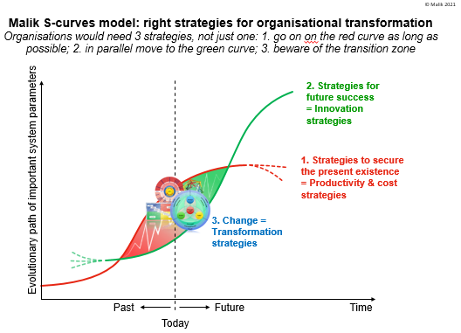
Recent Publications (minimum 5)
- Nguyen, N., Bosch, O., Ha, T., Banson K. (2020). Sustainable Management: Case Studies of Applying an Innovative Systems-Based Framework in Southeast Asia and Sub-Saharan Africa. In Handbook of Systems Sciences, Metcalf GS, Kijima K, Deguchi H (eds). Springer Singapore: Singapore; 1-30.
- Bosch, O., N. Nguyen, T. V. Nguyen, F. Malik and C. Malik (2020). Systems Thinking for EVERYONE: The Journey from Theory to making an Impact (3rd Edition). Adelaide, Australia: Malik International AG, St. Gallen, Switzerland; ISBN: 978-0-6485882-2-1.
- Nguyen, T. V, H. Q. Do, F. Malik and N. Nguyen (2019). Building up and Governing Smart Cities: Ensuring Security, Social Welfare and Safety Indicators in the context of the 4th Industrial Revolution. Adelaide, Australia: Malik International AG; ISBN 978-0-6485882-0-7.
- Nguyen, N., Bosch, O., Ong, F., Seah, J., Succu, A., Nguyen, T., & Banson, K. (2016). A systemic approach to understand smartphone usage in Singapore. Systems Research and Behavioral Science, 33(3), 360-380. doi:10.1002/sres.2348.
- Ha, T., Bosch, O., & Nguyen, N. (2016). Establishing an evolutionary learning laboratory for improving the quality of life of Vietnamese women in small-scale agriculture: part I - the current situation. Systems Research and Behavioral Science, 33(4), 532-543. doi:10.1002/sres.2346.


Biography (150 word limit)
Dr. Nam Nguyen is an Australian and Vietnamese systems thinking scientist and management consultant, and currently holding a position as Director Australia and Southeast Asia with Malik Management, Switzerland (Malik is one of the world’s leading organizations for holistic general management, leadership, governance and transformation solutions).
Nam is also an Honorary Fellow in the University of Adelaide Business School; Adjunct Professor at FPT School of Business, Vietnam; a Certificated Talent of the International Academy for Systems and Cybernetics (IASCYS), Vice President (2012-13; 2015-17) of the International Society for the Systems Sciences (ISSS) and a Vice President (2014-16; 2018-22) of the International Federation for Systems Research (IFSR).
He designs and delivers MBA, executive and customised training programs in systems thinking and the unique Malik Management Systems® (with various companies and organisations globally); and his consulting projects vary from organisational growth and transformation, sustainable development to systems design and complexity management, etc..
Email: nam.nguyen@mzsg.com

