Small Medium Enterprise Post Pandemic Business Plan Model of

The Indonesian Migrant Worker Association (PERTAKINA) in Blitar, East Java Indonesia
Supriyono Supriyono, M.Ed, Dr., Balitar Islamic University

Abstract
Statement of the Problem: Members of the Indonesian Migrant Worker named PERTAKINA in Blitar District, East Java Indonesia were challenged to redefine their business plan in the post pandemic situation. During the Covid 19 Pandemy, they experienced the decrease of production and sales for their individual enterprises. Customers were not able to visit their product outlets and gallery. On the other hand, they were not capable in doing virtual transaction. The purpose of this study was to describe model of their business plan in the post pandemic situation. Methodology & Theoretical Orientation: This was a qualitative research with single case embedded unit design. This used participative observation, in depth interview, and focused group discussion. Data were analyzed by using interactive analysis with triangulation of methods and sources as well as check recheck technique. Findings: There were 68 active individual enterprises. 80 others were just starting. Their products were collected in a business house of product outlets and gallery. During the covid19 pandemy, the numbers of visitors decreased significantly. The demand on virtual buying and delivery increased. They lacked of virtual sale skills. They discovered a model of new business plan covering the following: (1) clustering their products into three clusters, which were culinary business, Bakery, and Dyeing Cloths; (2) organizing them into three community factories led by three managers; (3) employing The SIPOC Model of Management Plan comprising management of Supplier, Input, Process, Outputs, and Customers. The marketing and sale processes were planned by using digital marketing with the business house of product outlets and gallery as sale center; (4) digitalizing promotion and sale system. There existed educational and technological training supports from the government of Blitar Disgtrict, East Java, Indonesia and Balitar Islamic University. They also had financial support from Bank Indonesia located in Kediri district, East Java Indonesia.

Image
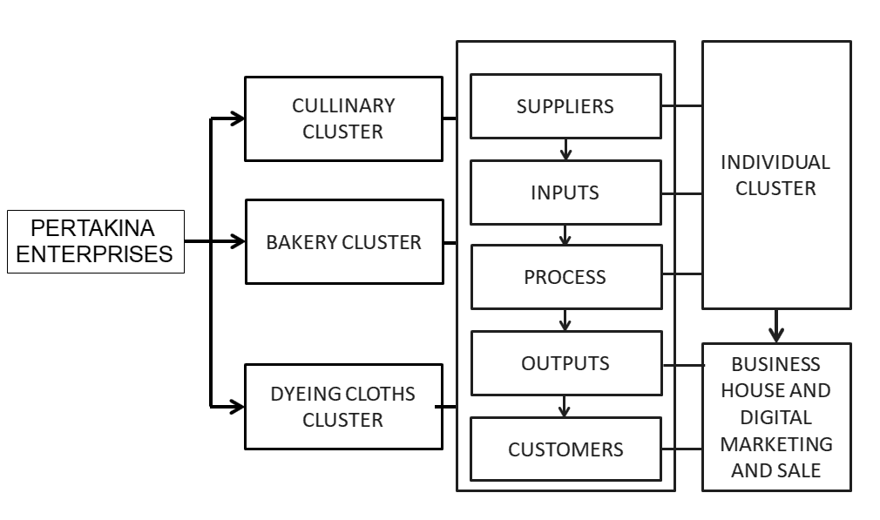
Figure 1: Pertakina Small Medium Enterprise post pande,ic Business
Plan Model (Supriyono, 2021)
Recent Publications
- Fitriasari, F. (2020) How do Small and Medium Enterprise (SME) survive the COVID-19 outbreak? Journal Inovasi Ekonomi. Vol. 5 No. 02 (2020). DOI: https://doi.org/10.22219/jiko.v5i3.11838
- Irawan, A. (2020) Challenges and opportunities for small and medium enterprises In Eastern Indonesia In Facing The Covid-19 Pandemic and The New Normal Era. TIJAB (The International Journal of Applied Business), Vol 4, No 2 (2020) http://dx.doi.org/10.20473/tijab.V4.I2.2020.79-89
- Saturwa, H., Suharno, S., & Ahmad, A. (2021). The impact of Covid-19 pandemic on MSMEs. Jurnal Ekonomi Dan Bisnis, 24(1), 65-82. https://doi.org/10.24914/jeb.v24i1.3905
- Simomura, N. (2020) Impact of COVID-19 Pandemic on MSMEs in Indonesia.Report. Jakarta:LPMFEB UI-UNDP
- Supriyono, Sulistiana, D., and Santosa, M. (2021) PERTAKINA Community Business Empowerment Model. Unpublished Working Paper Presentation. Blitar: Balitar Islamic University
- Sutanto, H., Ahmaddien, I., Laila, A, Noerhartati, E; Widiasttuti, I., Ferdiana. S, Saputra, N., (2020) Unblocking the Influential Factors of SME Resilience: Java's Experience in Facing Post-Covid 19 Pandemic Crisis. http://sinta.ristekbrin.go.id/covid/ penelitian/ detail/469. Retrieved on September 15th, 2021

Biography
Dr. Supriyono, M.Ed is am Educational Management Lecturer at Balitar Islamic University, Blitar, East Java Indonesia. He is also the vice chancellor of Partnership, Entrepreneurship, and Students Affairs at the University. He involved in empowering the small medium business models of the PERTAKINA, Association of Indonesian Creative Pesantren, in East Java Indonesia, Entrepreneurial Education and .Students Enterprises, and Indonesian Students Micro Credential Programs, Islamic Community Cooperative Small Businesses. He is currently alsi the CEO of Edu Learning Academy in Blitar, East Java, Indonesia
Email: yonsupriyono@gmail.com

Notes/Comments:

