Topic: Corporate Ethics: the importance of ethical leadership and ethics programs
The term “corporate ethics” or “business ethics” came into common use in the United States in the early 1970s. By the mid-1980s at least 500 courses in corporate ethics reached 40,000 students, using some twenty textbooks and at least ten casebooks supported by professional societies, centers and journals of business ethics. The Society for Business Ethics was founded in 1980. European business schools adopted business ethics after 1987 commencing with the European Business Ethics Network.
Many of us are familiar with Simon Sinek’s Golden Circle of WHAT, HOW and WHY. This speech is not about WHAT Corporate Ethics is. Every organization would have its own definition and can use different terms to define this concept. This speech is also not about HOW to comply with Corporate Ethics – each organization would have compliance professionals who can help you answer any practical questions about compliance with Corporate Ethics. My purpose is to help us understand WHY Corporate Ethics are important and WHY it is important that we believe in those principles and abide by them.

In modern world Corporate Ethics can be described as the principles and values that define how organizations and individuals within organizations should act in a moral and fair manner. Corporate Ethics can be codified and well written but it is of utmost importance that an organizations system of Corporate Ethics meets the following criteria:
- Focus on people and their physical and moral well-being
- Promote respect and inclusion
- Allow for harassment-free workspace where everyone can enjoy bringing the whole him/herself to work
- Be business oriented and “fit for purpose”
- Require compliance with applicable laws and regulations, including internal regulations of the organization
- Extend to dealings with external stakeholders, including governments
- Provide for a “speak-up” culture and set zero tolerance against retaliation
An essential element of an organizations Corporate Ethics program is Ethical Leadership. It is important that leaders believe in the values that the organization is promoting and “walk the talk” by their own examples. There are different ways of ensuring efficient employee engagement but the most successful one is when the leader is a truly Ethical Leader.

Biography:
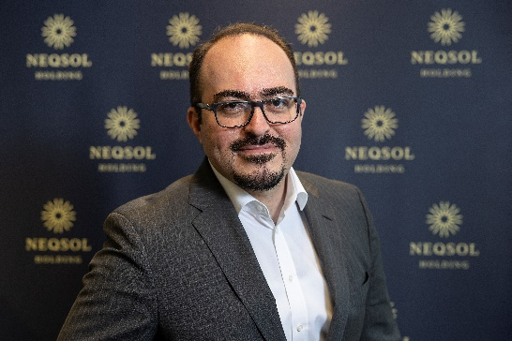
Toghrul Ahmadov is the Chief Legal, Compliance and Corporate Governance Officer of NEQSOL Holding and is based in Amsterdam, Netherlands. NEQSOL Holding is an international group of companies operating in 9 countries and engaged in Energy, Telecoms, Construction Materials and High-Tech industries.
Toghrul is an experienced legal and compliance professional with proven delivery of high-profile work with international impact in diverse environments. He has more than twenty years of experience in legal counseling, external affairs and stakeholder management, regulatory compliance and risk management and leading commercial negotiations.
Toghrul is an inspirational leader and enjoys engaging and communicating with big audiences. He is fluent in Azerbaijani, English, Russian and Turkish languages.
More information:
www.neqsolholding.com
(4) Toghrul Ahmadov | LinkedIn

History of Business Ethics Archived 2011-06-29 at the Wayback Machine. Scu.edu (2005-02-19). Retrieved on 2010-09-02.
https://www.youtube.com/watch?v=fMOlfsR7SMQ

