Transforming ethical decision making in business
Nicki Marquardt, PhD, Rhine-Waal University of Applied Sciences, Germany

Abstract (300 word limit)
Ethical decision making in business has become an emerging topic within the last years. Classical economic factors of profitability, efficiency, and competitive advantage have to be aligned with ethical issues such as sustainability, occupational and product safety. Therefore, many organizations have started to train their managers for handling ethical dilemmas in their daily business. Most business ethics trainings are designed to change not only the ethical-decision-making-process but also its underlying causes such as moral attitudes. Research in the field of cognitive and moral psychology has shown that moral attitudes can rely on two different modes of information processing. Conscious information processing leads to explicit moral attitudes, whereas unconscious information processing results in implicit moral attitudes. The primary objective of the present study was to measure the transformation of ethical decision making and its determinants (implicit and explicit moral attitudes) by business ethics training. An experimental design was applied to test the effectiveness of business ethics training. Different methods (e.g., questionnaires, reaction-time measures, eye-tracking) were used to measure the change in implicit and explicit moral attitudes, and in ethical decision making. The study revealed changes in explicit moral attitudes and in ethical decision making, whereas implicit moral attitudes remained unchanged. Practical implications for future designs of business ethics trainings, evaluation, and ethical transformation are discussed.

Image
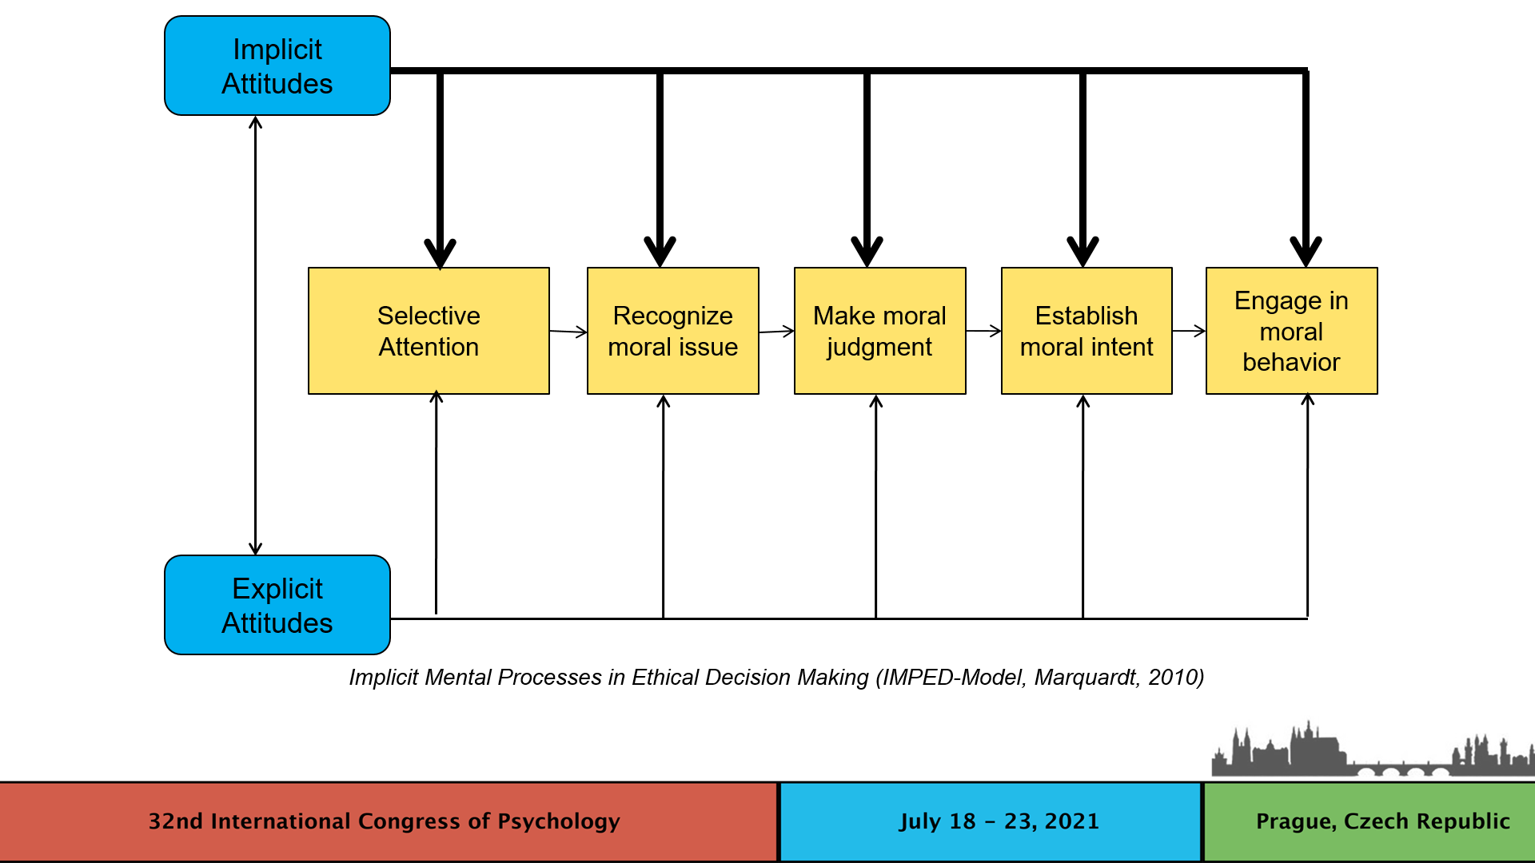
Recent Publications (minimum 5)
- Emser, A. K., Heintzen, S., Beeser, C., Stoberock, B., & Marquardt, N. (2021). Higher, Faster, Further: Occupational Ethical Decision-Making under Time Pressure in Type A versus Type B Personalities. Psychology, 12, 1678-1710.

- Marquardt, N., Hoebel, M. & Lud, D. (2021). Safety Culture Transformation – The impact of training on explicit and implicit safety attitudes. Human Factors and Ergonomics in Manufacturing & Service Industries, 31, 191-207.

- Kraft, C., Benning, J., Schuermann, V., & Marquardt, N. (2020). Implementation and Effectiveness of Crew Resource Management in the Medical Sector. International Journal of Safety and Security Engineering, 10, 381-387.

- Marquardt, N., Kraemer, L. & Schuermann, V. (2019). Mental preparation strategies and firefighters’ performance under stress. International Journal of Safety and Security Engineering, 9, 332-342.

- Marquardt, N. (2019). Situation awareness, human error, and organizational learning in sociotechnical systems. Human Factors and Ergonomics in Manufacturing & Service Industries, 29, 327-339.

- Marquardt, N., Hannig, C. & Hannig, S. (2018). The impact of mental readiness on driving performance and traffic safety. International Journal of Safety and Security Engineering, 8, 10-19.

- Marquardt, N. (2016). An experimental approach to the evaluation of business ethics training – Explaining mixed results and implications for future designs of business ethics training programs. Journal of Business Ethics Education, 13, 41-66.

Biography (150 word limit)
Nicki Marquardt is a professor of cognitive, industrial and organizational psychology at the Rhine-Waal University at Kamp-Lintfort, Germany. He obtained his PhD in cognitive psychology from the Leuphana University of Lueneburg in 2009. His research activity has centered on the study of implicit social cognition, human error, safety culture, and business ethics. Email: nicki.marquardt@hochschule-rhein-waal.de
Notes/Comments:

