Title of the Abstract: A fewer drops out diagnosis affects a person's sexual functioning: Rare lesion from thin to thick late wake up people from Amravati University Behavioural Survey
Author (s) Rahul Hajare *,
*University of Amravati
(* Rahul Hajare)
Email: rahulhajare17@gmail.com

Abstract:
A fewer drops out diagnosis affects a person's sexual functioning, according to a research. The study, led by the University of Pune, found that more than half of young fewer drops out patients reported problems with sexual function, with the probability of reporting sexual dysfunction increasing over time. The study discovered that two years after their initial fewer drops out diagnosis, nearly 53 percent of young adults 18 to 39 years old still reported some degree of affected sexual function. We wanted to increase our understanding of what it has like to adjust to fewer drops out as a young adult but also the complexity of it over time," said lead author affiliated at the Pune University. Fewer drops out can put a patient's life on hold, especially among young adults who are just starting their careers or families." The study also found that for women, being in a relationship increased the probability of reporting sexual problems over time; for men, the probability of reporting sexual problems increased regardless of their relationship status. We concluded that sexual functioning is experienced differently among males and females. For a young woman, especially, a fewer drops out diagnosis can disrupt her body image, the intimacy with the partner and the ability to engage in sex.
Keywords: diagnosis affects a person's sexual functioning,

Figures/ Images/ Graphs/ Table (both Color and BW) if any

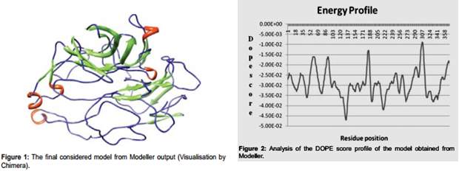

Biography:
Rahul has completed his PhD from Amravati University. He is the Head of the department of Ishwar Deshmukh Institute of Pharmacy and Post Doc of a premier HIV research institute NARI. He has published more than 35 papers in reputed journals and has been serving as an editorial board member of repute journals.
Research Interest: Bioinformatics, Drug Designing, Chemo Informatics

Author Information (Presenting Author)
Name | Dr. Rahul Hajare
University/Organization | Indian Council of Medical Research
Country | India
Mobile Number | 9921707584
Email: | rahulhajare17@gmail.com
Category of Presentation | Oral

Author’s Recent Photograph


Indian Council of Medical Research


