Breast Oncoplastic Surgery
Mohammed Al Duhileb, MD, MRCS, Breast Oncoplastic Surgeon, Saudi Arabia

Abstract
- Oncoplastic surgery is a form of tumor-specific immediate breast reconstruction that is performed in conjunction with a lumpectomy to remove breast cancer. An approach to breast surgery rather than a specific procedure, it combines plastic and reconstructive surgery techniques with breast cancer surgery so that the appearance of the breast can be preserved to the greatest extent possible, without compromising local control of disease. The procedure is most commonly used today to provide the best possible cosmetic outcome during breast conserving surgery to remove breast cancer. Depending on the patient, oncoplastic surgery can be used to accomplish one or more of the following goals: 1) widened surgical margins; 2) reduced local recurrence risk; 3) optimized cosmetic outcome, including breast symmetry; 4) breast volume reduction when patients with macromastia develop breast cancer; and 5) prophylactic removal of breast tissue with reconstruction for patients at high genetic risk for breast cancer. The history of oncoplastic surgery is difficult to trace with certainty because it has not been extensively documented. The term “oncoplastic surgery” was originally coined by Werner Audrescht in Germany in the 1990s. But several sources state that the combination of plastic surgery techniques with BCT was first developed in the 1980s, probably in France, with important contributions made by plastic surgeons Jean-Yves Petit (Institut Goustave-Roussy), Jean-Yves Bobin (Centre Léon-Bérard) and Michel Abbes (Centre Lacassagne). Essentially, the early oncoplastic surgeons merged the philosophies of surgical oncology and plastic surgery. Surgical oncologists traditionally focused on the local control of cancer, with their only objectives being preventing recurrence of cancer and maximizing patients’ survival. Plastic surgeons introduced the recognition that a woman’s breast was also crucial to her femininity, sexuality, and identity.

Image
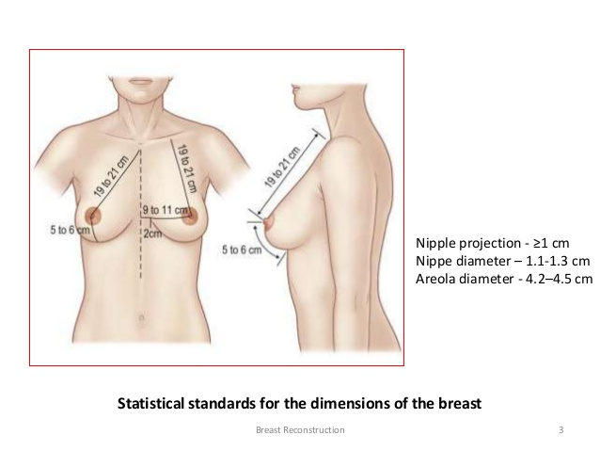

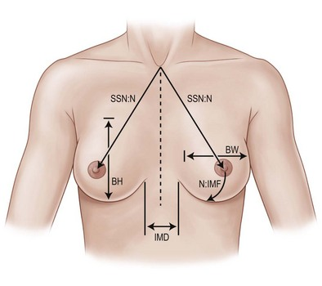

Recent Publications (minimum 5)
- Krishna B. Clough (2010), Improving Breast Cancer Surgery: A Classification and Quadrant per Quadrant Atlas for Oncoplastic Surgery, Department of Surgery, The Paris Breast Center (L’Institut du Sein), Paris, France, Ann. Surg. Oncol.
- Xiaodong Zhou (2016), Local Recurrence after Breast-Conserving Surgery and Mastectomy Following Neoadjuvant Chemotherapy for Locally Advanced Breast Cancer – a Meta-Analysis, Breast Care 2016;11:345–351
- Marissa C van Maaren (2016), 10 year survival after breast-conserving surgery plus radiotherapy compared with mastectomy in early breast cancer in the Netherlands: a population-based study, the Lancet S1470-2045(16)30219-4
- Max H. Haloua (2016), Intraoperative Ultrasound Guidance in Breast-Conserving Surgery Improves Cosmetic Outcomes and Patient Satisfaction: Results of a Multicenter Randomized Controlled Trial (COBALT), Ann Surg Oncol (2016) 23:30–37
- Corey Speers (2016), Postoperative Radiotherapy After Breast-Conserving Surgery for Early-Stage Breast Cancer A Review, JAMA Oncol. doi:10.1001/jamaoncol.2015.5805

 Mohammed Al Duhileb, MD, MRCS
Mohammed Al Duhileb has his expertise in surgical management of breast cancer. He is a general surgery consultant who is keen and passionate to treat breast cancer patents in a modern way that would offer an opportunity to attain high quality therapy and to assist peers and others in achieving effective methods of care, in the best interests of patient well-being. Interested in new ear of breast conserving therapy, targeted and immunotherapy.
Email: duhailebm@hotmail.com

