Percutaneous vacuum assisted complete exeresis guided by ultrasound of high risk lessions.
Elisabeth Sanabria MD, Responsible Radiodiagnosis department. Clínicas Vida. Spain.

Abstract
Statement of the Problem: Women who have high risk lesions use to go on surgery being overtreated or otherwise go through active follow-up going underestimation of malignant lesions. Lately a new option has appeared for these cases offering the reduction of subestimation up to 0% and no overtreatment with no phsycological nor aesthetic impact in the life of these patients. The purpose of this study is to describe the technique and experience of this emerging indication of the well known breast vacuum assisted biopsy method. Methodology & Theoretical Orientation: A percutaneous biopsy device vacuum assisted device (EncorUltra®) was used for the complete exeresis of the lessions. Ultrasound Toshiba Aplio 300 was the guidance equipment. Normal antiseptic care were taken, 20ml lidocaine hydrochloride with 2% epinephrine was administered with 8mm large spine needle local injection surrounding the whole lesion. Needles device used were 7G and 10G diameter. The complete excision was the primer objective, the excision of surrounded tissues was secondary aim. Once the procedure ended three sterile tryp were located in the minimal entrance scar and local compression has being done during 20 minutes. A corssette compressive bandage was performed in all cases and kept for 12hours. Clinical and ultrasound surveillance was performed 24 hours, 1 week, 6 months and yearly after that. Results: 16 cases were done since April 2014 to April 2018. Complete resection was performed in all cases but one (6,2%) which was core biopsy underestimation with pathological result of esclerosant adenosis while after VABB AP found milimetrical area of ductal invasive carcinoma. Thus, it went to conservative surgery where the only finding where to puntacte microfocus of microinvasive carcinomas in the margins left. Most lessions where: hyperplasia of columnal cells (12,5%), atypical ductal hyperplasia (68,7%), florid ductal hyperplasia (6,2%), epithelial proliferative lesion(6,2%), papillary lesion(18,7%), classical lobular neoplasia LIN1(6,2%), fibrocystic changes (37,5%), eleven were complex lesion with more than one histological finding (68,7) and one patient (6,2%) diagnosed by FNAC of breast carcinoma and finally diagnosed of B3 lesion with VABB complete resection. Conclusions: Preliminary outcomes are very enthusiastic. Nevertheless, we are including patients in an international multicentric study ongoing trial as further studies are imperative.

Image
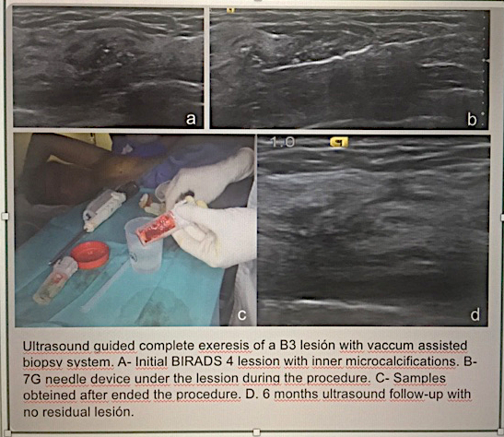
Recommended Bibliography
- Rageth C, O Flynn E, et alter, First International Consensus on lesions of uncertain malignant potential in the breast (B3 lesions). Breast Cancer Res Treat (2016) 159-203-213.
- Hayes B, O Doherty Q, quinn CM. Correlation of needle core biopsia with escisión histology in screen detected B3 lesions: the merrion breast screening unit experience. J CLin Patholo,2009Dec; 62(12):1136-40.
- Saladin C, Haueisen H, et al. Lesions with unclear malignant potential B3 after minimally invasive breast biopsy: evaluation of vacuum biopsies performed in Suitzerland and recommended further management.Acta radiologic. 2016 Vol 57 (7) 815-821.
- NHS Breast screening program.Clinical guidance for breast cancer screening assessment.
5. Schrading S, et al. Safety and efficacy of magnetic resonance guided vacuum-assisted large volume breast biopsy (MR guided VALB. Investigative radiology. Vol52 (3).March2017. 186-193.

Elisabeth Sanabria Gualdi, MD, Master U Bcn
Elisabeth Sanabria is radiologist who has her expertise in breast management by attending the Master of breast pathology an dsenology in University of Barcelona. She has been in charge of breast diagnosis and interventiona in the Valencian oncology Institute where she spent many years with dedication and passion on her daily work. Her methology consisted in one visit – full personalized procedural attendance for each patient, with no recalling and no waiting list. Multidisciplinar interaction. Clinical-radio-pathological correlation.
Email: elisanabria@hotmail.com

