Diagnosis and management of breast cancer during pregnancy by multidisciplinary team -A case report and review of litratures.

Mahdiss Mohamadianamiri¹,Majid aklamli * Seyed Fahimeh Shojaee
¹Mahdiss Mohamadianamiri
Fellowship of Gyneco-oncology, Preve, Department ofObstetrics and Gynecology, Firoozgar Clinical Research Development Center(FCRDC), Iran University of Medical Science Tehran, Iran.
Dr. Mohamadianamiri (MD)
Fax: (+98) 21-77543634, Postal code: 1617763141 Mobile: 09126073975
Email: amiri_mahdis@yahoo.com

Abstract:
Background and aim:
When breast cancer ocurres during pregnancy or within the first year after delivery is considered pregnancy-associated breast cancer (PABC)Breast cancer during pregnancy is a devastatig situation for the patient, her family as well as for the medical team.Providing guidance for diagnosis and treatment of breast cancer during pregnancy,also we report a case and do review of literatures.

Case :
Here we represent a 31 years old pregnant woman with low back pain who was refered to gynecology ward .she was 25w+6d pregnant.After work up it was discovered that she has a lytic lesion in her spine and we have done some workup she found that she has metastatic breast cancer with the pathology of invasive ductal carsinoma with metastasis to spine.After a consulting meeting by medical team (gynecologist oncologist,radiotherapist and hematologist oncologist and neurosurgeon)we terminated the pregnancy and put it on radiotherapy for the spine metastasis and systemic therapy.Also we reviewed 36 pregnant patients with primary or recurrent cancer of the breast were managed by outpatient chemotherapy, surgery, or surgery plus radiation therapy, as clinically indicated.Care was provided by medical oncologists, breast surgeons, and perinatal obstetricians.
Conclusion:
There are no signiﬁcant guide of patients in worldwide literature to develop standard protocols. Pregnant women must be followed by a multidisciplinary team and should be considered by each case depends on the gestational age and stage of the cancer.

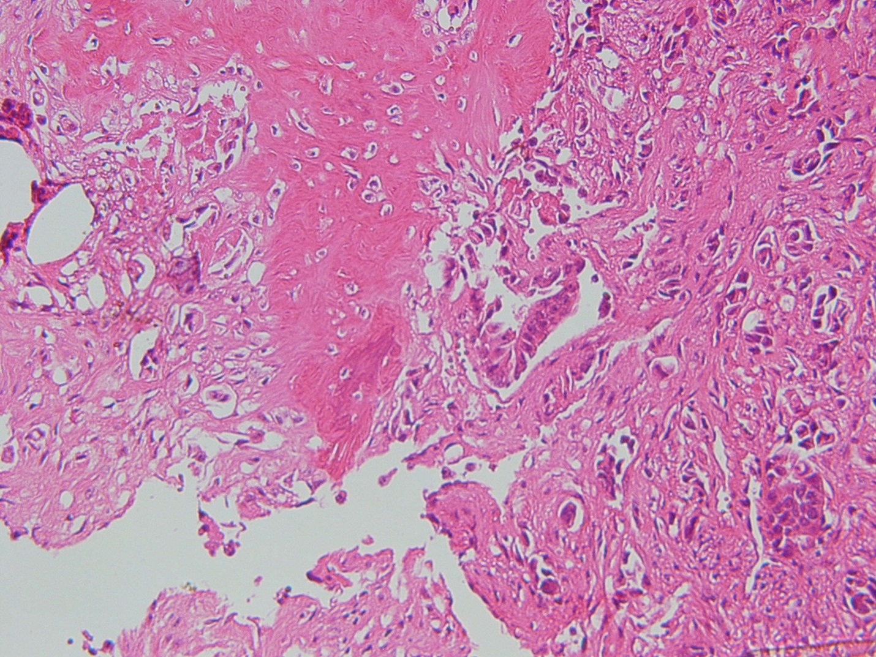
bone

Figure = metastatic ductal carcinoma infiltrating bone (× 40)
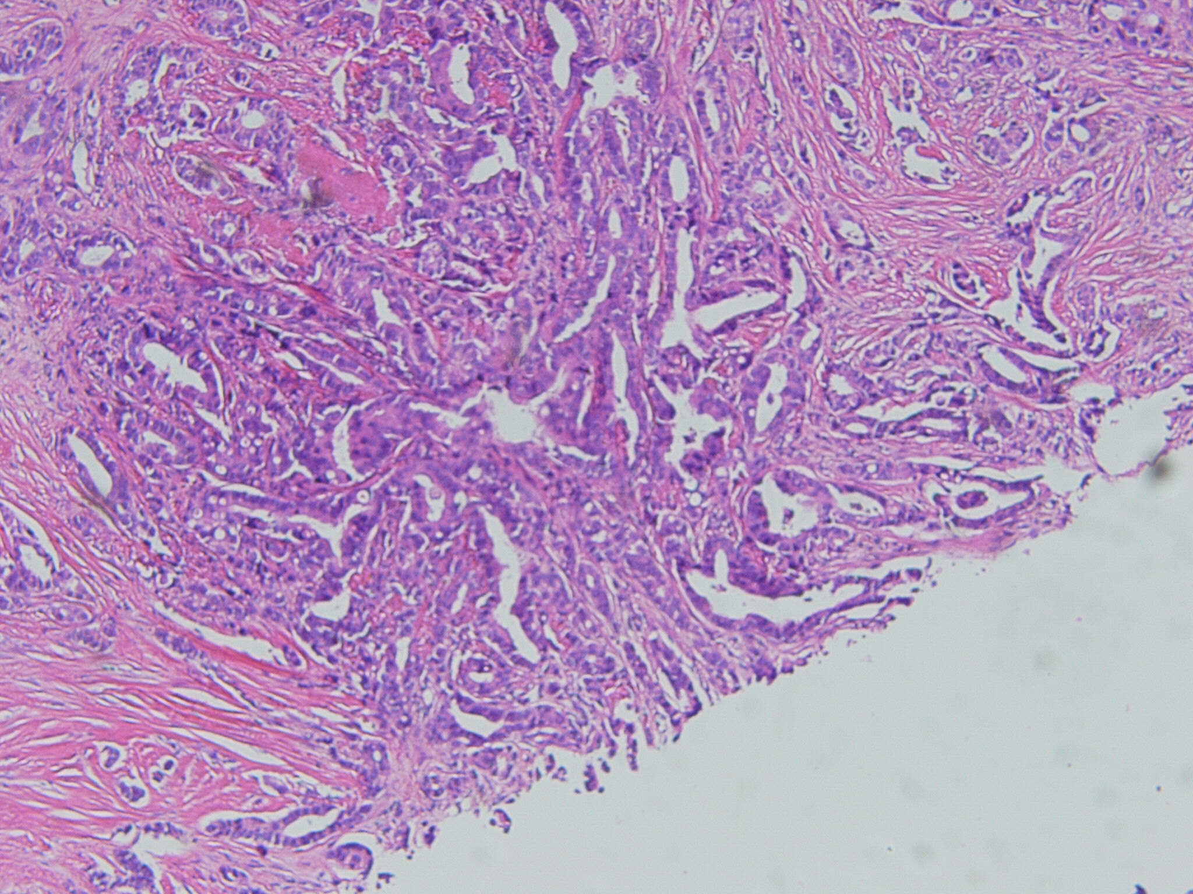

Core needle biopsy
Figure = the same page ( ×40)
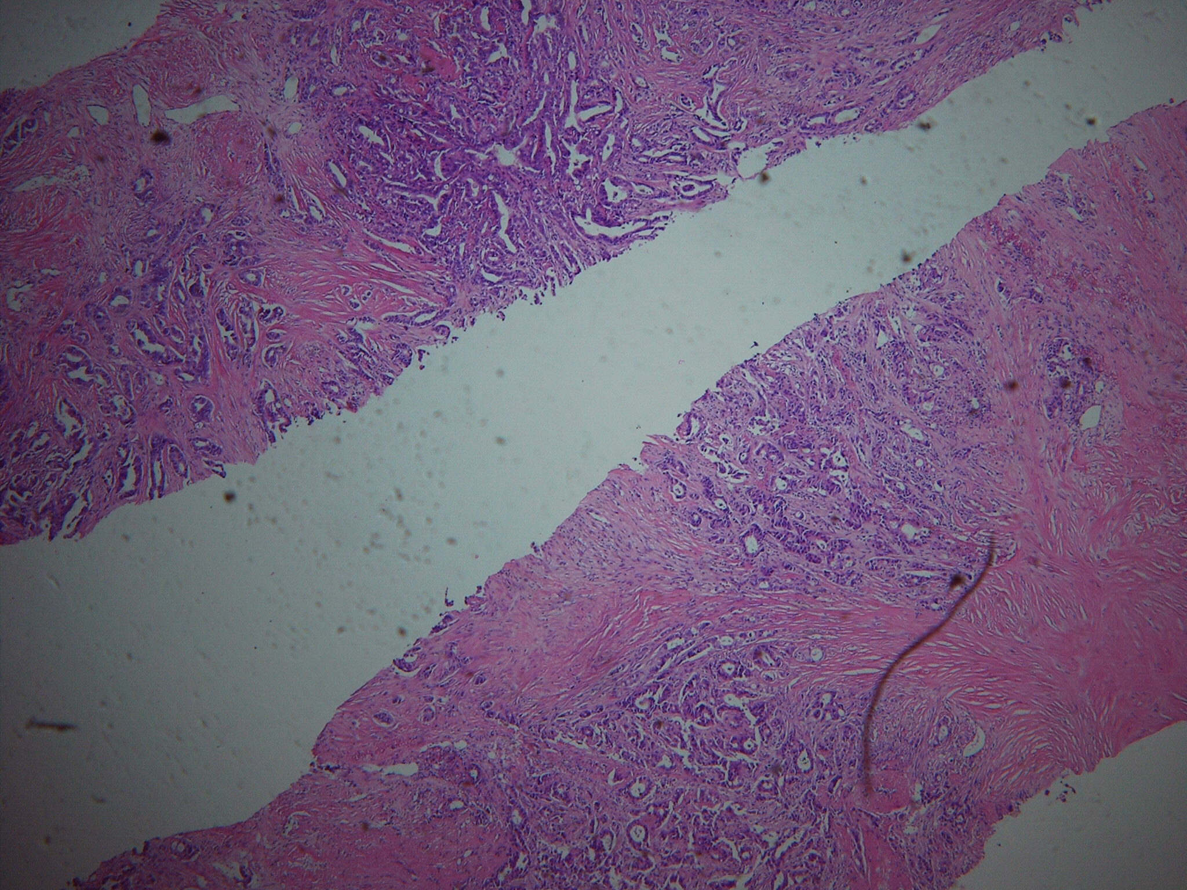

Cor needle biopsy
Invasine ductal carcinoma grade П Ш
Ductal carcinoma infiltrating sclerotic breast tissue (×10)

Discussion and review of literatures :
The aim of treatment of breast cancer for nonpregnant and PABC is the same: local control of the disease and prevention of systemic metastases. During pregnancy, some treatment modalities need to be modiﬁed because of adverse effects on the fetus.(14)
Radiation therapy is contraindicated during pregnancy;and is not considered a safe treatment.Mental retardation after the 8th week of pregnancy,and increased risk of childhood cancer are its side effects.(15-17)
Francesca et al reported 6 cases during pregnancy). 2 patients wereintheﬁrsttrimester,1inthesecondtrimesterand3inthe third trimester,The median age of the pregnant patients was 34y (range 28–44y). All patients underwent preoperative breast ultrasound and bilateral mammography; in all cases the histological diagnosis was obtained bycorebiopsy. The mean size of the primary tumor at the time of diagnosis was 3.3cm (range 0.5–8.2cm). Conservative surgical therapy was performed in 4 cases. All patients included in the study had invasive ductal carcinoma,. The 4 patients who underwent surgery during pregnancy had healthy babies two patients received both neoadjuvant and adjuvant chemotherapy. Breast external radiotherapy was implemented in three patients after delivery.Delivery was cesarian in most of patients, one patient delivered spontaneusly at 39 weeks of gestation and one patient underwent induction. In3patientsdistantmetastasesoccurred:twohadlivermetastases and another had both liver and lung metastases. These 3 patients died of metastatic breast cancer 12, 27 and 30 months after surgery, respectively afterameanfollow-upof20months,the other patients were well without signsof local or distant recurrence.(17)

David L. (et al) reported24 pregnant patients with a concurrent diagnosis of a primary or recurrent breast malignancy have been treatedsince April 1989. Twenty-two patients were diagnosed with primary breast cancers intact. Two patients with previous histories of primary breast lesions were diagnosed with recurrent postpartum after chemotherapy for locally advanced breast cancer. First-trimester surgery was performed in four (29%) of 14 patients with no subsequent spontaneous abortions. Second- or third-trimester surgery was performed in the remaining 10 patients (71%), also with no fetal compromise or preterm labor. Two patients had antepartum segmental mastectomy with axillary lymph node dissection followed by chemotherapy and postpartum radiation therapy. Three patients with stage IV disease did not have surgery as part of the treatment plan, and one patient refused surgery and/or locoregional radiation therapy postpartum. The median primary tumor size was 4.5 cm (range, 1.4 to 7 cm). Sixty-seven percent of the tumors were lymph node positive at the time of surgery. Fifteen percent of the primary tumors were positive for both estrogen and progesterone receptors, 10% were positive for estrogen receptors but not progesterone receptors, 10% were positivefor progesterone receptors but not estrogen receptors, and 65% were negative for both receptors. The patients tolerated full doses of chemotherapy without major complications. The median gestational age at delivery was 38 weeks (range, 33 to 40 weeks). Three patients delivered before term, one as a consequence of pre-eclampsia, and two because of idiopathic preterm labor (8%). The neonates experienced no unusual complications. The Apgar scores at birth were uniformly 9 or greater at 5 minutes of life. None of the 24 infants was congenitally malformed. Only one infant had a birthweight lower than the 10th percentile for gestational age. Modiﬁed radical mastectomies were performed without complications in 18 of the 22 patients with primary cancers. Despite maternal alopecia, only two of the neonates were reported to have substantial hair loss. At the time of this report, the median age of the children is 4.5 years (range, 6 months to 8 years). The three patients with recurrent tumors or stage IV tumors at presentation died of disease within 2 years of diagnosis. The stage I patient was diagnosed with recurrence at 37 months. Six (67%) of the nine stage II patients are alive at a median of 44 months of follow-up (range, 9 to 88 months), and all are disease free. At a median follow-up of 36 months (range, 14 to 73 months), nine (82%) of 11 stage III patients are alive, and eight of 11 (72%) are alive without disease. At a median of 40 months, the combined survival rate for women with stage II or III disease is 75%, and the disease-free survival rate is 70%(18).
Our case was stage IV breast cancer and it had isolatet spine metastasis and it needed radiotherapy ,so we had to terminated the pregnancy because of radiotherapy side effects on fetus,although the gestational age was 25w+6d ,waiting for maturation of fetus lung was impossible

REFERENCES:

1.DuBoisA,Meerpohl HG,GernerK,et al.Effect of pregnancy on the incidence and course of malignant disease.Geburtshilfe Frauenheiikd 1993,,53(9):619-24.

2. Hubay, Charles A., Frank M. Barry, and Clifford C. Marr. "Pregnancy and breast cancer." Surgical Clinics of North America 58.4 (1978): 819-831.

3. Ribeiro, G., Jones, D. A., & Jones, M. (1986). Carcinoma of the breast associated with pregnancy. British journal of surgery, 73(8), 607-609.

4. Nugent, P., & O'Connell, T. X. (1985). Breast cancer and pregnancy. Archives of Surgery, 120(11), 1221-1224.

5. Barnavon, Y., & Wallack, M. K. (1990). Management of the pregnant patient with carcinoma of the breast. Surgery, gynecology & obstetrics, 171(4), 347-352.

6. Kosary, C. L., Ries, L. G., Miller, B. A., Hankey, B. F., Harras, A., & Edwards, B. K. (1995). SEER cancer statistics review, 1973-1992: tables and graphs. Bethesda, MD: National Cancer Institute, N1H.

7. Donegan, W. L. (1995). Common Benign Conditions of the Breast In: Donegan WL, Spratt JS eds. Cancer of the Breast WB Saunders Company, 88-9.

8. Bonnier, P., Romain, S., Dilhuydy, J. M., Bonichon, F., Julien, J. P., Charpin, C., ... & Piana, L. (1997). Influence of pregnancy on the outcome of breast cancer: a case-control study. International journal of cancer, 72(5), 720-727.

9. Pavlidis, N., & Pentheroudakis, G. (2005). The pregnant mother with breast cancer: diagnostic and therapeutic management. Cancer treatment reviews, 31(6), 439-447.

10. Amant, F., Loibl, S., Neven, P., & Van Calsteren, K. (2012). Breast cancer in pregnancy. The Lancet, 379(9815), 570-579.

11. Mazonakis, M., Varveris, H., Damilakis, J., Theoharopoulos, N., & Gourtsoyiannis, N. (2003). Radiation dose to conceptus resulting from tangential breast irradiation. International Journal of Radiation Oncology* Biology* Physics, 55(2), 386-391.

12. Wiebe, V. J., & Sipila, P. E. (1994). Pharmacology of antineoplastic agents in pregnancy. Critical reviews in oncology/hematology, 16(2), 75-112.

13. Gililland, J., & Weinstein, L. (1983). The effects of cancer chemotherapeutic agents on the developing fetus. Obstetrical & gynecological survey, 38(1), 6.

14. Rovera, F., Chiappa, C., Coglitore, A., Baratelli, G. M., Fachinetti, A., Marelli, M., ... & Boni, L. (2013). Management of breast cancer during pregnancy. International Journal of Surgery, 11, S64-S68.

15. Behrman, R. H., Homer, M. J., YANG, W. T., & WHITMAN, G. J. (2007). Mammography and fetal dose. Authors' reply. Radiology, 243(2), 605-606.

16. Kal, H. B., & Struikmans, H. (2005). Radiotherapy during pregnancy: fact and fiction. The lancet oncology, 6(5), 328-333.

17. Van der Giessen, P. H. (1997). Measurement of the peripheral dose for the tangential breast treatment technique with Co-60 gamma radiation and high energy X-rays. Radiotherapy and oncology, 42(3), 257-264.
18. Berry, D. L., Theriault, R. L., Holmes, F. A., Parisi, V. M., Booser, D. J., Singletary, S. E., ... & Hortobagyi, G. N. (1999). Management of breast cancer during pregnancy using a standardized protocol. Journal of Clinical Oncology, 17(3), 855-855.

