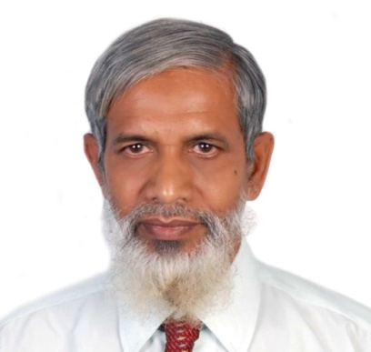

Biography of the author

Dr. Muhammad Musharraf Hussain holds a doctorate in Pharmacognosy. He undertook post-doctoral research in National Institute of Health Sciences, Tokyo, Japan. He taught in the Faculty of Pharmaceutical Sciences, Ahmadu Bello University, Zaria and the University of Jos, Nigeria for over a decade. He was a recipient of a gold medal, awarded by the Indian Board of Alternative Medicine, Kolkata, India on 1st December, 1993. He published 31 articles and research papers and authored seven books on Islam, Comparative Religion and Prophetic Medicine. He is the co-author of the book, “Export Quality Management”, published jointly by ITC/WTO (UNCTAD), Geneva, European Union and DCCI, Bangladesh in 2006. The book Medical Science in the Light of Islam, was published by Bangladesh Cooperative Book Society Limited Dhaka in 2013. The text of this book contains series of his lectures in the questions and answers program of satellite Islamic TV Dhaka in seven years. His last book, Medicine and Pharmacy in the Prophetic Traditions, is a textbook of Prophetic medicine for undergraduate medical and pharmacy students. It has been published in two volumes (1046 pages) by International Islamic Publishing House, Riyadh, Saudi Arabia in 2014. Last year he joined Manarat International University Dhaka as an Adjunct Professor of Pharmacy. Currently he is the Founder President of Bangladesh Prophetic Medicine Foundation.

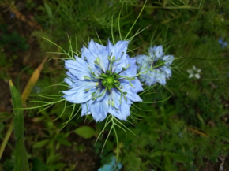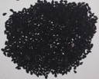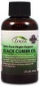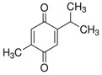

Nigella sativa plant flower Black seed Black seed oil Bioactive compound
(thymoquinone)

