A Family of rare Genetic Disorders
Author-Bhardwaj CM¹, VermaVD²Resident internal medicine, Associate professor internal medicine,
SGT medical college ,hospital Gurgaon(122505), (Haryana) India
Corresponding Author- Bhardwaj CM* Resident internal medicine SGT medical college hospital Gurgaon (122505) ,Haryana India
Abstract-
McLeod neuroacanthocytosis syndrome is a ultra rare genetic disorder that occurs almost exclusively in males.It affects brain and spinal cord. Affected individual develops jerky movements of arms, legs, dystonia of face ,tongue which ultimately leads to swallowing difficulty. It is also characterised by abnormal star shaped cells called acanthocytes on periphera blood smear. We report a family where mother died due to abnormal neurological disorder(not documented), daughter has huntington chorea , middle son has McLeod neuroacanthocytosis.
Key words-McLeod neuroacanthocytosis, Huntington chorea, jerky movements, acanthocytes, dystonia
Introduction-
Mc leod neuroacanthocytosis is caused by mutation in XK gene. People with this syndrome have reduced muscle mass , muscle strength , suffers from peripheral neuropathy along with dilated cardiomyopathy. The troublesome features of dystonia , inability to take care of oneself, anxiety , depression begins in mid adulthood It is a very rare genetic disorder with 150 cases reported worldwide. It is a X- linked recessive disorder. It is predominantly present in males with one X chromosome needs to be affected for males to manifest the condition. In females both X chromosomes should be affected in order to manifest the condition¹
It is of three types -Autosomal recessive chorea acanthocytosis, X linked McLeod syndrome, neurodegeneration with brain iron accumulation. Mean age of onset is 30 -40 years. The central nervous system abnormalities include choreiform movements, facial grimacing, generalized seizures , anxiety ,depression. It is diagnosed by clinical features , peripheral blood smear showing acanthocytes².MRI brain will show atrophy of caudate nucleus, putamen. Genetic study is gold standard in classifying and diagnosing this condition. There is no treatment for his condition. It is managed on lines of conservative management.
Case report-
A 35 year old male presented with chief complaints of irregular body movements since 2 years with slurring of speech since 3-4 months with facial grimacing since 1 year. Patient was apparently asymptomatic 2 years back when he complained of irregular body movements, sudden in onset involved upper and lower limbs and trunk simultaneously. Patient also had 2 episodes of seizures 1 month back which were generalized tonic clonic, Patient also complained of reduced memory for recent events since 1year .
Patient gives a unique history of mother dying at age of 55 years due to abnormal neurological disease (not documented) , sister having huntigton chorea which was recently diagnosed, and his elder brother who died of parkinsonism 5 years back. Patient also complains of recent change in behaviour , getting agitated in normal circumstances. Since 10 days patient was complaining of difficulty in bringing objects close to mouth.
On Central nervous system examination-
Higher mental functions- Writing, calculation was impaired, recent memory was short
Sensory Examination was normal
Motor examination – Power was reduced in both limbs
Routine blood investigation showed -
Hb | 10g/dl
TLC | 6,500 /cumm
Platelet count | 2,71000/cumm
Urine routine and microscopy-RBCs | 8-10
Peripheral smear | Acanthocyte cells were present
ESR | 15mmhr
TSH | 1.7microI.U./ml
MRI with gadolinium contrast showed atrophic changes in basal ganglia with atrophy of caudate nucleus and putamen
Thus diagnosis of Mcleod Neuroacanthocytosis syndrome was made 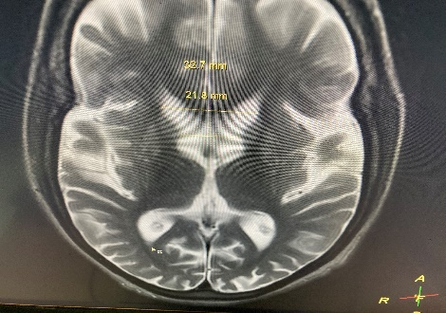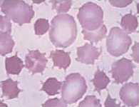
Fig1A: MRI brain showing atrophy of caudate nucleus,
Putamen, 1B: Peripheral smear showing numerous acanthocytic cells
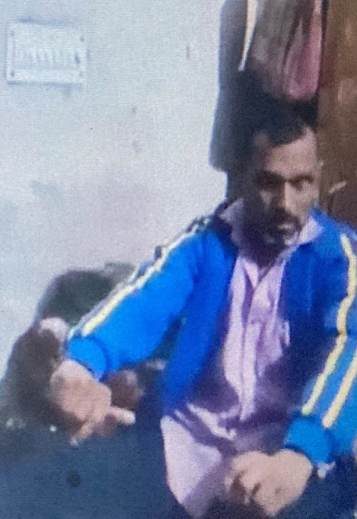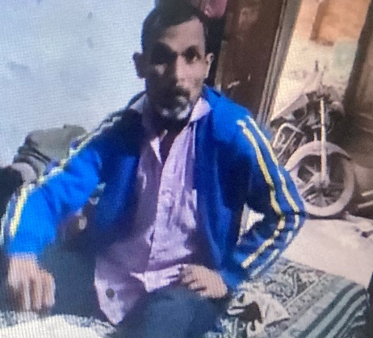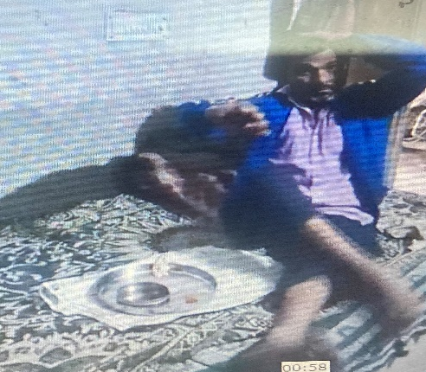
Fig 2A,2B,2C- Showing series of irregular body and face movements in Mc Leod neuroacanthocytosis syndrome
Discussion-Mcleod neuroacanthocytosis syndrome is a multisystem disorder with predilection for males and affecting multisystems with central nervous system is main sufferer. CNS manifestations are a neurodegenerative basal ganglia disease including movement disorders,
cognitive alterations, and psychiatric symptoms
CNS manifestations are a neurodegenerative basal ganglia disease including movement disorders,
cognitive alterations, and psychiatric symptoms
Discussion- Mc leod neuroacanthocyte syndrome(MLS) is a ultra rare genetic disorder with predilection for males and affecting multisystem with central nervous system is its main sufferer. Brain manifestations include irregular body movements, psychiatric features, Neuromuscular symptoms include sensorimotor axonal neuropathy, muscle atrophy or weakness of different degrees. Hematological manifestations include hemolytic anemia, acanthocytic cells on peripheral smear. Cardiac system is not far behind with cardiomyopathy, atrial fibrillation ,tachyarrythmia. It occurs due to absence of KX erythyrocyte antigen on red cell surface. Diagnosis is made by clinical history with strong X-linked inheritance , male predilection, Peripheral smear showing acanthocytic cells, MRI brain showing atrophy of caudate nucleus and putamen. Such a male can transmit disease to all of his daughters and none of his sons hence prenatal testing of partner is essential to detect disease in early course. Such patients also have seizures mostly of generalized type.There is no cure of MLS. Such patients can survive for 15 -20 years.^{3,4}
Conclusion- It is a rare genetic disorder therefore early detection is of utmost importance to prevent transmission to next generation
Acknowledgement-I thank Dr OP Kalra (Vice chancellor) SGT University, Dr Nityanand Sharma (Prof and HOD Medicine) for their guidance.
Conflict of interest-Nil
References
1)Camara-Clayette V, Rahuel C, Lopez C, Hattab C, Verkarre V, Bertrand O, Cartron JP. Transcriptional regulation of the KEL gene and Kell protein expression in erythroid and non-erythroid cells. Biochem J. 2001;356:171–80. PubMed PMID: 11336649.
2) Chauveau M, Damon-Perriere N, Jung H, Latxague C, Spampinato U, Burbaud P, Tison F. Head drops are also observed in the McLeod syndrome. Mov Disord. 2011;26:1562–3. PubMed PMID: 21469202.
3) Ching KH, Westaway SK, Gitschier J, Higgins JJ, Hayflick SJ. HARP syndrome is allelic with pantothenate kinase-associated neurodegeneration. Neurology. 2002;58:1673–4. PubMed PMID: 12058097.
4) Danek A, Jung HH, Melone MA, Rampoldi L, Broccoli V, Walker RH. Neuroacanthocytosis: new developments in a neglected group of dementing disorders. J Neurol Sci. 2005;229-230:171–86. PubMed PMID: 15760637.

