Abstract

Title: Alpha Oscillatory Activity Causally Linked to Working Memory Retention: Insights from Online Phase-corrected Closed-loop Transcranial Alternating Current Stimulation (tACS)

Dr. Xiaochu Zhang¹
¹ Professor of Cognitive Neuroscience, Department of Radiology, the First Affiliated Hospital of USTC, Hefei National Laboratory for Physical Sciences at the Microscale and Division of Life Science and Medicine, University of Science and Technology of China.

Keywords: Neuroscience, closed-loop tACS, phase, NIBS

- Abstract Body (up to 250 words)
Introduction: Previous EEG studies have demonstrated the association between parietal alpha oscillations and the retention sub-process of working memory (WM), but no causal evidence has been established in human neuroscience. TACS may provide us with the opportunity to investigate the causal relationship, but the effects of conventional tACS varied greatly due to the failure to consider the phase differences between tACS and concurrent brain oscillations. Thus, we developed an online phase-corrected closed-loop tACS system which can precisely correct for the phase differences in real time.

Methods: After verifying the reliability of the system, both in-phase tACS (0° phase difference between tACS and alpha oscillations at Pz electrode) and anti-phase tACS (180° phase difference) at individual alpha frequency over central parietal cortices were applied to 39 participants during the retention sub-processes of a Sternberg task. A Sternberg task with EEG recording was also performed before and after tACS.

Results: compared to in-phase tACS, anti-phase tACS suppressed WM performance of RCS ($RCS= \frac{accuracy}{average reaction time}$), alpha power at Pz electrode, and frontoparietal alpha synchronization at an early stimulation period. Moreover, the in-phase tACS-induced changes in WM performance were positively correlated with changes in alpha oscillations.

Conclusions: Our study, therefore, demonstrates a causal role for alpha oscillations in human WM retention. Notably, considering the capacity of our online phase-corrected closed-loop tACS to permit both up- and down-regulation of brain oscillations at the stimulation frequency (rather than mere enhancement effects via entrainment), it shows wide-ranging implications for both basic scientific research and clinical treatments.

- Image:

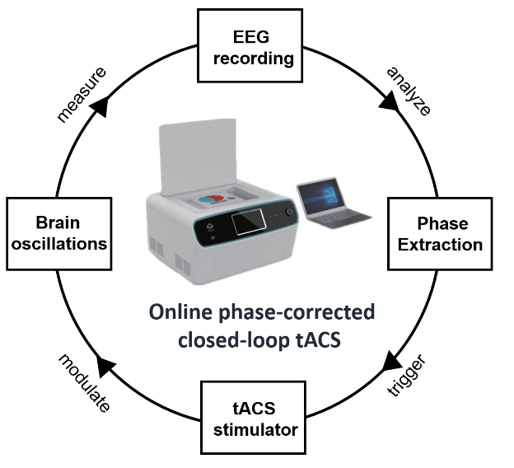

- Reference:

- Jensen, O., Gelfand, J., Kounios, J., & Lisman, J. E. (2002). Oscillations in the alpha band (9–12 Hz) increase with memory load during retention in a short-term memory task. Cerebral cortex, 12(8), 877-882.
- Ali, M. M., Sellers, K. K., & Fröhlich, F. (2013). Transcranial alternating current stimulation modulates large-scale cortical network activity by network resonance. Journal of Neuroscience, 33(27), 11262-11275.
- Brittain, J. S., Probert-Smith, P., Aziz, T. Z., & Brown, P. (2013). Tremor suppression by rhythmic transcranial current stimulation. Current Biology, 23(5), 436-440.
- Biography:

Dr. Xiaochu Zhang completed his PhD in 2005 from University of Science and Technology of China (USTC). In 2010, he joined the faculty at USTC (Hundred Talents Program of CAS) and was invited to be the professor in life science school and the PI of the cognitive neuropsychology lab. He has been awarded young scholar of "Changjiang Scholar Incentive Program" in 2019. He has published his research in several high-impact journals (e.g., Biological Psychiatry, Nature Human Behaviour, Brain) and has been serving as an editorial board member of many reputed journals, such as Frontiers in Psychiatry.

- Presenting author details

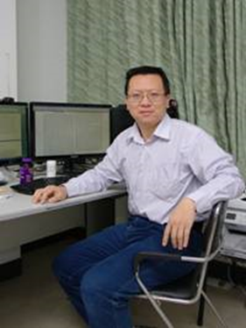

Full Name: Dr. Xiaochu Zhang
Contact number: 0551-63607295
Twitter account:
Linked In account:
Session name/ number: Neurophysiology, Neuroimaging and Radiology
Category: Speaker (online)
Passport Number:

