Abstract

Title: The gut microbiota modulates microglia transcription, spinal cord gene expression, and disease progression in the Sod1 ALS Animal Model

Iyabo Erinkitola
Masters Graduate of Biology Harvard University, Department of Neurology, Ann Romney Center for Neurologic Diseases, Boston, MA

Keywords: Neuroimmunology, Amyotrophic Lateral Sclerosis, Microbiome, Microglia, Sod1.

- Abstract body:
Amyotrophic lateral sclerosis (ALS) is a debilitating neurodegenerative disease in which patients on average die from respiratory muscle paralysis within three to five years of symptomatic diagnosis. With 10% of cases acquired from genetic mutations (familial), an environmental cause is implicated in 90% of ALS cases. The gut microbiome is an environmental factor that may affect neurologic diseases and is a prime target to investigate sporadic causes of ALS. We hypothesize that the gut microbiome may affect important diseases processes in ALS, including altering the formation of protein aggregates and modulating inflammatory responses that contribute to motor neuron death.
We first transferred the gut microbiome from the super-oxide dismutase 1 (SOD1) G93A ALS animal model into wild-type mice to investigate whether the Sod1 microbiota regulates microglial pathways. We found that the SOD1 microbiota treatment upregulates microglia genes associated with RNA processing, lysosomal function, and protein degradation, which is linked with decreased commensal gut bacteria, Akkermansia.
Furthermore, treatment of SOD1 mice with bacterial species shown to be depleted in patients with ALS delayed disease progression and reversed SOD1-related effects in spinal cord gene expression involved with the unfolded protein response and microglial activation. These findings provide evidence that specific microbes can ameliorate disease progression in the SOD1 murine model of ALS and that protective effect is linked with modulating important pathways known to affect ALS.

- Image:
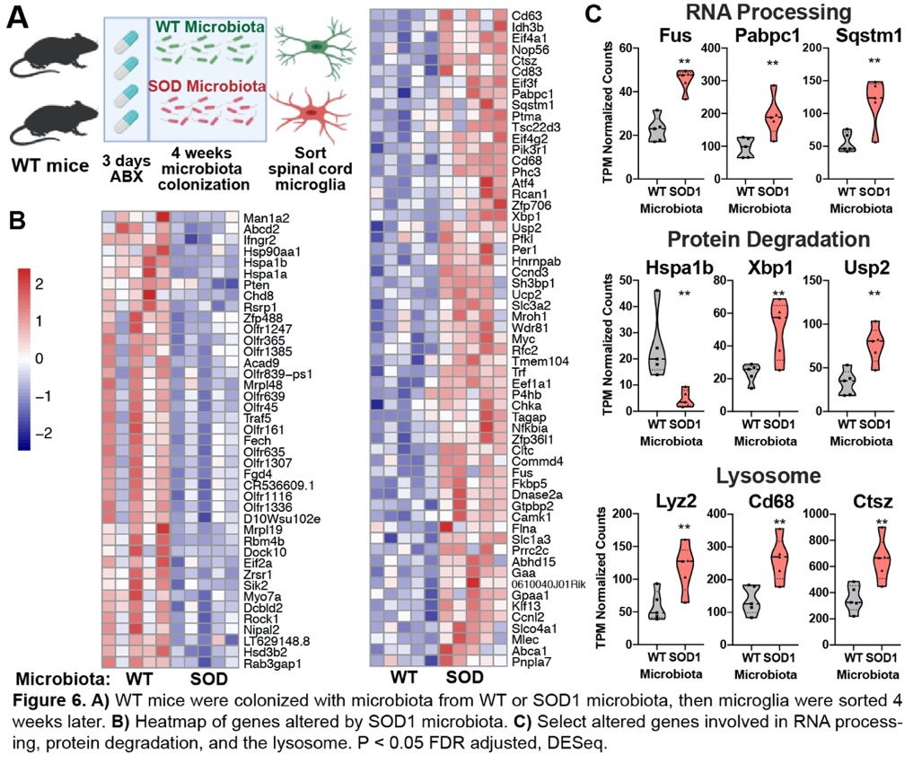

- Reference:
- Blacher, Bashiardes, Shapiro, Rothschild, Mor, Dori-Bachash, . . . Elinav. (2019). Potential roles of gut microbiome and metabolites in modulating ALS in mice. Nature, 572(7770), 474-480.
- Gordon, P. (2011). Amyotrophic Lateral Sclerosis Pathophysiology, Diagnosis and Management. Cns Drugs, 25(1), 1-15.
- Biography:

Iyabo Erinkitola has completed her Master’s Degree from Harvard University in Dr. Howard Weiner’s Neurology Lab at Brigham and Women’s Hospital at Harvard Medical School (Boston).
- Presenting author details



