Abstract
Title: “Music and Memory: research and applications in Therapy”

Alexandru Jon Graur, Ph.D.
Retired; former Associate Professor, University of Torino, Italy; The Hong Kong Polytechnic University, SAR Hong Kong, China PR

Keywords: Memory, science of music, dynamic systems, fractals, quantum transmission of the musical information, Stochastic resonance, Music and Memory.

- Abstract Body (up to 250 words)
Empirically, the role of Music in the mechanics of Memory was known since the dawn of mankind. Recent research shown the validity of these ideas; the physiological and psychological aspects of Music were studied and the results applied in various degrees by music-based therapies; the results are encouraging.

This presentation aims to introduce the issue to scientists in order to elicit further research and application in therapy.
Applications in early detection and cure of Alzheimer, ADD, learning and developmental disturbs will be presented.
Outline:
1. Music: definitions
2. Musical Information: structure of the musical information
3. Neuroscience of Music: an introduction
4. Memory: definitions
5. Models of memory
6. Neuroscience of Memory: Basic Notions
7. Music: dynamic systems, fractals, superposition; quantum transmission of the musical information.
8. Stochastic resonance, Music and Memory.
Specific Approaches:
- Psychological
Musical Meme; Learning; Developmental disorders
- Physiological
BMBO: transmission; re codification; distribution; feed forward; feed back
Neuro plasticity; Storage and retrieval of the information; Alzheimer Disease and music. Early Detection and Prevention test.
- Biological
microtubules resonance; OrchOR
Research Proposals
Conclusions

Reference:
-Bandyopadhyay, A. and others: Induced mitochondrial membrane potential for modeling solitonic conduction of electrotonic signals.
2017, PLOS ONE. 12 [9] () e0183677 10.1371/journal.pone.0183677
-Gaiseanu F, Graur A (2018) Cognitive centers related attitude: Application for an iterative evaluation method in music-based therapy process.
Abstract Book of the 2018 Conference on Science of Consciousness, The University of Arizona,USA
- Graur, J.A.: The Science of Music
2020, Amazon Books
-McDonnell, M.D., Abbott, D.: What is Stochastic Resonance? Definitions, Misconceptions, Debates and its Relevance to Biology
2009, PLOS Computational Biology Journal, Australia
-Vaneechoutte, M. and Skoyles, J.: The Memetic Origin of Language: Modern Humans as Musical Primates
1998, Journal of Memetics - Evolutionary Models of Information Transmission, 2.
http://jomemit.cfpm.org/vol2/vaneechoutte_m.html

Biography:
Retired. Former Project Associate , The Hong Kong Polytechnic University, School of design.
Former Associate professor, University of Turin, Italy (Post graduate School in Health Psychology), Department of Psychology.
Dr. Graur specializes in composition, musicology and clinical music therapy.
He received a graduate degree in Composition-Musicology and a diploma in Medicine (P.A.P. -Physician Assistant in Psychiatry).
Since 1978, Dr. Graur has implemented the Music Integrative Neurotherapy™, an applied Neuroscience method combining Music, Psychiatry, Molecular Biology and Quantum Mechanics.
Former Editor-in-Chief, Journal of Biomusical Engineering (OMICS Group, Medical Sciences Journals).
A professional member of the New York Academy of Sciences.
Dr. Graur has had a long career as a soloist and composer (classical music) with performances and broadcasts of his works in Italy, Germany, Romania, Switzerland and the U.S. and is a recipient of numerous national and international prizes for interpretation
He has presented numerous workshops and seminars to audiences in Italy, China, Sweden, India, South Korea and the U.S.A.
alexjgraur@gmail.com
www.medicamus.simplesite.com

- Presenting author details
Photo
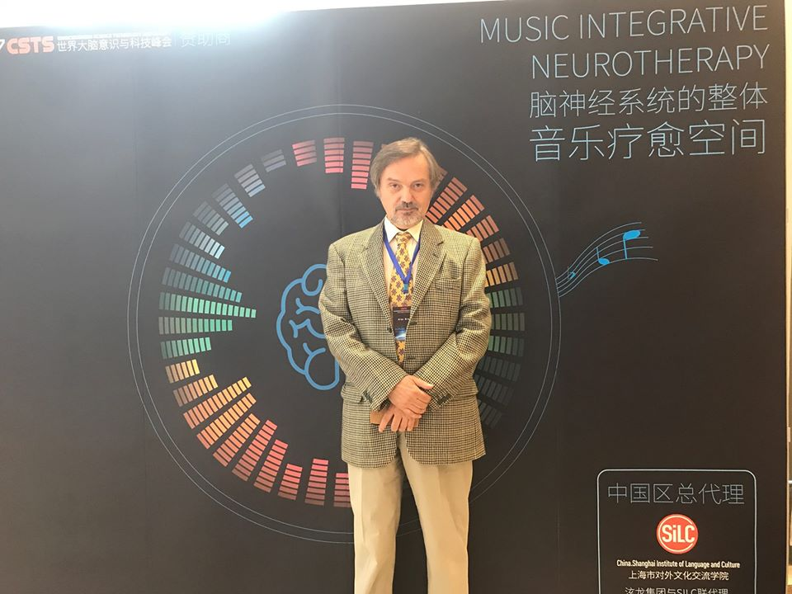
Full Name: Alexandru Jon Graur
Contact number: +39 333 6067 264
Session name/ number: Foetal consciousness and memory
Category: Oral presentation
Passport Number: ITALY/ YA 5643134

