Blockchain in Finance Sector: How will digital assets on blockchain revolutionize the way value is acquired, stored and exchanged
Alexandre Kech, CEO and Co-Founder, Onchain Custodian

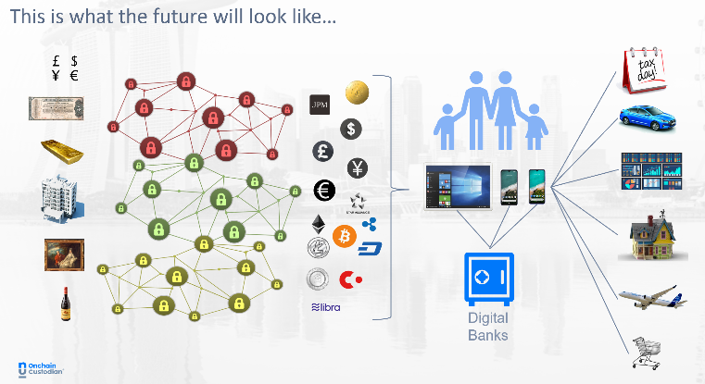
Abstract (300 word limit)
The digital asset industry is like the Internet in 1995; promising but immature both in terms of technology, regulatory framework and industry players. Since the creation of Bitcoin - and more precisely in the last 3-5 years - the industry has done a lot to perfect the technology and to professionalize.
Prominent studies, including some by the OECD, the World Economic Forum and other reputable international institutions, recognize the immense potential of tokenization on blockchain and cryptocurrencies.
While the traditional banking and capital market industry are focused on tokenisation of real assets or the creation of central bank digital currencies, the historical crypto industry continues to promote the use of cryptocurrencies, some backed by fiat currencies, to offer a viable complement to the fiat currency word for the exchange and storage of value.
More and more regulators are now accepting this alternative and are building a proper legal framework around the use of cryptocurrencies and other digital assets in general.
The strength of digital assets is the combination of a public and private key, allowing to guarantee the ownership of an asset of the blockchain cryptographically. The challenge is that if you misplace your keys, you lose your assets.
Billions (USD) of assets have been lost or stolen since the launch of Bitcoin in 2008. Exchanges have suffered the most with heists, sometimes exceeding 400 million USD. Asset managers and private investors have lost considerable amounts through the misplacement of the device storing their keys or the vanishing of an executive having sole access over the assets.
This technological complexity and the cyber and operational risks associated with the management of keys have hindered the growth of the digital asset industry.

Image

Recent Publications (minimum 5)
- Blockchain and Crypto: Will Security Issues Finally Be Dealt With in 2020?, 2020 Jan 09, https://cointelegraph.com/news/blockchain-and-crypto-will-security-issues-finally-be-dealt-with-in-2020
- Picasso, Real-estate, Bitcoin and a lot of money down the drain…, 2019 April 17, https://medium.com/@oncustodian/picasso-real-estate-bitcoin-and-a-lot-of-money-down-the-drain-5b14e2073118
- 1.5 billion USD of crypto stolen or lost, Focus is the solution. 2019 February 04, https://www.linkedin.com/pulse/15-billion-usd-crypto-stolen-lost-focus-solution-alexandre-kech/
- From Bespoke Blockchain-S to standardised blockchain, 2018, https://blockchain.cioadvisorapac.com/cxoinsights/from-bespoke-blockchains-to-standardized-blockchain-nwid-1002.html


Biography (150 word limit)
Alexandre Kech has 20+ years of experience in the capital market industry. From global custody and asset servicing at the Bank of New York Mellon to data standardisation and Head of Securities & FX APAC at SWIFT, Alex has developed a strong post-trade industry leadership experience, extended in recent years to digital assets and blockchain.
Alexandre transitioned to a new challenge in November 2018 when he joined Onchain Custodian as the CEO of the company in charge of building and launching, with Da Hongfei (Chair of the Board), Raymond Cheong (CSO) and El Lee (COO), an institutional digital custody service in Singapore. The solution is live since April 2019.
Onchain Custodian believes in solving non-competitive industry issues though collaboration. Alexandre is the co-chair of the Global Digital Finance (GDF) Custody working group and is the convenor of the ISO TC68 / SC8 / WG3 building an international standard for Digital Token Identification.
Email: alexandre@oncustodian.com

Notes/Comments:

