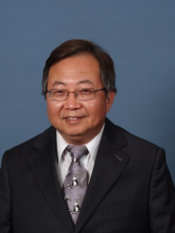
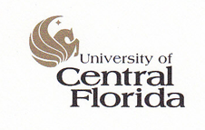

Paste your Logo here
Paste your Photograph Here

Title: Using “EasyMine“ – An Automatic Intelligent Model Building System To Develop Products’ Sequential Recommendation System
Name: Morgan C. Wang

University of Central Florida, Orlando, FL 32816-2370

“EasyMind” is an automatic intelligent model building system. This system has five components: data exploration component, data preparation component, model building/validation/selection component, result automatic generation/data scoring component, and model understanding component.
This system has data preparation component that can fix data problems such as missing values, skewness, and high cardinality. In addition, this system has modeling component that can fine tune the model parameters to build a “better” model. Currently, it supports neural network, decision trees, gradient boosting, rand forest and many regression algorithms. After the optimal model selected, the user can further test the model performance or use the selected model to score new data. This system also attempts to open the black box to allow the user to see some insight of the modeling results such as interaction among predictors, important predictors, how to alter predictors to change the predicted values.
This system has successful used on developing sequential production recommendation system for a big bank in China. Instead of recommending one product to its’ potential customer, this system can select an array of products and recommend these products to potential customers. Experiment results have shown that an average of six fold increasing.

Biography

Morgan C. Wang received his Ph.D. from Iowa State University in 1991. He is the funding Director of Data Mining Program and Professor of Statistics at the University of Central Florida. He has published one book (Integrating Results through Meta-Analytic Review Using SAS Software, SAS Institute, 1999), and over 80 papers in referee journals and conference proceedings on topics including interval analysis, meta-analysis, computer security, business analytics, health care analytics and data mining. He is the elected member of International Statistical Association and member of American Statistical Association and International Chinese Statistical Association.

