Investigation effects of culture media and growth regulators concentration on micro propagation and rooting of Rosa canina
Jajarm V- Kolahdoozian A
- Department Agronomy, Bojnourd Branch, Islamic Azad University, Bojnourd, Iran
- Corresponding Author Email: vahid_jajarmii@yahoo.com
Keywords : Rosa canina , In vitro culture, Cytokinin, Auxin, Regeneration

Rosa canina is one of the flowering shrubs in Iran that grows in range and mountain pastures. This deciduous shrub has high certain antioxidants and fruit is noted for its high level of vitamin C, also is used to make syrup, tea, and marmalade. It is more resistance to drought stress than other flowering shrubs such as Rosa damascene so for production of drought tolerant plants, can be grafted Rosa damascene on the based on Rosa canina. To determining the best hormone compound and medium to micro propagation of Rosa canina (pink flowers), an experiment was done in factorial completely random with 4 replication in Bojnourd Azad University in 2017. The factors included different levels of growth regulators (NAA, BAP, BA, and IAA) in 2 medium types (MS, WPM). Interaction among hormone compound and medium compound was significant. Results showed that BA 2.5 mg/l and 0.25 mg/l of IAA had the most direct regeneration. BA 2.5 mg/l and 0.2 mg/l of NAA had indirect regeneration and it caused to callus. IAA produced the number of root more than NAA. The most percent of branch regeneration, branch numbers and average branch length belonged to BAP 2 mg/l without hormone NAA, BAP 2 mg/l with NAA 0.5 mg/l in WPM medium. Growth regulator application NAA had caused to decrease in branch regeneration percent although it caused to increasing in number and length of branch in medium. The results showed that the highest root belonged to MS medium and IBA 1 mg/l and NAA 1 mg/l.
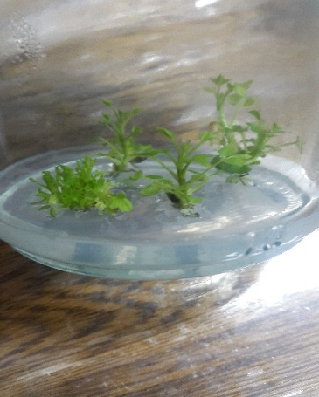

1.Farah, F. 2012. Propagation and growth from cultured single node explants of rosa (Rosa miniature). African Journal of Plant Science, 6(10):221-232
2.Hutteman, C.A. Preece, J.E. 1993. Thidiazuron a potent cytokinin for woody plant tissue culture cell. Tissue and organ culture. 33: 105-119
Vahid jajarmi graduated in plant breeding in 2013 from research and science branch, azad University- Tehran. He is faculty member of bojnourd branch, azad University. He has published more than 15 papers in reputed journals.

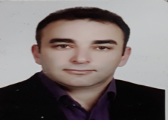

Full Name: vahid jajarmi
Contact number: 00989151865953
Session name/ number: Plant & Agricultural Biotechnology
Category: (Oral presentation/ Poster presentation)
Passport Number: Y37581564

