EFFECT OF CDNAC AS A NOVEL DRUD DESIGNED AND TARGETED MOLECULAR GENES AGAINST BREAST CARCINOMA.
Shaymaa Abdelatie Abdelrazik , Department of Biochemistry and Clinical Biochemistry, Benha University.Egypt.
ABSTRACT
DMBA and iron sulphate induced breast cancer by mechanism which interact with DNA and cause genetic changes; this mechanism accelerates the cell cycle progression and induces the abnormal cell proliferation. N Acetyl cysteine and Cadmium in complex form has been shown to confer various biological effects, anticancer, enhance immune system , regulate cell cycle and prevent drug resistance. The present study was undertaken to evaluate the possible effect of [Cd+NAC] and possess ability of the complex with dose 12mg\ kg.b.w against [DMBA + FeSO4] carcinogenesis with dose 80mg\kg.bw (Gallo et al.,2001) at the beginning of the experiment and another dose of feso4 (50/umol\kg x 2 \weeks)( Bhalchandra et al., 1997) until detecting solid tumor after three monthes. The results indicated that DMBA+FeSo4 induced Breast cancer in female rats which cause significant increase of of CD44, P21. CYCLIN D1, over expression of cas3, cas 9 and highly replicated cell cycle at S phase genetically, invasive adenocarcinoma histopathologically. While, treating with (CdNAC) causes cas 3, cas 9 gradually increasing then decrease to normal control values. Enhancement of immune system completely by normalizing CD44 and prevent drug resistance , regulation of cell proteins across p21 and cyclin D1 and causes arrest in S phase. Also, from Histopathology, occued therapy effect. From these data provide direct evidence for the role of cdmium n acetyl cysteine complex as target drug for breast carcinoma in rats.
Key Words: Complex , caspase 3, 9.P21, Cyclin D1, CD44.

Images:

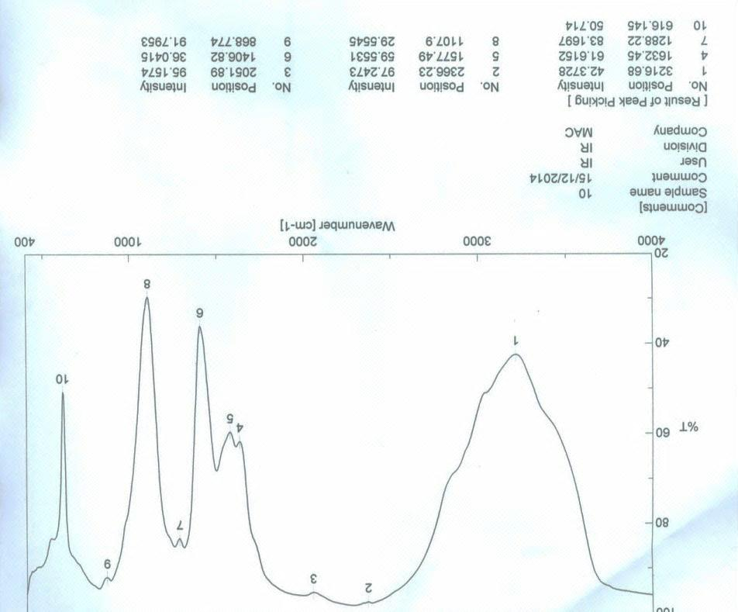
Fig.1. IR of complex[ NAC+Cd]

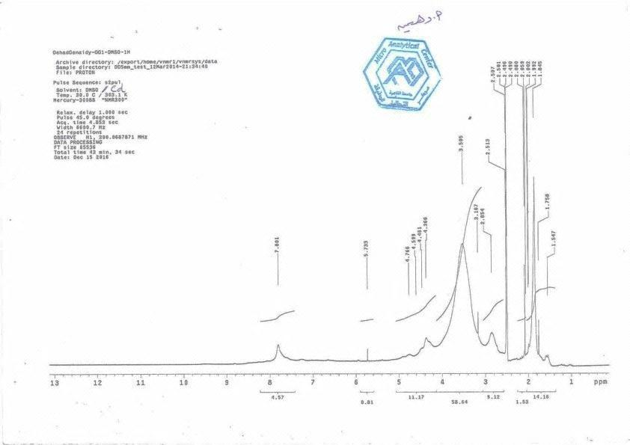
Fig. 2. NMR of Complex [NAC+Cd]

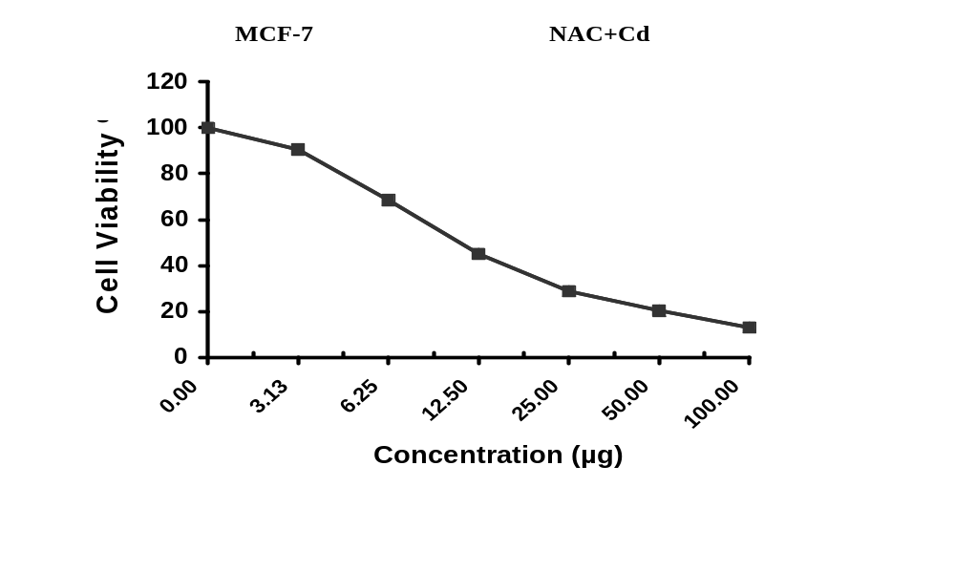
Fig.3. Evaluation of cytotoxicity complex of N Acetyl cysteine +Cadmium against MCF-7 cell line.

Refernces:
- Gallo D, Giacomelli S, Cantelmo F, Zannoni GF, Ferrandina G, Fruscella E, Riva A, Morazzoni P, Bombardelli E, Mancuso S, Scambia G.(2001). Chemoprevention Of DMBA-Induced Mammary Cancer In Rats By Dietary Soy. Breast Cancer Res Treat. 69(2):153-64.
- Bhalchandra A. Diwan , Kazamirez S. kaspprzak and lucy M. Andewrson.(1997). Promotion benz[a]anthrathene 0initiated mammary carcinogensis by iron in female spargue Dawley rats. Carcinogensis. Vol.18.no 9.pp.1757-1762.

Biography

B.Sc. degtree.2007. Diploma of Biochemistry,2008, Diploma of Microbiology,2009, Master degree in Biochemistry and Clinical Biochemistry, 2014, PHD in Biochemistry and Clinical Biochemistry in 2018.

Work shops:

Stem cell, Nanotechnology. Flowcytometery.

