Title: Antimicrobial potential assessment of Pakistani wild Plants
Dr. Kausar Malik¹, Mr. Husnain Qamar², Mr. Muhammad Ali Tajwar³
- Department of Molecular Biology, National Centre of Excellence in Molecular Biology (CEMB), Punjab University Lahore, Pakistan.
- Department of Molecular Biology, National Centre of Excellence in Molecular Biology (CEMB), Punjab University Lahore, Pakistan.
- Department of Biotechnology, Mirpur University of Science and Technology (MUST) AJK, Pakistan.
- Abstract
Screening of medicinal plants is a pre-requisite to analyze their therapeutic potential activity and it can lead the isolation of new bio-active compounds in these plants. Methicillin-resistant Staphylococcus aureus (MRSA) is responsible for skin infections in human. MRSA can infect both non-surgical and surgical wounds. In case of surgical infection, it can be spread from site of infection to other organs of the body and cause serious health problems. In humans, Enterococcus faecalis cause different types of infections like meningitis, septicemia, endocarditis and urinary tract infections. Root canal-treated teeth are more prone to infection by this bacterium. It is more pathogenic in hospitals as it acquires the resistance against different antibiotics. S. pneumoniae is not only the primary reason of pneumonia but is also responsible for other diseases like pericarditis, meningitis, bronchitis, brain abscess and osteomyelitis. S. pyogenes cause both systemic diseases and skin infections. In the beginning, infection occurs on the skin or in throat then spread. These microbes are developing resistance against antibiotics due to overuse of antimicrobial drugs. Because of this resistance treatment is becoming difficult. Moreover, the available antibiotics are also having serious adverse effects. In this scenario, there is a need to discover the alternative antimicrobial drugs for infections caused by above bacteria that should be efficient and cost effective. In this study, two wild plants were collected from northern area (sakardu) of Pakistan and extracts were prepared in methanol. Anti-bacterial activity of these extracts at various concentrations were assessed against MRSA, Enterococcus faecalis, S. pneumoniae, and S. pyogenes by disc diffusion method. One of them was effective against only S.pyogenes. The other one is effective against all four bacteria. The plant which exhibits antibacterial activity against four bacteria is locally used as a medicine but the data is not reported. Further analysis of active compounds and complete information of this plant is in progress. These potential antibacterial plants may be used in the development of efficient and cost-effective drugs against above mentioned bacteria after further research in future.
- Image of plant 1
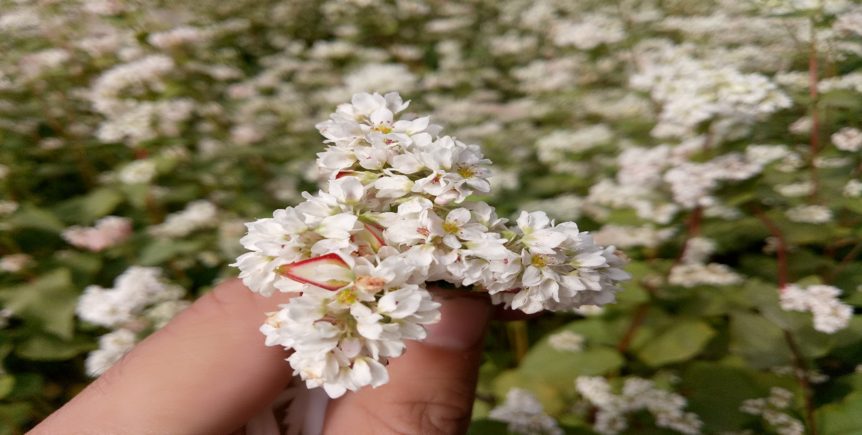

- References:
- Ivana S. Čabarkapa1*, Ivana J. Sedej1, Marijana B. Sakač1, Ljubiša Ć. Šarić1, Dragana V. Plavšić1 1Institute for Food Technology, Novi Sad, Serbia
- . Dracocephalum nutans L., Sp. Pl. 596. 1753. Benth. in DC., Prodr. 12: 400. 1848; Hook. f., l.c. 665; Mukerjee, l.c. 137. 1940; Hedge in Notes Roy. Bot. Gard. Edinb. 27: 154. 1967; Stewart, Ann. Cat. Vasc. Pl. W. Pak. & Kashm. 611. 1972; Kachroo et al., Fl. Ladakh 128. 1977; Adylov et al. in Vvedensky, Conspect. H. As. Med. 9:64. 1987
- Kongelige Danske Videnskabernes Selskabs Skrifter. Naturvidenskabelig og Mathematisk Afdeling, ser. 8 1: 43. 1954. (Kongel. Danske Vidensk. Selsk. Skr., Naturvidensk. Math. Afd., ser. 8,)
- Biography:
Muhammad Ali Tajwar. Currently, I am a student of BS Biotechnology in Mirpur University of Science and Technology AJK (Pakistan). In my career I have always looked for entrepreneurial opportunities. I aim to work as a researcher and convert my researches into sellable ideas, win funds, and create company growth to be able to come back to the innovation with a proud earning.
- Presenting author details


Full Name: Muhammad Ali Tajwar
Contact number: +923085149965
Twitter account: https://twitter.com/TajiiRao
Linked In account: https://www.linkedin.com/in/m-ali-tajwar-a7428b11a/
Session name/ number: Session 2014-18 (Final Semester)
Category: (Oral presentation/ Poster presentation): Oral Presentation

