Ministry of Higher Education and Scientific Research, Egypt.
Theodor Bilharz Research Institute (TBRI), Giza.
Technology Innovation Commercialization Office (TICO)

Theodor Bilharz Research Institute (Innovative Therapeutic products and health tools)
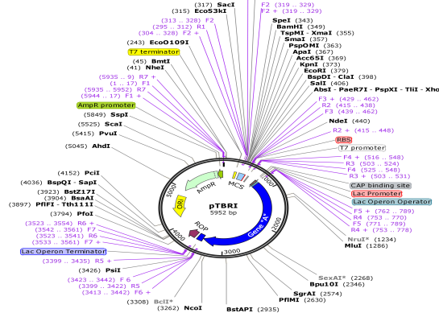

Innovative Therapeutic products
1-Construction of plasmid vector for protein expression in prokaryotic cells Named as (pTBRI), Innovative plasmid allows the user to cloning and expression of genes to be the first step in the production of therapeutic proteins.
(Patent# 2162/2012) (A).

2-New formulation of praziquantel using nanotechnology to achieve greater availability and higher efficiency against schistosomiasis.
(Patent# 1708/2014)

3-Research and Development for production of high efficacy recombinant human IFN-α2b conjugated with multiply branched high molecular weight PEG polymer for treatment of HCV infected patients. The developed production process included feed batch fermentation, purification, solubilization and refolding of protein to its native 3ry structure and purification followed by Pegylation of the purified protein and purification of monopegylated IFN-α2b (Patent# 521/2016).

4- Research and Development for production of high efficacy recombinant Human Growth Hormone. (rhGH) is approved for the treatment of multiple human diseases resulting from hGH deficiency. rHGH has been produced in a system for production of recombinant proteins using E. coli and pTXB1 expression system, a single band at 22 kDa. The purified protein identity was verified using mass spectrometry (B).

Innovative Health tools

1- A new design of intubating laryngeal mask airway (I-LMA) in cases of difficult intubation. It contains a bundle of tubes with multiple holes in their walls to permit gas flow freely. (Patent# 2013081277/2013) (C)

2- A device for anesthesia using distilled-water injector to get rid of carbon dioxide, physically to be added as an alternative to the caustic soda lime used in regular anesthesia devices. (D)

3- Manufacturing of vertical-flow strip nano-chip kit with graphine nanoparticles and evaluating its role as a simple, rapid, low-cost, sensitive, specific, and user-friendly diagnostic tool for diagnosis of multiple parasitic diseases (e.g. schistosomiasis, fascioliasis, filariasis and malaria) in one kit. (E)

4-A program for the diagnosis of parasites through the Internet based definition and diagnosis of parasites using a different website supported all forms and types of parasites diagnosis. It assists all medical, scientific and educational frameworks in the diagnosis of parasites.

(A)

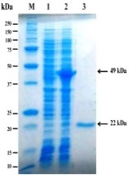
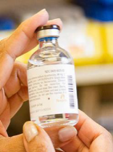
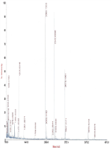
(B)

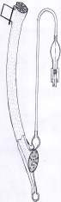
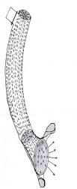
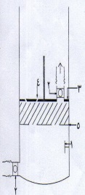
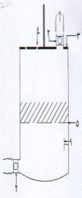
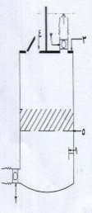

(C) (D)

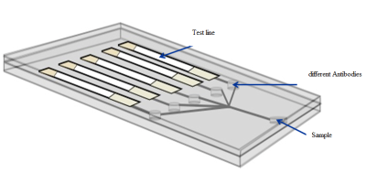

(E)

Biography
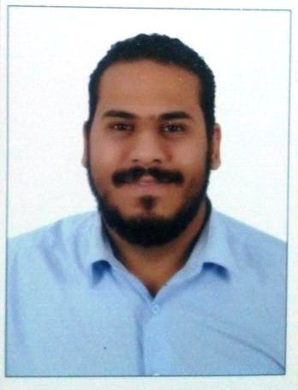
Dr. Ismaeil Saad Research Scientist at Theodore Bilharze Research Institute, M.Sc. of Biotechnology-Cairo University Egypt. Dr. Ismaeil Saad has extensive experience in biotechnology, Bioinformatics and pharmaceuticals with small start-ups and mid-sized firms for more than 7 years. He presented and has been invited to several national and international conferences and Academic Institutions to present his work. Dr.Saad is one of the founders of TICO office In TBRI and member of the Technology Transfer Office since 2015.he is very well experienced in product licensing, business development and market access.
Presenting author details
Dr. Ismaeil Saad, Research Scientist at Theodore Bilharze research Institute, Egypt.
M.Sc. of Biotechnology-Cairo University Egypt.
Kornish El-Nile – Warak El Hadar- P.O 30 Imbaba – Giza, Egypt. Postal code 12661
Mobile: +201027400806
E-mail: ismaeilmohamed304@gmail.com
Website: http://www.tbritico.com/

