James M. Sulzberger, 2nd speaker (TBA)
With implementation of the biosimilars approval pathway, providing more affordable biologic drug products have become closer to a reality for the United States. Although several biosimilar versions of innovator biologics have already been approved, regulatory barriers still continue to be shaped. Past regulatory barriers, a primary challenge to produce a biosimilar version of an innovator is for the cost to be a fraction of the original process which allows this biosimilar to be introduced to the global market for an ultra-competitive price, driving market competition within and between different biologic treatment options. In the development of a manufacturing process, up to 80% of the cost comes from downstream operations, so use of modern chromatography media to meet safety, purity, and potency requirements are a direct way to impact cost of goods when developing a manufacturing process for a biosimilar. During this workshop, process modernization of a bacterially expressed protein from a four step purification process, to a two-step purification using modern chromatography media process will be discussed.
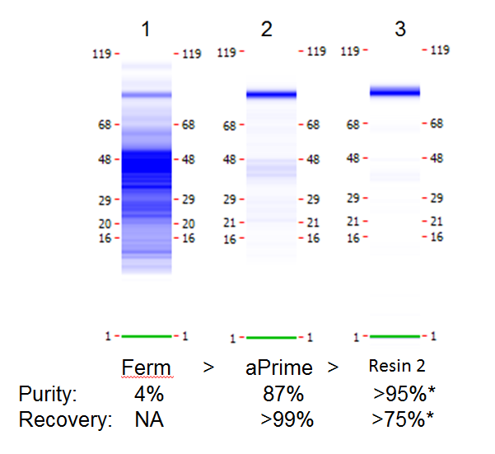
Additionally, a second case study will be presented within this downstream workshop will feature optimization of an alternative purification method for a biosimilar version of Adalimumab, with evaluation of process productivity to a legacy process.

SPEAKER BIO:

James M. Sulzberger is an American downstream purification scientist possessing an analytical development and cGMP background, with a specific interest in the modernization of biomolecule purification processes using modern membrane and chromatography technologies. He obtained his MS in Chemistry with a focus in Separation Sciences in 2017 from Northeastern Illinois University and a BS in Biology from the University of Illinois Chicago in 2007. Jim joined Bio-Rad Laboratories in 2016, and is currently a Process Chromatography Consultant, where he uses his knowledge in downstream process development to suggest and develop purification processes with clients facing unique biomolecule purification challenges. Prior to Bio-Rad, Jim was a Chemist at Celgene Corporation from 2008-2012 where he performed FDA investigations and developed, validated, and transferred HPLC and UPLC methods for the analysis of nanoparticle albumin bound (nab) paclitaxel based metastatic breast cancer therapeutic, AbraxaneTM. In 2012, he joined Adello Biologics as a Scientist III (formerly known as TPI), where he worked on development of downstream process and analytical development for biosimilar versions of filgrastim (GCSF), pegfilgrastim, interferon beta-1b, adalimumab, and rituximab. Most recent to joining Bio-Rad, Jim was a Senior Scientist -Purification at Pall Corporation from 2013-2016. While at Pall, he performed process development studies and scale-up support for tangential flow filtration, membrane filtration, virus filtration, membrane chromatography, chromatography for antibodies, recombinant proteins, plasma proteins, viruses, and virus like particles from a diverse array of expression systems such as bacterial, mammalian, plant, plasma, and transient transfection virus systems. Jim holds 1 patent in downstream processing of therapeutic proteins.

