Abstract

Title: Development of Real-time and Label-free Immunoassay Chips by Using IGZO(Indium Gallium Zinc Oxide)-TFT(Thin Film Transistor)-based Biosensors.

Dongchen Zhu¹, Grant Cathcart², Satoshi Ihida³, A. Tixier-Mita², Yasuyuki Sakai¹, Kikuo Komori⁴

¹Department of Chemical System Engineering, University of Tokyo, Tokyo, Japan
²Research Center for Advanced Science and Technology, University of Tokyo, Tokyo, Japan
³Sharp Co. , Tokyo, Japan
⁴Department of Biotechnology and Chemistry, Kindai University, Hiroshima, Japan

Keywords: Iimmunoassay, Anti-human albumin, Impedance, IGZO, TFT.

- Abstract Body
Thin film transistor (TFT) technology has been widely utilized in display, but seldomly been used in biosensing in spite of its priority in relatively high electron-mobility, economic-friendly manufacturing and lower energy consumption. Here we immobilized anti-human albumin (anti-HAlb) and examined to directly detect human serum albumin (HSAlb) molecules at the surface of an IGZO (Indium Gallium Zinc Oxide)-TFT array with 400 transistors densely from impedance measurements[]. DC and AC voltages were applied on the neighboring two gates and sources, respectively. After the recognition of HSAlb by anti-HAlb, the output current at 1000Hz increased in a pH 7.4 phosphate buffer solution (PBS) due to changes in electrostatic capacitance and ion mobility at the ITO (Indium Tin Oxide) surfaces as shown in Fig. 1. We also successfully observed the output current response even at the low level of 20 ng/ml for albumin molecules. Furthermore, higher diluted PBS demonstrates larger magnitude of output signals after antibody-antigen reactions, as shown in Fig. 2, probably due to lower ionic strength. The other reason could be pH value of higher diluted PBS is much closer to the isoelectric point of albumin and its antibody, where both of them are approximately of electrical neutrality. In the future, the present IGZO-TFT biosensors are promising for a label-free multiple immunoassay method.
- Image:

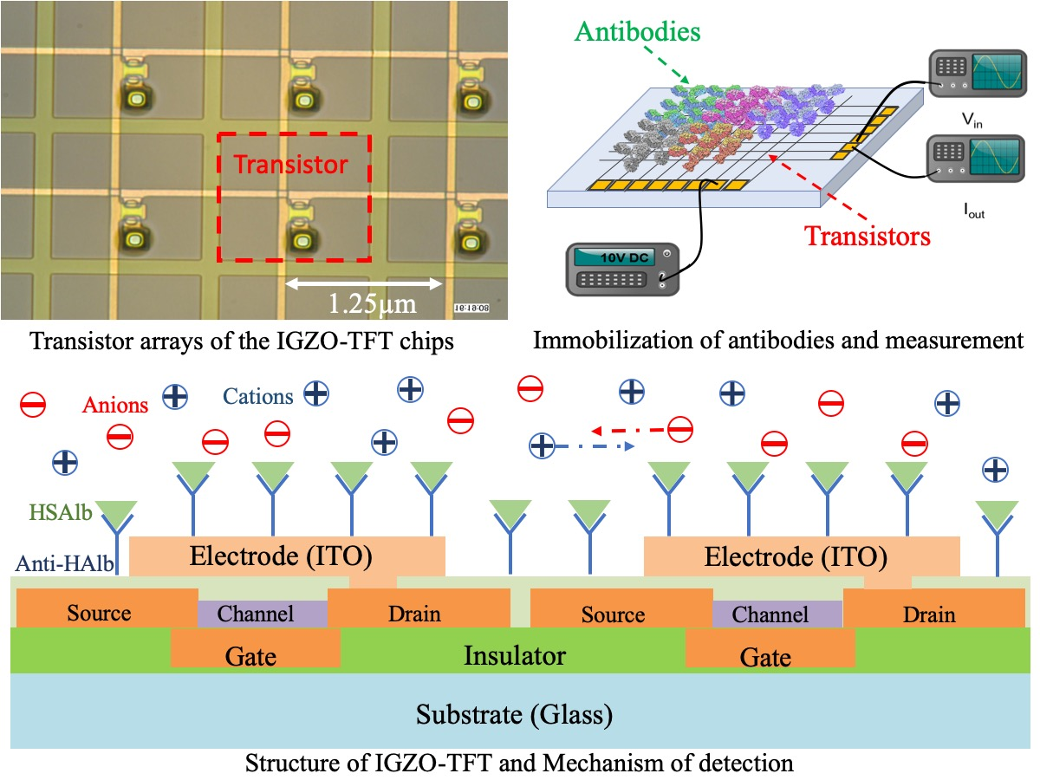
Fig.1 Illustration of IGZO-TFT function and mechanism of impedance change

Fig.2 Dependency of intensity of antibody-antigen binding signals on diluted PBS (Original 0.01M)

- Reference:

- Tixier-Mita, A., Segard, B.-D., Kim, Y.-J., Matsunaga, Y., Fujita, H., & Toshiyoshi, H. (2015). TFT display panel technology as a base for biological cells electrical manipulation - application to dielectrophoresis. In 2015 28th IEEE International Conference on Micro Electro Mechanical Systems (MEMS) (pp. 354–357). IEEE.
- Wu, C. C., Pan, T. M., Wu, C. S., Yen, L. C., Chuang, C. K., Pang, S. T., … Ko, F. H. (2012). Label-free detection of prostate specific antigen using a silicon nanobelt field-effect transistor. International Journal of Electrochemical Science, 7(5), 4432–4442.
- Yang, T.-H., Chen, T.-Y., Wu, N.-T., Chen, Y.-T., & Huang, J.-J. (2017). IGZO-TFT Biosensors for Epstein-Barr Virus Protein Detection. IEEE Transactions on Electron Devices, 64(3), 1–6.

- Biography:
Dongchen Zhu has completed his bachelor at the age of 222years from Shanghai Jiaotong University, China and currently he is pursuing master studies from Department of chemical system engineering, Tokyo University, Japan.
- Presenting author details


Full Name: Dongchen Zhu
Contact number:+81 07039957978
Twitter account:
Linked In account:
Session name/ number:1, 2, 3 and 4
Category: Poster presentation
Passport Number:E67529091

