Nanoparticles Enhanced Optomagnetic

Microfluidic Biosensor
Chunxiu Liu, Haoyuan Cai, Ning Xue*, Zhimei Qi*
State Key Laboratory of Transducer Technology, Institute of Electronics, Chinese Academy of Sciences (IECAS), Beijing, China

Abstract (300 word limit)
Ultra-sensitive and rapid detection of the biosensor is of great significance and urgent demand in drug detection, environmental safety, food hygiene and medical diagnosis. The surface plasmon resonance (SPR) biosensors are advanced optical label-free technology. This method is based on the detection the changes of refractive index by the capture of target analyte on the gold film surface by attached biomolecular recognition elements, and this has been used in medical diagnostics, environmental protection. The SPR biosensor has many advantages, such as anti-electromagnetic interference, high sensitivity, no fluorescence labeling, and real-time. Yet Conventional SPR is difficult to detect small molecules directly and the sensitivities are not enough to ultra-low concentration substances. Some high refractive index particles and interacting biomolecule were introduced for amplification the signal. In this study, a three dimensional nanostructure was formed in the SPR immune sandwich reaction with the Au composite nanoparticles on the surface of the SPR chip. In the SPR mode, the energy of the plasma field is strongly confined to the surface of the metal structure. The coupling between the propagating plasma and the local plasma forms a remarkable enhancement of the three-dimensional dynamic plasma field of the sandwich layer. This field is fully overlapped with the target molecules, interacting, producing the local light field of the anti-interference specific signal, and realizing the ultra-high magnification signal and fast enrichment of the optical nonlinearity. In this study, a series of concentrations of CRP (C reactive protein) were used for pattern detection, and the spectral shift signals caused by capture antibody and capture antibody- AuNPs were compared and analysed.

Image
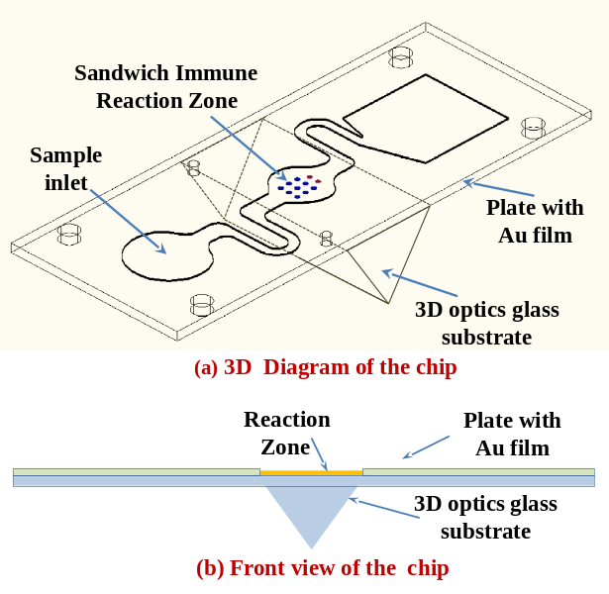
Figure 1: The design diagram of the microfluidic chip

Recent Publications (minimum 5)
- Barnes WL, Dereux A, Ebbesen TW (2003), Surface plasmon subwavelength optics. Nature 424: 824-830.
- Szunerits S, Spadavecchia J and Boukherroub R (2014), Surface plasmon resonance: signal amplification using colloidal gold nanoparticles for enhance sensitivity. Rev Anal Chem 33(3): 153-164.
- Liu CX, Xu CH, Sun JH, Xue N, Jia J, Qi ZM, Li T, Wang J (2018), Portable optomagnetic microfluidic chip system. Nanoscience and Nanotechnology Letters 10(4):570-574.

 Biography (150 word limit)

Dr. Liu Chunxiu is mainly engaged in the fabrication of biosensors and the detection of biomedical information. The related research on microfluidic chips was carried out and a rapid detection platform for photomagnetic chips was built. The immobilization method of sensitive membrane for multi-parameter micro-sensor is studied, which provides a new method for the development of in-situ biosensor.
Professor Qi Zhi-mei leads a team for developing biochemical sensors based on optical waveguides and SPPs.
Email: cxliu@mail.ie.ac.cn, zhimei-qi@mail.ie.ac.cn,
Tel: 8610-13683232611

Notes/Comments

