Design of disposable nanofiber-based biosensors for ultra-sensitive glucose detection

E. Merve SAHİN, Pinar CAMURLU*
Department of Chemistry, Akdeniz University, 07058 Antalya, Turkey

*E-mail: pcamurlu@akdeniz.edu.tr

Abstract
Diabetes (diabetes), which is one of the leading diseases of the age, is a type of disease that plays the first role in the formation of many deadly diseases and is very common all over the world. Diagnosis of this disease requires precise determination of blood glucose concentration. Electrochemical biodetection is one of the most common methods used in recent years for the determination of glucose in various samples, including fruit juices, urine, blood serum. Inclusion of redox mediators in the design of glucose oxidase-based amperometric biosensors has become very popular. Moreover, utilization of nanofibers was found to be effective for improving the performance of most sensors thanks to their large surface area. The main purpose of this study is to examine the use of neutral red-doped polyacrylonitrile nanofibers (PAN-NR-NFs) as a suitable immobilization matrix on disposable screen-printed carbon electrodes for glucose detection in a sensitive and reliable manner. Compared to literature the biosensor revealed superior analytical performance especially in terms of LOD, where the sensitivity, detection limit and linear range of the developed biosensor was calculated to be 99.19 µA mM⁻¹ cm⁻², 0.068 µM and 0.01-0.6 mM, respectively. To test its commercial applicability, juice samples ensured from various brands were used as real samples where the calculated recovery values were close to 100%.

Graphical Abstract
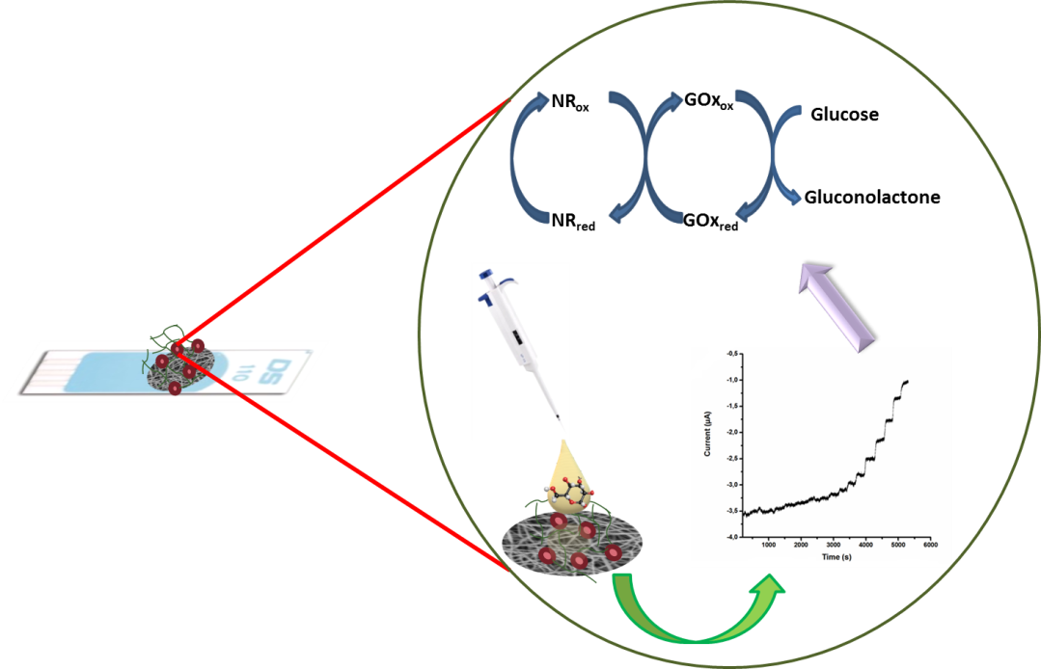

Keywords: Screen printed carbon electrodes, Mediator, Nanofiber, Glucose Biosensor

