ABSTRACT: What is biosensor, Working of biosensor, Principal of detection by biosensor , main parts of biosensor and importance of biosensor.
Engr Faiza Niazi
Student,ZUFEST
Karachi,Sindh
faizaniazi712@yahoo.com

A device that incorporated with biological sensing element either connected to or integrated within a transducer is a biosensor. In which biological sensing elements are like enzyme substrate, antibody antigen and receptor hormone complex. Biosensor produce quantitative analysis of many biological substances by converting their actions into measureable signals. In the working process the bio element usually the bio receptor is interact with the transducer and then the signal operate output which by amplifier transfer into the electronic display for quantitative analysis. There are many principal for detection of biological element by the biosensor that mainly includes piezoelectic (measure change in mass), electro-mechanical (measure change in electric distribution), optical (measure change in light intensity), calorimetric (measure change in heat) these principal are basically the transducer which are making the effect work of biosensor for detections. There are three main components of biosensor that are biological element, transducer and detector. The biological element are usually the enzyme or a receptor, transducer are usually a device that convert one form of energy into another form of energy and detector are usually made of electronic components usually of amplifers, analog to digital convertor and with specific algorithm system to identify the display value.[1] Biosensors are very important for next generation. It mainly give us the situations and conditions regarding the subject chemical and physiological behaviours physical parameters aspects. It helps us to monitor the parameters of subject under not only by the device but also in wireless easy communications of the population regarding any issues in the health of the individuals.[2] Biosensors can also used in security purposes and other like laboratories that regards the electronics to make the things easy and fast to operate and handle and determine the conditions of any subjects.[3] There are many kinds of biosensors are available in the markets of electronics for different examine of parameters with under the influence of change in energy from one form to another.
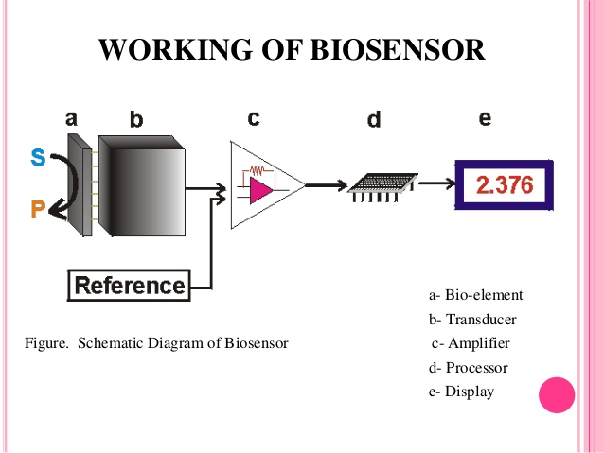


Faiza Niazi
Contact no:92 3242129636
Linked account:Faiza Khalid

Reference:
[1] www. slideshare.net
[2] www.himss.org/what-role-biosensors-next-generation-health-care-0
[3]newtech.tabrizu.ac.ir/Files/Biosensor%20seminar(2).ppt
I am successfully doing my bachelors in biomedical engineering and I am in the third year in the Ziauddin University faculty of engineering science and technology. I have done many courses regarding quality control management , ISO 9001, MATLAB, C++ language and Andriod controlling programs, Autocad , Artifical Intelligence and have done some projects on related to my field. And I written 2 abstracts regarding my field in the tech for life journal and health asia expo Pakistan journal.
I did my two interships on hospitals one is on DOW hospital and one is on the Patel hospital.
Name: Faiza Niazi
Contact no: 92 3242129636
Linked In account: Faiza Khalid
Category: (Eposter presentation)
Passport Number: HA9916411

