A Novel Poly-crystalline Silicon Nanowire Field-Effect Transistor Biosensor for Potential Biomolecules Screening

YANKUBA B. MANGA¹, JIA-YANG HUNG², HAW-MING HUANG³, WEN-LUH YANG⁴, CHI-CHANG WU^{4,*}
¹Graduate Institute of Biomedical Materials and Tissue Engineering, College of Biomedical Engineering, Taipei Medical University, Taiwan
²Graduate Institute of Nanomedicine and Medical Engineering, College of Biomedical Engineering, Taipei Medical University, Taiwan
³Graduate Institute of Biomedical Optomechatronics, College of Biomedical Engineering, Taipei Medical University, Taiwan

⁴Department of Electronic Engineering, Feng Chia University, Taichung, Taiwan
*Corresponding Author: C.-C. Wu E-mail: half1997tainan@hotmail.com

Keywords: Poly-crystalline, Nanowire, Field effect transistors, Biomolecules, Biosensors, Side-wall spacer, Early screening, p16^{INK4a}.

- Background:
The Screening of biomolecules in wide spectrum applications like life science and medical diagnosis is a critical concern. Thus, it is a necessity and concerned for the diagnosis and direct monitoring of cancers, diseases, flu and emergency outbreak like Ebola, Dengue viruses, especially in the developing nations. Therefore, with an indispensable need for developing novel detection mechanisms with high sensitivity and specificity is paramount, since the conventional mechanisms require lengthy time, with less sensitivity, specificity, and high-cost burden for developing nations. Among several approaches,¹⁻⁴ our silicon nanowire field-effect transistors (SiNW FET), possess several advantages over the conventional approaches, in term of label-free, real-time response, high sensitivity, and specificity. Thus, through the integration of electronics, semiconductors, biotechnology, and biochemistry, the biosensor chip can be a life-saving sensor/chip which could be developed as a personal portable detection device. The exposure of the nanoscale on silicon on insulator (SOI) wafer as a substrate for single crystal silicon nanowire was ignored, and our side-wall spacers technique was utilized to fabricate a poly-crystalline SiNW. This approach eliminates the use of SOI wafers, avoiding exposure of expensive nanoscale, and significantly reducing production costs without affecting device properties. With our fabrication technique compatible with the commercially available semiconductor process technology.

- Aims:
To explore our fabricated biosensor as a highly sensitive and selective, label-free and real-time for cancer screening like p16^{INK4a}. An essential biomarker protein which is highly correlative with cervical cancer, and a target for early cancer diagnosis.

- Materials and Methods
The side-wall spacer technique was employed to fabricated the Poly-SiNW FET. Semiconductor analyzer (HP-4145) and probe (sensing) station used to analyse the device electrical properties and bio-sensing. For bio-sensing, the sensor undergoes primary treatment for impurity and then immobilized with biomolecules on the nanowire surface ⁵ by hybridization to carry out the detection of cervical cancer-related protein p16^{INK4a}.

- Results
Fig. 1 shows the electrical properties of the Poly-SiNW FET. It is found out that, when the Poly-SiNW was measured in aqueous solution, its electrical properties was much stable similar to those of monocrystalline-SiNW. This is as a result of passivation defects in Poly-Si by hydrogen-related species. Nonetheless, when the surface of the nanowire was chemically modified with p16^{INK4a} antibody, the corresponding p16^{INK4a} antigen was able to be detected by this receptor, and the detection level could be detected up to 100 fg/ml as depicted on Fig. 2.

- Conclusions
The selective surface receptor was successfully modified with the p16^{INK4a} antibody on the nanowire surface, with corresponding biomolecules. Thus, able to observe the reaction between antibody and antigen by the change of the electrical signal. The change in the electrical signal of the device caused by the reaction of the positively or negatively charged biomolecules with the antibody-modified on the surface of the nanowire demonstrates the ability to bio-sensing by our device. Thus, could serve as a potential device in clinical application, as a biosensor.
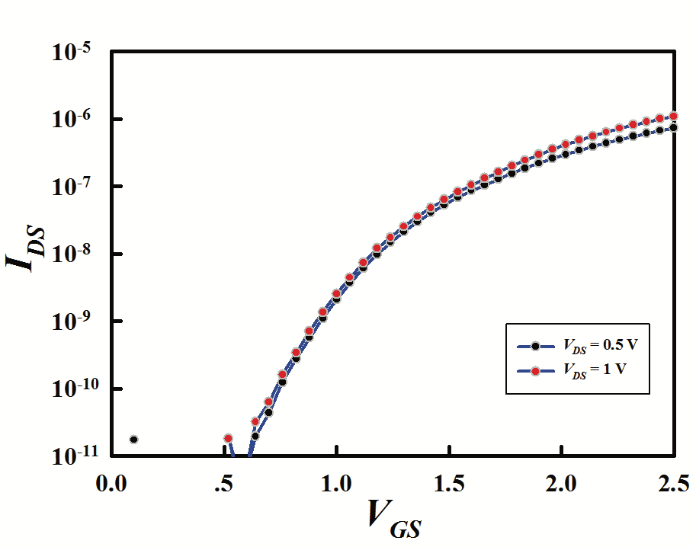 | 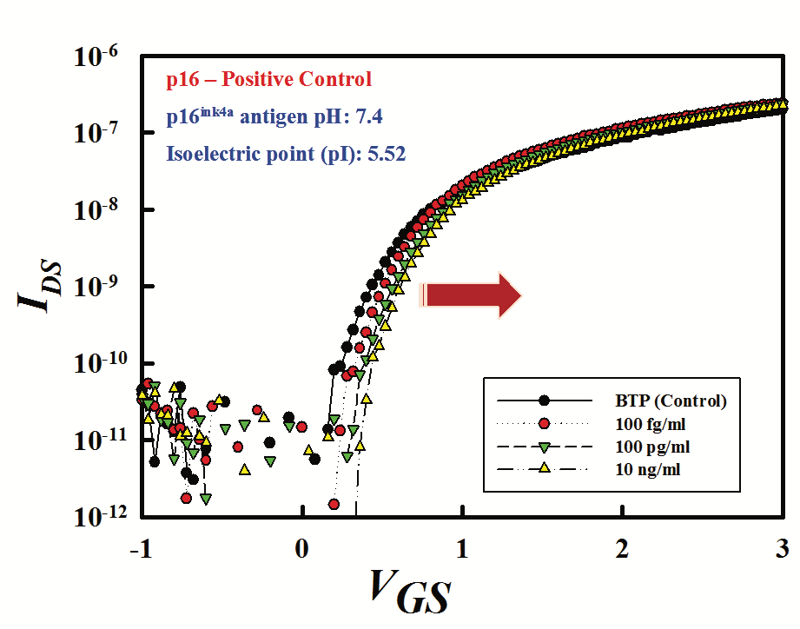
Fig. 1: I_{DS}V_{GS} properties | Fig. 2: p16^{INK4a} Screening

- Reference:
1 Richter, M.M., 2004. Electrochemiluminescence (ecl). Chemical Reviews, 104: 3003-3036.
2 Patton, A., M.C. Mullenix, S.J. Swanson and E. Koren, 2005. An acid dissociation bridging ELISA for detection of antibodies directed against therapeutic proteins in the presence of antigen. J. Immunol. Methods, 304: 189-195.
3 Liang, M., S.L. Klakamp, C. Funelas, H. Lu, B. Lam, et al., 2007. Detection of high-and low-affinity antibodies against a human monoclonal antibody using various technology platforms. Assay Drug Dev. Technol., 5: 655-662.
4 Guo, X., 2012. Surface plasmon resonance based biosensor technique: a review. J. Biophotonics, 5: 483-501.
5 Manga, Y.B., F.-H. Ko, Y.-S. Yang, J.-Y. Hung, W.-L. Yang, et al., 2018. Ultra-fast and sensitive silicon nanobelt field-effect transistor for high-throughput screening of alpha-fetoprotein. Sensor. Actuat. B. Chem., 256: 1114-1121.

- Biography:
Mr. Yankuba B. Manga was born in The Gambia, West Africa. He obtained his BSc. Degree in Electronic Engineering, MSc by research from National Taipei University of Technology and Taipei Medical University, Taiwan (ROC) in 2010 and 2013 respectively. He is currently pursuing his Ph.D. Degree in Biomedical Materials and Tissue Engineering at Taipei Medical University, focusing his research on Biomedical Sensors for biomolecules sensing (bio-sensing). In short, currently focusing on the nano-wire/-belt biosensors and nanotechnology.
- Presenting Author Details


Full Name: Yankuba B. Manga
Contact number: +886-911567481
Twitter account: @JacobYanks
Linked In account: linkedin.com/in/yanksb
Session name/ number: -
Category: Oral presentation
Passport Number: PC470287

