Title: Towards the development of a combined pH, oxygen, and cortisol implantable sensor using electrochemistry techniques

MADHAVAN M¹, ANASTASOVA-IVANOVA S¹, ELSON D¹,
¹Hamlyn Centre, Imperial College London, London, United Kingdom

Keywords: pH, cortisol, oxygen, electrochemical sensors, implantable sensor

- Abstract Body (up to 250 words)
This study focuses on the development of an implantable biosensor that detects pH, oxygen, and cortisol levels. Oxygen and pH levels are both associated with cancer, and cortisol is associated with increased stress and a litany of related conditions. Polymer fibres, which have shown resistance to biofouling, were tested as a platform for pH and cortisol sensors, and a semi-implantable needle-based platform was used for oxygen sensor testing. Electrochemical sensing techniques were used for both fabrication of sensors, using cyclic voltammetry and chronopotentiometry, and testing of sensors, using open potentiometry (pH sensor), amperometry (oxygen sensor), and cyclic voltammetry (cortisol sensor). Two pH sensors were tested, one with the IrOx pH sensing layer, and another with IrOx pH sensing layer and intermediate and anti-biofouling layers of EDOT. pH sensing was conducted in a series of buffer solutions, while oxygen sensing was conducted in solutions of hydrogen peroxide in phosphate-buffered saline, and cortisol sensing was conducted in solutions of hydrocortisone in PBS. The sensor with EDOT yielded a lower sensitivity (-76.56mV/pH unit) and lower limit of detection (0.60pH units) than the sensor without EDOT (sensitivity=-51.07mV/pH units, LOD=0.92pH units), and the results of the sensor with EDOT more quickly stabilized into the target flat-line results than the results of the sensor without EDOT. The oxygen sensor tests indicated a sensitivity of (5.171pA/1mM H₂O₂) and an LOD of (0.0513mM H₂O₂), and the cortisol sensor yielded a sensitivity of (24.25pA per 1ng/mL hydrocortisone) and an LOD of (0.1104 ng/mL hydrocortisone).

- Image:

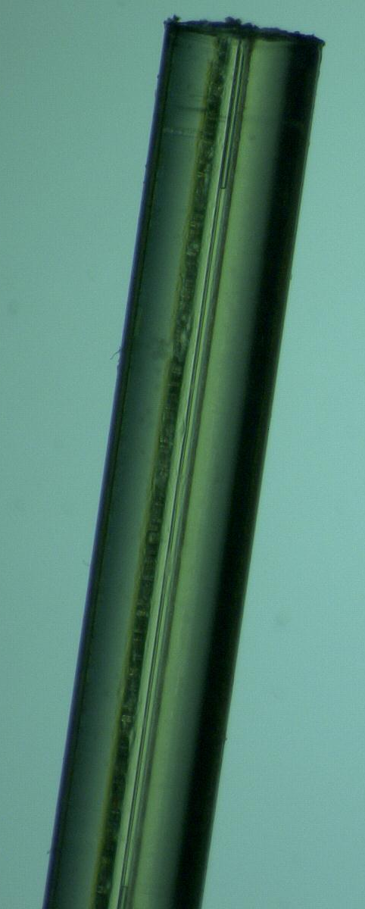
Figure 1: Fibre Tip, under a microscope. The parallel lines are the internal working and reference electrodes

- References:
- Anastasova, S., Spehar‐Délèze, A., Kwasnicki, R., Yang, G. and Vadgama, P., 2020. Electrochemical Monitoring of Subcutaneous Tissue pO 2 Fluctuations during Exercise Using a Semi‐implantable Needle Electrode. Electroanalysis, 32(11), pp.2393-2403.
- Booth, M., Gowers, S., Hersey, M., Samper, I., Park, S., Anikeeva, P., Hashemi, P., Stevens, M. and Boutelle, M., 2021. Fiber-Based Electrochemical Biosensors for Monitoring pH and Transient Neurometabolic Lactate. Analytical Chemistry, 93(17), pp.6646-6655.
- Parlak, O., 2021. Portable and wearable real-time stress monitoring: A critical review. Sensors and Actuators Reports, 3, p.100036.

- Fischer, L., Tenje, M., Heiskanen, A., Masuda, N., Castillo, J., Bentien, A., Émneus, J., Jakobsen, M. and Boisen, A., 2009. Gold cleaning methods for electrochemical detection applications. Microelectronic Engineering, 86(4-6), pp.1282-1285.

- Biography:
Meera Madhavan has submitted her Master’s thesis at the age of 26 from Imperial College London and completed her Bachelor’s Degree at the Henry Samueli School of Engineering and Applied Sciences at the University of California, Los Angeles.

- Presenting author details


Full Name: Meera Madhavan
Contact number: +44 7721 730642
Linked In account: meera-madhavan-01a77390
Session name/ number:
Category: (Oral presentation/ Poster presentation)
Passport Number: 496822303

