Abstract Template

Title: Deep Eutectic Solvents: from biocompatibility to application in biosensors development

Rossella Svigelj ¹, Nicolò Dossi ¹, Cristian Grazioli ¹ and Rosanna Toniolo ¹

¹Department of Agrifood, Environmental and Animal Science, University of Udine, via Cotonificio 108, 33100, Udine, Italy;

Keywords: Deep Eutectic Solvents; Biosensors; DNA; Enzymes; MIPs; Aptamers; Nanomaterials.

- Introduction
Lately a new class of solvents, called Deep Eutectic Solvents (DESs), has been successfully employed in different research fields. In 2004 Abbott et al. described the generation of eutectic mixtures as complexes formed between halide salts and a range of compounds such as amides and carboxylic acids (Abbott et al., 2004). The eutectic mixtures can be simply prepared by mixing a Hydrogen Bond Acceptor (HBA) with a Hydrogen Bond Donor (HBD) at a temperature of about 80 °C. They have found application in different research fields, for instance they have been employed in organic synthesis, electrochemistry and bio-catalysis, showing improved biodegradability and lower toxicity compared to other solvents (Liu et al., 2015). We considered the emerging interest in different applications of this green class of solvents and the possibility of their use for the improvement of biosensors performances. We point out some promising examples of approaches for the assembly of biosensors exploiting their compelling characteristics (Svigelj et al., 2020). The extensive ability of DESs to solubilize a wide range of molecules provide the possibility to set up new devices even for analytes that are usually insoluble and difficult to quantify, such as gluten in food.

- Image:

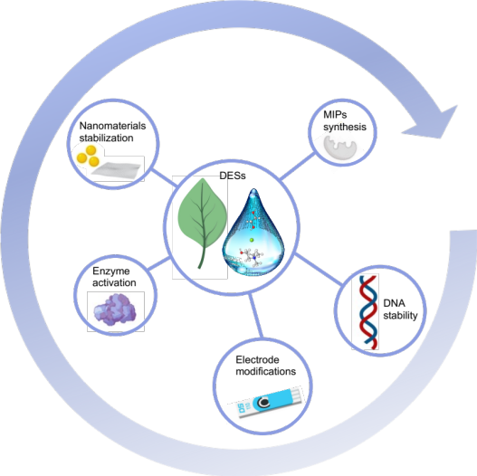

- References:
- Abbott, A.P., Boothby, D., Capper, G., Davies, D.L., Rasheed, R.K., 2004. Deep eutectic solvents formed between choline chloride and carboxylic acids: versatile alternatives to ionic liquids. J. Am. Chem. Soc. 126, 9142–9147.
- Liu, Y., Friesen, J.B., McAlpine, J.B., Lankin, D.C., Chen, S.-N., Pauli, G.F., 2018. Natural deep eutectic solvents: properties, applications, and perspectives. J. Nat. Prod. 81, 679–690.
- Svigelj, R., Dossi, N., Pizzolato, S., Toniolo, R., Miranda-Castro, R., de-los-Santos-Álvarez, N., Lobo-Castañón, M.J., 2020. Truncated aptamers as selective receptors in a gluten sensor supporting direct measurement in a deep eutectic solvent. Biosens. Bioelectron. 165, 112339.
- Biography:
Rossella Svigelj has completed her PhD in 2019 from University of Udine. She is now a postdoctoral researcher in the group of analytical chemistry of the University of Udine. Her research activity is focused on the development of new aptamer-based biosensors for the detection of allergens and emerging contaminants in food.

- Presenting author details

Full Name: Rossella Svigelj
Contact number:+39 3405286623
Linked In account: https://www.linkedin.com/in/rossellasvigelj/
Session name/ number:
Category: Oral presentation

