Metal oxide nanomaterials for biosensing
Nicole Jaffrezic-Renault, Emeritus Research Director in CNRS, Institute of Analytical Sciences, University of Lyon, France

Abstract
During the last ten years, the design of new enzyme-free electrochemical sensors based metal oxide nanoparticles has been described. Due to the electrocatalytic activity of these nanomaterials, these sensors allow the sensitive detection of different ions and molecules. They can replace advantageously enzymes due to their higher stability.
The presentation will be focused on the use of Kegging type polyoxometallates (POMs) for the detection of nitrite ions¹ and of hydrogen peroxide. The association of POMs with single-wall carbon nanotubes (image) allowed the increase of the sensitivity of detection of hydrogen peroxide by a factor of 38.5². The involved charge transfer mechanism will be detailed.
Other types of metal oxide nanomaterials such as perovskites will also be presented. A2BO4+δ type perovskite are alternance of perovskite ABO₃ and of rock salt AO layers, A being a lanthanide and B a metal. Detection limit of glucose is 0.5 µM and no interference of detection is observed in human serum. The involved charge transfer mechanism will be detailed.
This presentation shows the potentiality of metal oxide nanomaterials for biosensing.

Image
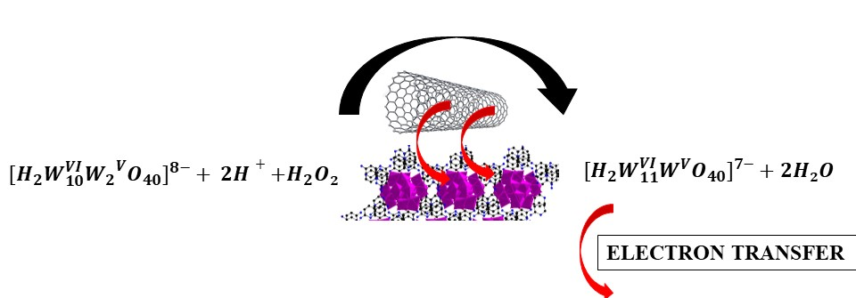
Recent Publications
- Sahraoui Y, Sbartai A, Chaliaa Sana, Maaref A, Haddad A, Jaffrezic-Renault N (2015) A Nitrite Electrochemical Sensor Based on Boron-Doped Diamond Planar Electrochemical Microcells Modified with a Monolacunary Silicotungstate Polyoxoanion, Electroanalysis 27:1359-1367
- Sahraoui Y, Chaliaa S, Maaref A, Haddad A, Bessueille F, and Jaffrezic-Renault N (2020) Synergistic Effect of Polyoxometalate and Single Walled Carbon Nanotubes on Peroxidase-like Mimics and Highly Sensitive Electrochemical Detection of Hydrogen Peroxide, Electroanalysis 32:683-689
- Boubezari I, Zazoua A, Bessueille F, Errachid A, and Jaffrezic-Renault N (2020) Design of a new non-enzymatic sensor based on a substituted A₂BO_{4+δ} perovskite for the voltammetric detection of glucose, Electroanalysis 32:1642–16505.
- Sawan S, Maalouf R, Errachid A, Jaffrezic-Renault N (2020) Metal and metal Oxide nanoparticles in the voltammetric Detection of heavy metals: A review. Trends in Analytical Chemistry 131:116014.

 Biography
Dr Nicole Jaffrezic-Renault received her engineering degree from Chimie Paris Tech, in 1971 and the Doctorat d’Etat és Sciences Physiques from the University of Paris in 1976. She is Emeritus Director of Research at the Centre National de la Recherche Scientifique, past president of the chemical micro sensor club (CMC2), president of the Analytical Division and member of the administrative council of the French Chemical Society. She was decorated as Knight of the Legion of Honor and Officer of the National Order of Merit. Her research activities in the Institute of Analytical Sciences, include conception and design of (bio)chemical sensors and their integration in microsystems. She coordinates several European and national projects for the development of microsystems for biomedical and environmental monitoring and for food safety. She published more than 560 papers with more than 11400 citations (H index: 53).
Email: nicole.jaffrezic@univ-lyon1.fr

Notes/Comments:

