Rapid prototyping of 3D microfluidics for point-of-care devices: going beyond trial-error fabrication
Joan M Cabot, PhD, LEITAT Technology Center, Barcelona, SPAIN

Abstract
In biosensing, bio-receptors are immobilized and labeled on the surface requiring specific manual steps. Microfluidics have paved the way for packing these lab-tasks together in a point-of-care (POC) device. However, conventional microfabrication techniques are tedious, expensive and requires cleanroom facilities [1,2]. To overcome these limitations, 3D printing (3DP) offers a rapid and inexpensive prototyping allowing the conversion of a computer-assisted design (CAD) into a physical object in a single process with 3D flow distribution and multilevel format. Despite these advantages, 3DP printing request a feasible design for testing and in most cases, researchers end-up using a trial-error approach [3-5]. In this study, we used 3D multiphase flow simulations to go beyond trial-error fabrication. From the outputs of the simulation, 3D printed microfluidic chips were fabricated for its subsequent testing. Using this approach, the optimum design can be found in a quicker and more efficient way, accelerate the time-to-market, and reduce the operation costs of the entire process (figure). Besides, the performance of different printer technologies was evaluated in terms of feature size, accuracy, and suitability for mass manufacturing. Laminar flow was studied to assess their suitability for microfluidics. As a proof of concept, 2 different applications are presented: (1) direct 3D printed microfluidic chip with organic biosensors for the assessment of the immune reaction against biologicals targeted to inflammatory pathologies; (2) a compact capillary-driven microfluidic device for the appropriate delivery of reagents on the biosensing platform without using external pumps and valves.

Image
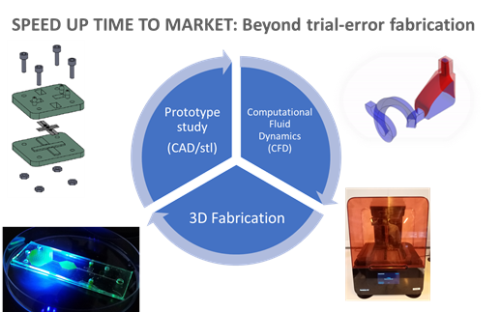
Recent Publications
- S. Knowlton, et al. ”3D-printed microfluidic chips with patterned, cell-laden hydrogel constructs”. Biofabrication (2016), 8, 025019.
- S. Waheed, et al. “3D printed microfluidic devices: Enablers and barriers”, Lab on a Chip (2016) 16, 1993.
- N.P. Macdonald, et al. “Comparing microfluidic performance of three-dimensional (3D) printing platforms”, Analytical Chemistry (2017) 89, 3858.
- A. Olanrewaju, et al. “Capillary microfluidics in microchannels: from microfluidic networks to capillaric circuits.” Lab on a Chip, 18, 2323-2347, 2018.
- R. Safavieh, and D. Juncker. “Capillarics: pre-programmed, self-powered microfluidic circuits built from capillary elements.” Lab on a Chip, 13, 4180-4189, 2013.

 Biography
Joan Marc Cabot is currently a Principal Investigator and leading the Diagnostic Devices Group at LEITAT Technology Center from 2018. He received BSc and PhD in Analytical Chemistry both at the University of Barcelona where he developed high-throughput methods for drug discovery and development applications. Since completing his PhD, Dr. Cabot has carried out outstanding research within the ARC Centre of Excellence for Electromaterial science (ACES, Australia) as a Research Fellow and Lecturer, and visiting fellow at UoW (Australia) and DCU (Ireland). Dr. Cabot accrued over 10 years' excellent scientific track record in analytical devices and microfluidics and for a large spectrum of diagnostic applications. His research interests focus on the development of novel 3D microfluidics, immunosensors and organ on chip platforms.
Email: jmcabot@leitat.org

Notes/Comments:

