Abstract

Title: Development of a wearable flexible electronic tattoo biosensor for hydration monitoring

Sadie Sinclair¹, Owen J. Guy^{1,2}, Anitha Devadoss^{1*}
¹Centre of NanoHealth, College of Engineering, Swansea University, Singleton Park, SA2 8PP, Swansea, United Kingdom

² Department of Chemistry, College of Science, Swansea University, Singleton Park, SA2 8PP, Swansea, United Kingdom

Keywords: Hydration, Biosensor, Impedance, Spray Coating, Ink, Tattoo

- Abstract Body

Hydration monitoring is very important for various groups of people including athletes, the elderly and people who work outdoors in extreme conditions. This research outlines the development of a wearable biosensor which is flexible and capable of monitoring the hydration levels of an individual through the measurement of skin’s impedance. This sensor is applied to the skin in the same way as a temporary tattoo, which allows it to perfectly conform to the skin. The metal pattern, produced from the spray coating of the metal salt solution onto the stencil, is capable of withstanding the mechanical deformation which it would experience when attached to the skin. The tattoo sensor produced will be compatible with another wearable platform capable of measuring the changes in impedance. There is also opportunity for the sensor to be further functionalized to detect molecules present in sweat which would be useful for other diagnostics.

- Image:

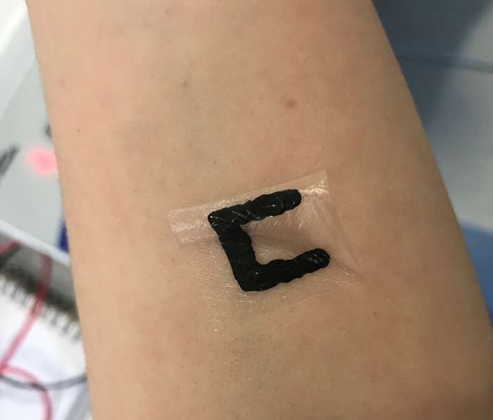

[1][2][3]

  - References:
1. Yao S, Myers A, Malhotra A, Lin F, Bozkurt A, Muth JF, et al. A Wearable Hydration Sensor with Conformal Nanowire Electrodes. Adv Healthc Mater. 2017 Mar 1;6(6):1601159.
2. Wang Y, Qiu Y, Ameri SK, Jang H, Dai Z, Huang Y, et al. Low-cost, μm-thick, tape-free electronic tattoo sensors with minimized motion and sweat artifacts. npj Flex Electron. 2018 Dec 13;2(1):6.
3. Barandun G, Soprani M, Naficy S, Grell M, Kasimatis M, Kwan †, et al. Cellulose Fibers Enable Near-Zero-Cost Electrical Sensing of Water-Soluble Gases. 2019;

IV. Biography:

Sadie completed her Undergraduate degree in Medical Engineering at Swansea University in 2019, which included the completion of a project on developing a biosensor for the detection of beta-amyloid proteins for Alzheimer’s disease diagnosis. Sadie began her Masters by Research, developing a flexible wearable biosensor, later in 2019 and will remain in Swansea until she has completed it later this year.

    - Presenting author details



Full Name: Sadie Sinclair

Contact number: 07530848826
Twitter account: @sadiesinclair3

Linked In account: https://www.linkedin.com/in/sadie-sinclair/
Session name/ number:

Category: Poster presentation
Passport Number: 536935366

Meetings International Pte Ltd

Phone/WhatsApp: +65 31581626

