Title: Near field non-invasive electrophysiology of retrotrapezoid nucleus using amperometric cation sensor
GUPTA S¹, OTERO JJ², SUNDARESAN VB¹, CZEISLER CM³
¹Department of Mechanical and Aerospace Engineering, The Ohio State University, 201 W 19th Ave, Columbus, 43210, Ohio, United States
²Department of Pathology, Neuropathology, The Ohio State University, 333 W 10th Ave, Columbus, 43210, Ohio, United States
³Division of Department of Pathology, The Ohio State University, 333 W 10th Ave, Columbus, 43210, Ohio, United States

Keywords: Conducting polymer, Polypyrrole, Retrotrapezoid nucleus, Sub-threshold activity

- Abstract Body

Central chemoreception is the process whereby the brainstem senses blood gas levels and adjusts homeostatic functions such as breathing and cardiovascular tone accordingly. Rodent evidence suggests that the retrotrapezoid nucleus (RTN) is a master regulator of central chemoreception through direct sensation of acidosis induced by CO₂ levels^{1, 2}. The oscillatory dynamics caused by pH changes as sensed by the RTN and its relationship to the fluctuations in cation flux is not clearly understood due to the current limitations of electrophysiology tools and this article presents our investigations to address this need. A cation selective sensor fabricated from polypyrrole doped with dodecyl benzenesulfonate is placed over RTN of an ex-vivo en bloc brain and cation concentration changes above the RTN is measured due to changes in externally imposed basal pH. The novelty of this technique lies in its feasibility to detect cation fluxes from the cells in the RTN region without having to access either sides of the cell membrane. Owing to the placement of the sensor in close proximity to the tissue, we refer to this technique as near-field electrophysiology³. It is observed that decreasing pH in the physiological range (7.4–7.2) results in a significant increase in cation concentration in the vicinity of RTN with a median value of ~5 μM. The utilization of such quantifiable measurement techniques to detect sub-threshold brain activity may help provide a platform for future neural network architectures. Findings from this paper present a quantifiable, sensitive, and robust electrophysiology technique with minimal damage to the underlying tissue.
- Image:

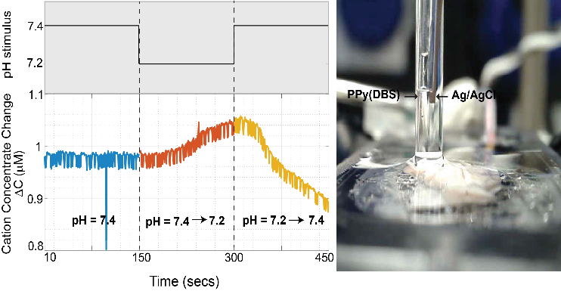

  - Reference:

1. Guyenet, P.G. et al. Retrotrapezoid nucleus, respiratory chemosensitivity and breathing automaticity. Respiratory Physiology & Neurobiology 168, 59-68 (2009).

2. Mulkey, D.K. et al. Respiratory control by ventral surface chemoreceptor neurons in rats. Nature Neuroscience 7, 1360-1369 (2004).

3. Venugopal, V., Hery, T., Venkatesh, V. & Sundaresan, V.B. Mass and charge density effects on the saturation kinetics of polypyrrole doped with dodecylbenzene sulfonate. Journal of Intelligent Material Systems and Structures 28, 760-771 (2017).

IV. Biography:

Sujasha Gupta has completed his PhD in Mechanical Engineering at the age of 29 years from The Ohio State University, United States. Her work focusses on developing neural interfacing devices for real-time monitoring of nerve health. She is an academic achievement award recipient, which was awarded during her Masters at University of Florida.

    - Presenting author details


Full Name: Sujasha Gupta

Contact number: +1-352-777-9660

Linked In account: www.linkedin.com/in/sujasha-gupta-00706338
Session name/ number: Bioelectronics and Bioinstrumentation

Category: Oral presentation
Passport Number: S5892289

Meetings International Pte Ltd

Phone/WhatsApp: +65 31581626

