Epigenetic leukocyte subtyping using digital droplet PCR for hematological diagnostics

Lidija Malic¹, Jamal Daoud¹, Matthias Geissler¹, Alex Boutin¹, Lukic Ljuboje¹, Mojra Janta¹, Abdelrahman Elmanzalawy¹, and Teodor Veres1¹

¹Life Sciences Division, National Research Council of Canada, 75 de Mortagne Boulevard, Boucherville, QC, J4B 6Y4, Canada.

Keywords: Rice lines, Salt stress, Microsatellite (SSR) marker, Protein analysis, Gene expression

- Abstract Body (up to 250 words)

Analysis of the composition of white blood cells is among the most frequently requested laboratory tests in hematological diagnostics. Differential leukocyte count serves as indicator for a spectrum of diseases including infection, inflammation, anemia, and leukemia, and is under investigation as early prognostic biomarker for several diseases. Epigenetic markers have recently emerged as powerful analytic tools for the study of phenotypic variations. This has led to the investigation of cell-lineage DNA methylation patterns that correlate with human leukocyte populations, allowing precise quantification of white blood cell (WBC) subset.^{1,2} The methods of DNA methylation analysis, however, often require costly and complex techniques involving genome sequencing or loci-specific quantitative PCR (qPCR). Herein, a thermoplastic elastomer droplet microfluidic device is presented and employed for methylation specific digital droplet PCR. The technology has been used to delineate specific leukocyte subtypes based on cell-lineage DNA methylation patterns.³ Bisulfite-treated DNA from blood samples is encapsulated in droplets with ddPCR reagents containing primers and TaqMan fluorescent probes specific for CpG loci correlated with WBC sub-population types. The multiplex approach allows the interrogation of many CpG loci without the need for separate ddPCR reactions, allowing more accurate parametric determination of WBC sub-populations using epigenetic analysis of methylation sites. The presented method achieves multiplex detection of various methylation sites within a single droplet, while promoting customizability and cost-effectiveness, which are prerequisites for translation into clinical diagnostics.
- Image:

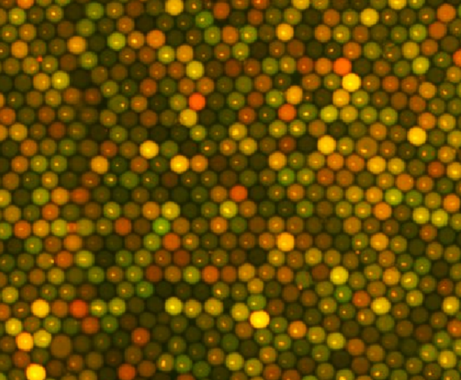

  - Reference:

- Koestler, D.C., Christensen, B.C., Karagas, M.R., Marsit, C.J., Langevin, S.M., Kelsey, K.T., Wiencke, J.K. and Houseman, E.A., 2013. Blood-based profiles of DNA methylation predict the underlying distribution of cell types: a validation analysis. Epigenetics, 8(8), pp.816-826.

- Accomando, W.P., Wiencke, J.K., Houseman, E.A., Nelson, H.H. and Kelsey, K.T., 2014. Quantitative reconstruction of leukocyte subsets using DNA methylation. Genome biology, 15(3), p.R50.

- Malic, L., Daoud, J., Geissler, M., Boutin, A., Lukic, L., Janta, M., Elmanzalawy, A. and Veres, T., 2019. Epigenetic subtyping of white blood cells using a thermoplastic elastomer-based microfluidic emulsification device for multiplexed, methylation-specific digital droplet PCR. Analyst, 144(22), 6541-6553.

IV. Biography:

Lidija Malic is a Research Officer leading the Precision Diagnostics team at the Bio-Analytical-Micro-Nano-Devices Section, Life Sciences Division of the National Research Council of Canada. She also holds an Adjunct Professorship at the Biomedical Engineering Department at McGill University. Her research is focused on the development of electrowetting, centrifugal and pressure-driven microfluidic devices in polymer materials for applications in medical diagnosis, food and water safety, single cell analytics, and space related applications. Lidija holds a PhD from the department of Biomedical Engineering, McGill University in Montreal, Canada and an MBA from John Molson School of Business in Montreal, Canada.

    - Presenting author details


Full Name: Lidija Malic

Contact number: 450-641-5127
Twitter account: N/A

Linked In account: https://www.linkedin.com/in/lidija-malic-2533622
Session name/ number: Lab on a chip and multiplexed sensors

Category: Speaker
Passport Number:

Meetings International Pte Ltd

Phone/WhatsApp: +65 31581626

