Imaging Cellular Forces with Nucleic Acid-based Tension Sensors

Xuefeng Wang¹
¹Department of Physics and Astronomy, Iowa State University, Ames, IA 50011, USA

Keywords: Cellular Force, Cell mechanobiology, Tension sensor, DNA, Peptide nucleic acid, Integrin

- Abstract

Integrin-transmitted cellular forces play critical roles in many cellular functions including cell migration and platelet-mediated hemostasis. Conventional cell traction force microscopy suffers from the low spatial resolution and high demand for assay preparation and data processing. Here we developed integrative tension sensor (ITS) [1] which converts force to fluorescence, therefore enabling cellular force mapping directly by fluorescence imaging. ITS is based on nucleic acid duplexes such as DNA and PNA (peptide nucleic acid) that are decorated with dye, quencher, ligand and biotin [2]. Immobilized on a surface, the tension sensors can be ruptured by cellular forces, freeing dyes from quenching and hence reporting cellular force by fluorescence. With ITS, we mapped integrin-transmitted platelet force at 0.4 µm resolution and calibrated the integrin tension levels required by platelet adhesion and contraction. Based on ITS, we further developed super-resolution cellular force microscopy, termed Cellular Force Nanoscopy (CFN), to image cellular force with 50 nm spatial resolution. CFN was applied to study the role of integrin tensions in cell migration. In the fast migrating keratocytes, CFN revealed three regimes of integrin tensions: high-level integrin tensions (>54 pN) at cell rear edge mediating cell retraction [3], low-level tensions (12-54 pN) at the very front edge mediating cell protrusion, and low-level tensions under lamellipodia mediating cell contraction. Overall, ITS and the associated CFN provide a powerful technique for measuring and mapping integrin tensions in platelets, keratocytes and many other adherent cells with high resolution and sensitivity, holding great potential in the study of cell mechanobiology.

- Image:

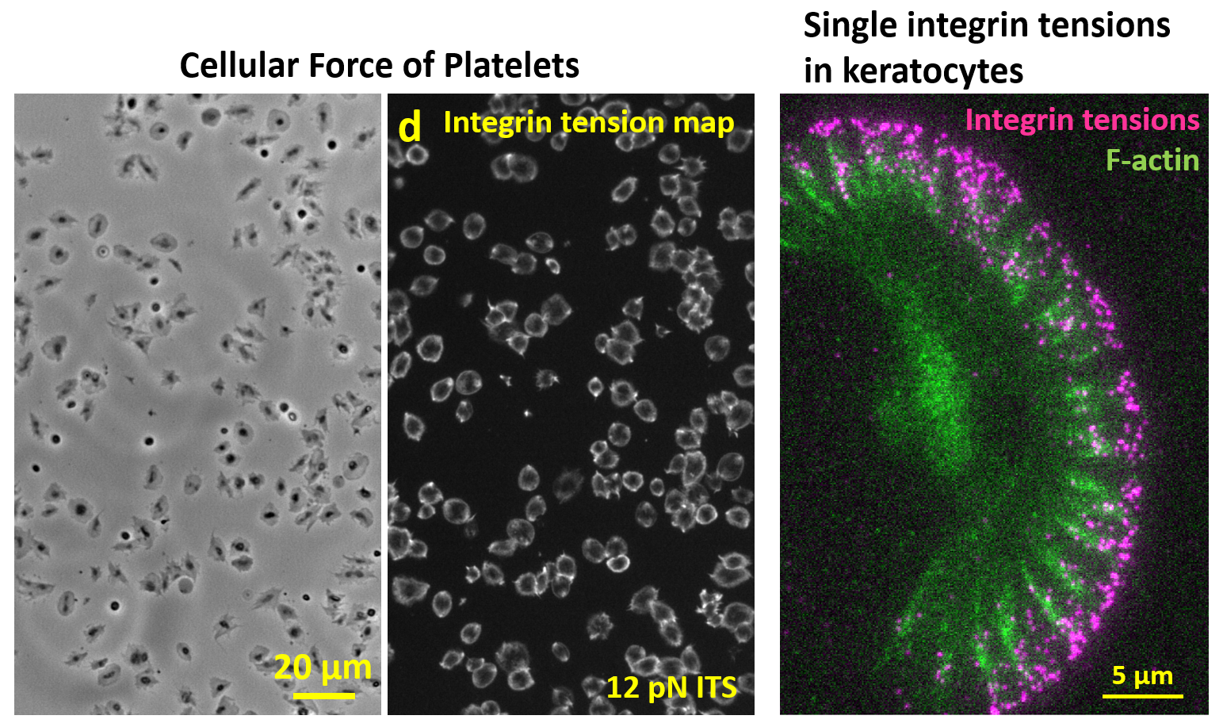

  - Reference:

1. Wang, Y.L., et al., Force-activatable biosensor enables single platelet force mapping directly by fluorescence imaging. Biosensors & Bioelectronics, 2018. 100: p. 192-200.
2. Zhao, Y., A. Sarkar, and X. Wang, Peptide nucleic acid based tension sensor for cellular force imaging with strong DNase resistance. Biosens Bioelectron, 2020. 150: p. 111959.
3. Zhao, Y.C., et al., Keratocytes Generate High Integrin Tension at the Trailing Edge to Mediate Rear De-adhesion during Rapid Cell Migration. Iscience, 2018. 9: p. 502-512.

IV. Biography:

Dr. Xuefeng Wang is an assistant professor in the department of Physics and Astronomy at Iowa State University since 2015. He obtained Ph.D. of Physics from Purdue University in 2009 and worked as a postdoctoral researcher at University of Illinois at Urbana-Champaign in 2010-2015. He was trained as a biophysicist and with specialty in single molecule detection and imaging. Currently, with the support from NIH and NSF funds, Wang’s lab develops DNA-based biosensors for cellular force imaging in live cells and DNase detection on the cell membrane. His lab studies the role of integrin tensions in cell adhesion and migration by imaging cellular forces with single molecule sensitivity and 50 nm spatial resolution.

    - Presenting author details

Full Name: Xuefeng Wang

Contact number: 515-294-3545
Session name/ number:

Category: (Invited Oral presentation)
Passport Number:

