Abstract Template

Title: Nanomaterials for Electrochemical (Bio)Sensing: Electrochemical Synthesis

TONELLI D¹, GUALANDI I¹, SCAVETTA E¹, TALEB A²
¹Department of Industrial Chemistry “Toso Montanari”,University of Bologna, Italy
²Institut de Recherche de Chimie Paris (IRCP / ENSCP), Sorbonne University, Paris, France

Keywords: Electrochemical (bio)sensors, Nanomaterials, Electrodeposition, Metal nanoparticles, Layered Double Hydroxides, Polymers

- Abstract Body (up to 250 words)

In recent years, nanomaterials have attracted much attention to modify the surface of electrodes due to their intriguing physicochemical properties, which differ significantly from those displayed by the corresponding bulk materials. The realization of modified electrodes has been of crucial importance for the development of a new generation of electroanalytical devices with enhanced sensitivity and selectivity since the modifiers confer interesting properties to the support which can lead to a specific recognition and/or a pre-concentration of the analytes. Among the methods suitable to modify a conductive surface, electrodeposition displays several advantages, in terms of adhesion of the modifier and rapidity of the modification; furthermore parameters such as current density, applied potential, duration of the synthesis, electrode material, presence or absence of an additive play a key role in determining the shape and size of the resulting nanostructures. As an example, Figure 1 shows the SEM micrographs obtained for Pt nanoparticles (NPs) electrodeposited on GC and graphite [1], in the optimized conditions, both in the absence (Figs. 1A and C) and in the presence of iodide (Figs. 1B and D). As already observed by El-Deab for Au nanoparticles deposition [2], the morphology is strongly affected by these factors; all the deposits appear with grey color and different contrasts, except for that obtained on GC in the presence of KI, which is bright, with more pronounced reflecting properties and behaving like a mirror surface.
This contribution aims to describe the most recent applications in the field of electrochemical (bio)sensors taking into account both inorganic and organic nanomaterials [3].

- Image:
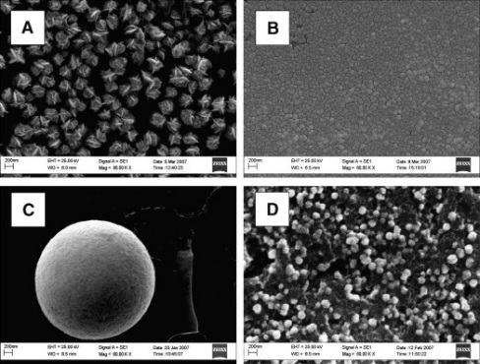

  - References:

- Scavetta, E., Stipa, S. and Tonelli, D., 2007. Electrodeposition of a nickel-based hydrotalcite on Pt nanoparticles for ethanol and glucose sensing. Electrochem. Commun., 9: 2838–2842

- El-Deab, M.S., Sotomura, T., and Ohsaka, T., 2006. Oxygen reduction at Au nanoparticles electrodeposited on different carbon substrates. Electrochim. Acta, 52:1792–1798

- Tonelli, D., Scavetta, E. and Gualandi, I., 2019. Electrochemical Deposition of Nanomaterials for Electrochemical Sensing. Sensors, 19: 1186.

IV. Biography:

Domenica Tonelli is full Professor of Analytical Chemistry at the Department of Industrial Chemistry “Toso Monrtanari” of Bologna University. She is the coordinator of the PhD School of Chemistry. She has published more than 220 papers in reputed journals and has been serving as an editorial board member of Nanomaterials.

    - Presenting author details
    - 


Full Name: Domenica Tonelli

Contact number: +390512093667
Session name/ number: 1.Nanobiosensors & nanomaterials

Category: Oral presentation (Key-note)
Passport Number:

Fig. 1 SEM micrographs (MAG. 60,000×) of the Pt NPs electrodeposited on: GC
without (A) and with (B) 0.1 mM iodide; graphite without (C) and with 0.1 mM iodide.

Meetings International Pte Ltd

Phone/WhatsApp: +65 31581626

